Date
21st April 2021 | Page 1 of 1

For immediate release


Glamox supplies energy-efficient lighting solution for new zero-emission cargo vessel

Global LED lighting specialist Glamox has designed and supplied a modern, energy-efficient, LED lighting solution for Yara International’s new zero-emission container vessel, Yara Birkeland.

Built by Norwegian shipbuilder Vard, Yara Birkeland is reputedly the world’s first zero-emission cargo vessel. 80 metres in length, 15 metres wide and a cargo capacity of 120 standard, 20-foot containers, the vessel will be used to move goods between the Yara production site in Porsgrunn to Brevik and Larvik in Norway, helping to shift transportation from road to sea, thereby reducing noise and dust, as well as NO_{x} and CO₂ emissions. The vessel is a fully battery-powered solution prepared for autonomous operation.

The Glamox lighting solution provided for Yara Birkeland consists of 240 luminaires with low energy consumption and high lumen output. The luminaires also have an extremely long life span of more than 100,000 hours at 45°C. The solution comprises of both indoor and outdoor lighting, including floodlights. The solution ensures good onboard working light in all weather conditions.

Yara Birkeland is an example of Yara’s ambition to innovate and find climate-friendly solutions that can be commercialised. The lighting solution provided by Glamox makes an important contribution to the vessel’s zero-emission profile.

Glamox is a leading supplier of lighting solutions to the world’s marine and offshore markets, focusing on providing the latest LED lighting solutions, contributing to lower energy consumption, reduced maintenance and environmentally-friendly working conditions for its customers. As a local partner with a strong global network and a range of popular lighting brands, Glamox can fulfill all maritime lighting requirements, including interior lighting, floodlights and searchlights, explosion-proof luminaires and navigation lights. Glamox products and solutions are developed and tested by engineers at its own research and testing facilities and are manufactured and certified in accordance with all relevant quality and environmental standards.

For more information on Glamox lighting solutions for commercial marine applications, please visit www.glamox.com/commercialmarine

About Glamox AS
Glamox is a Norwegian industrial group that develops, manufactures and distributes professional lighting solutions for the global market. The Glamox Group is a leading supplier to the world’s marine, onshore and offshore markets, and a significant supplier to the professional building market in Europe.
The Glamox Group is a global organisation, with more than 2,400 employees within sales and production in several European countries, as well as Asia, North and South America. The turnover is NOK 3.1 billion. The Group owns a range of quality lighting brands including Glamox, Luminell, Aqua Signal, Norselight, Luxo, LINKSrechts, Küttel, Luxonic and ES-SYSTEM. Glamox is committed to meeting customer needs and expectations by providing quality products and solutions, service and support. www.glamox.com
Captions for Photographs:

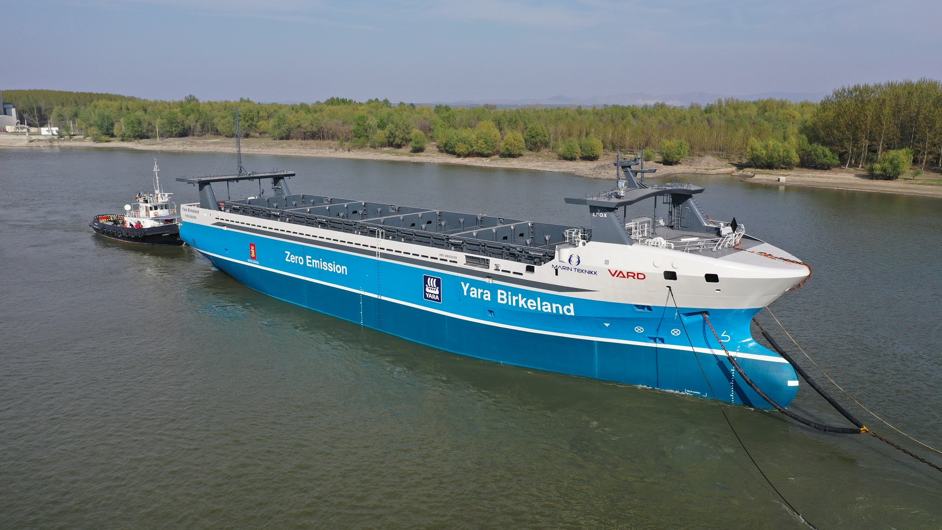

Glamox has supplied 240 luminaires to Yara Birkeland, the world’s first zero-emission cargo vessel.

Contact information
For more information, please contact:

Glamox International
Tel: +44 (0) 7719 547 175
Service.gi@glamox.com
www.glamox.com/gmo
Press Release Issued by:
Dean Palmer, Director,
SilverBullet PR Ltd,
19, Glen Crescent, Stamford,
Lincolnshire PE9 1SW
Tel: +44 (1780) 764 254
Mobile: +44 (7703) 023771
dean@silverbulletpr.co.uk
www.silverbulletpr.co.uk
High resolution images are available on request from SilverBullet PR.

