Date
4th July 2019 | Page 1 of 1

For immediate release


From racing car to bus – KEB supports e-mobility and the vehicle drive of the future.

Future engineers have built an electrically driven racing car for Formula Student. For the "Speeding Scientists Siegen" Racing Team (S3) KEB Automation is supporting the vehicle drive of the future: e-mobility in the endurance test. But how does this relate to auxiliary power drives for buses?
"At the Hannover Fair 2012, we sealed our cooperation with a handshake," says Kuno Winkelheide, KEB Applications Engineer in the field of e-mobility. At that time, the young engineers of the University of Siegen in Germany came to the KEB stand in search of suitable inverters for its electric racing car. "Of course, we were happy to help out with the products and technical advice."

A few weeks ago, the 2019 Formula Student car was unveiled by the students – christened "Molly". Initially, F5 drives from KEB were used, but now the team uses KEB COMBIVERT H6 drives. The advantage of the H6 drive is its modular design, which also makes it a pioneer for KEB’s recently launched COMBIVERT T6 APD (Auxiliary Power Drives) e-mobility solution. "This allows the S3 Racing Team to adapt the size of the inverter drives to the requirements of an electric racing car," adds Winkelheide.
This means that the components can be installed where there is space. "To place four times 75 kilowatts in a 'small shoe box' is already an exciting accomplishment by the students," comments Winkelheide, enthusiastic about the performance of the young engineers.

Transfer of knowledge
KEB is wholeheartedly supporting the S3 racing car team. "Of course, racing cars fascinate many people," says the experienced engineer, "but for us, it’s also an important connection to science." In addition to the transfer of knowledge, several of the engineers of the first S3 team now work at KEB in the area of control and automation.
And it is precisely this that the new e-mobility solution for auxiliary power drives in commercial vehicles benefits from. The former racing engineers are now part of the development team for the COMBIVERT T6 APD. In this way, fully electric or hybrid buses, excavators and transporters are already being operated using racing know-how.
In addition, the close cooperation with the S3 team is also exciting for the KEB students and apprentices. At the latest presentation, the roll-out of the new "e-Racer", they got a glimpse behind the scenes. This meant they had the chance – apart from their daily work – to see what science projects can involve: the creation of a new racing car in 12 months.
The Formula Student races will take place in various categories from 5 to 11 August 2019 at the Hockenheimring in southern Germany. For more information visit www.s3racing.de

The drive of the future
The COMBIVERT T6 APD from KEB Automation is a modular, scalable combined drive & controller system for hybrid and electric vehicles. The system can be adapted to suit specific customer requirements and associated drive functions, particularly applications in wholly- or partly-electrified trams, buses, trains, agricultural and construction vehicles and Light Commercial Vehicles (LCVs).

In urban transport, conventional vehicles consume up to 30% of the energy purely for the auxiliary drives and so the potential for energy savings is significant. Converting to electric auxiliary drives means improved energy efficiencies and greater controllability. Various applications on the vehicle can be controlled individually (e.g. power-on-demand) and therefore more efficiently, while optimising processes to meet the precise needs of the vehicle. This can lead to significant reductions in vehicle noise and CO₂ emissions.

Regardless of whether energy is produced or provided by diesel generators, fuel cells, battery packs or supercapacitors, the COMBIVERT T6 APD offers a connection or adaptation facility to suit all vehicle energy sources. This means auxiliary drive components such as air conditioning, air compressors, hydraulic pumps, Power Take Off / Shaft substitutes and ventilators can be decoupled from the combustion engine (main drive) and installed in the most cost effective or mechanically favourable position on the vehicle.

The capabilities of the T6 APD controller are efficient, on-demand adjustment of voltage, current and frequency in up to six drive/motor axes. The T6 APD controls all types of electric motor, providing automatic motor identification. The controller provides excellent shaft performance, dynamic speed and torque control, as well as a variety of control algorithms, including open-loop control and SCL (sensorless-closed-loop) for synchronous and asynchronous (A.SCL) motors.

For more information on the COMBIVERT H6 or T6 APD, please visit www.keb.co.uk

About KEB Automation KG
KEB provides a complete Automation Solution from gear shaft to HMI screen, including motion control up to CNC level, safety systems with FsoE (Failsafe over EtherCAT) and visualisation. KEB’s aim is always to find the optimum drive and control solution tailored to suit a customer’s precise requirements.
Headquartered in Barntrup, Germany, KEB is a medium-sized global business with a workforce in excess of 1,400 worldwide, with more than 10% of these working in research and development. With structured growth over the last 40 years, the company’s motto is ‘reliability creates trust’. Every day, the quality and performance levels of KEB solutions are reflected in its customers’ machines and installations.
KEB group consists of 10 subsidiary companies worldwide, including KEB (UK) Ltd. and Sales & Service Centres in a further 23 countries to support its growing customer base.

Photographs and Captions:

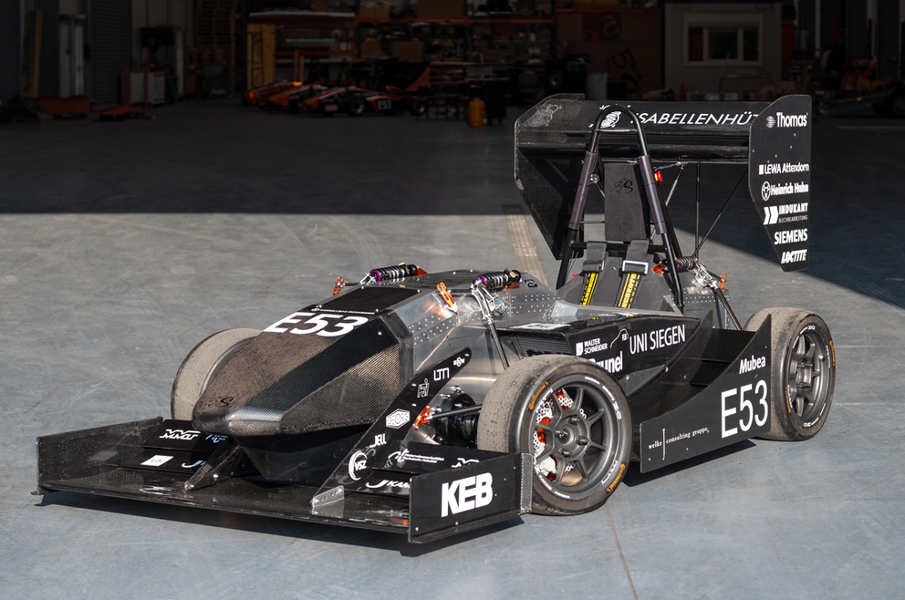
Molly, S3 Racing’s 2019 Formula Student car, uses COMBIVERT H6 drives, a pioneer for the recently launched COMBIVERT T6 APD e-mobility solution (Photo copyright: Speeding Scientists Siegen).

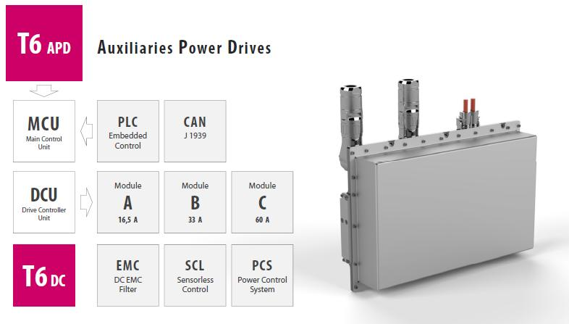
The COMBIVERT T6 APD from KEB Automation is a modular, scalable combined drive & controller system for hybrid and electric vehicles.

Contact information
For more information, please contact:

Mark Checkley
Sales & Marketing Manager,
KEB (UK) Ltd.
5 Morris Close,
Park Farm Industrial Estate,
Wellingborough, Northants, NN8 6XF
Tel: +44 (0) 1933 402 220
Mobile: +44 (0) 7810 568056
Email: mark.checkley@keb.co.uk
Website: www.keb.co.uk

Press Release Issued by:
Dean Palmer,
Director,
SilverBullet PR Ltd,
19, Glen Crescent, Stamford,
Lincolnshire, UK.
PE9 1SW
Tel: +44 (1780) 764 254
Mobile: +44 (7703) 023771
Email: dean@silverbulletpr.co.uk
Website: www.silverbulletpr.co.uk
High resolution images are available on request from SilverBullet PR.

