Date
16th January 2020 | Page 1 of 1

For immediate release
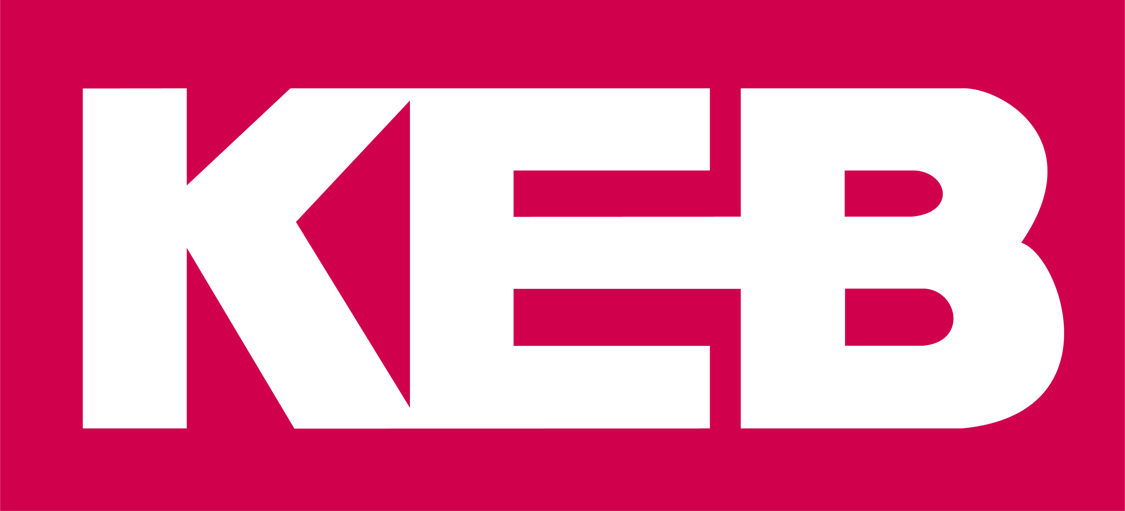

Concrete Canvas chooses KEB drives, controllers and HMIs for new production line

By installing servo drives with integrated functional safety, HMIs and controllers from KEB Automation on its new production line, Concrete Canvas Ltd has reduced wiring installation costs and has greater flexibility in terms of future expansion plans for machines and additional lines.

Based in Pontyclun, Wales, Concrete Canvas Ltd is the sole manufacturer of the award-winning products, Concrete Canvas (CC) and CC Hydro (CCH), which are manufactured in South Wales and exported to more than 80 countries. CC is a new material technology called a geosynthetic cementitious composite mat, or GCCM. The material is a flexible concrete impregnated fabric that hardens on hydration to form a thin, durable, waterproof concrete layer. Essentially, the product is ‘concrete on a roll’. CC can be installed using simple hand tools, with no requirement for specialist labour or equipment, and can be installed up to 10 times faster than conventional methods.

In Spring 2018, due to increased demand for its products, Concrete Canvas Ltd purchased a new facility in Pontyclun, around six miles from the original factory in Pontypridd. This new site is around three times the size of the Pontypridd facility, providing the company with significant opportunities for continued growth.

Graham Rose, Engineering Manager at Concrete Canvas Ltd, is responsible for developing the new production lines at Pontyclun, including machinery, controls and automation systems. He states: “As there was no off-the-shelf machinery available for producing our new product, all the design and build work was performed in-house.”

The continuous production line for the new prototype rolled product comprises a variety of machines, equipment and automated systems, including unwinders, dry cement powder handling systems, a main process section that forms the cement filled web, coating machines, web handling machines and rewinders.

“The prototype production line is quite complex. There are many different machines with parts that need to be moved at different speeds. We therefore started to search for a suitable supplier of drives that could handle this type of application. We needed the drives to be flexible and easily expandable to allow easy, rapid future expansion of the line and individual machines, with as little panel wiring as possible. Another key requirement for us was safety, so we wanted drives with in-built functional safety,” explains Graham.

After a thorough supplier evaluation process, which included on-site demonstrations, Graham chose KEB Automation for its servo drives with FSoE (FailSafe-over-EtherCAT), as well as HMIs, a smart controller and the COMBIVIS 6 software that provides a common development platform.

“At present, we have around 10 COMBIVERT S6-A servo drives and some F6 drives from KEB operating on the production line. The lower powered drives tend to perform lighter duties such as transporting the web material, whereas the larger drives control the conveyors and mixers for the cement, the main web forming process section and the centre winding machine, as well as performing general positional and control tasks. Some of the drives are linked so that they operate synchronously, which is critical when controlling line speed set points and the intricate, varying tensions of the web material,” he adds.

Compact, flexible and powerful, the COMBIVERT S6-A is suitable for a wide range of highly dynamic servo applications, including highly automated, safety-oriented machines. The drives provide optimal motor control in real time, integrated safety functionality and are designed in a compact, space-saving book-style format for easier mounting in control cabinets where space can be limited. The drives are 100% in-house designed and built by KEB and can be customised with a variety of design options to suit the specific application. Safety functionality can be selected from three modules to suit the requirements of the machine.

“We use a variety of electric motors on the line including synchronous and asynchronous induction motors, permanent magnet motors and servo motors. The S6 drives are so flexible that they can drive any type of motor, with or without encoders, so this was never an issue for us,” says Graham.

Drives with integrated functional safety
The S6-A drive is a flexible, modular design that allows scaleable functional safety, from basic STO to encoder-based safe motion. Optional use of current speed-based safety functions (e.g. Safe Limited Speed, Safe Maximum Speed, Safe Operating Stop, and Safe Direction) is available. All safety functions can be used in applications up to IEC 62061-SIL3 in accordance with IEC 61508 or up to PLe in accordance with ISO 13849. The safety functions are controlled via secure digital inputs or via FSoE. The S6-A also provides more real time fieldbus control options and safety PLC communications (EtherCAT, PROFINET, POWERLINK), giving Concrete Canvas a genuine future-proof, Industry 4.0/IoT-capable servo drive.

“In terms of safety, we need some of the drives to be capable of breaking or ramping down at controlled rates, so we’re already using some of the drive safety functions. In the future, as the line expands, we’ll use a lot more, as we’ll need to introduce more safety systems to the line, including safety gates, light curtains and safe interlock switches. With KEB drives, we can support this expansion quickly and easily using the KEB COMBIVIS 6 development software platform,” he explains.
Start up and analysis software
COMBIVIS 6 enables start up, administration and analysis of KEB drives. This includes start-up Wizards for quick and easy product configuration, direct access to device documentation, as well as enabling online drive parameter list comparisons and the set up of key safety indicators and functions. With a foundation built on libraries, devices and template databases, COMBIVIS 6 allows rapid, simple solutions to be generated for a wide range of applications.
Smart controller and HMIs
Concrete Canvas also installed a C6 smart controller from KEB to control and manage all the automation and safety programs. The C6 SMART is perfectly tailored to the runtime environment and real-time capability with a powerful processor for performing complex automation tasks. The integrated micro UPS and spacious onboard memory make it a robust, reliable system. The device takes up just 47mm on the DIN rail and supports direct coupling with remote I/O modules. Operators on the line are also benefiting from the use of KEB HMIs, which allow them to alter or control set points on the machines, visualise the complete line or individual machines, and to look at key production parameters and performance indicators.”
“Our environment here is digital fieldbus and EtherCAT, so in the future I can add safety and functionality to the machines easily and quickly, with reduced panel wiring. The COMBIVIS 6 software is critical here, as it allows us to quickly add new safety features to the drives and gives our engineers a common platform for the development environment,” says Graham.
The new prototype production line has been up and running for almost a year now and Graham is delighted with the results: “By installing servo drives with integrated functional safety, we’ve reduced the wiring, so our installation costs in terms of materials (e.g. reduced number of safety relays) and time have been minimised. We also have greater flexibility in terms of future expansion of the line. Any changes or additions can be made using software rather than installing new hardware. We can control the motors with or without encoders using the same drive, giving us even greater options, flexibility and cost savings. We’re also about to introduce a new machine with Siemens S7 PLCs. KEB has provided us with a software module that allows data to be exchanged between this and our other controllers.”
He concludes: “We’ve been very impressed with KEB in terms of their technical capabilities and support over the last 12 months. They’ve been very helpful and have responded quickly when we’ve needed support on resolving any issues. I was also impressed by the excellent price-performance ratio of the KEB S6 drives compared to other drive suppliers on the market. I look forward to working with KEB in the future as our production line expands.”
For more information, please visit www.keb.co.uk

About KEB Automation KG
KEB provides a complete Automation Solution from gear shaft to HMI screen, including motion control up to CNC level, safety systems with FsoE (Failsafe over EtherCAT) and visualisation. KEB’s aim is always to find the optimum drive and control solution tailored to suit a customer’s precise requirements.
Headquartered in Barntrup, Germany, KEB is a medium-sized global business with a workforce in excess of 1,400 worldwide, with more than 10% of these working in research and development. With structured growth over the last 40 years, the company’s motto is ‘reliability creates trust’. Every day, the quality and performance levels of KEB solutions are reflected in its customers’ machines and installations.
KEB group consists of 10 subsidiary companies worldwide, including KEB (UK) Ltd. and Sales & Service Centres in a further 23 countries to support its growing customer base.

Photographs and Captions:

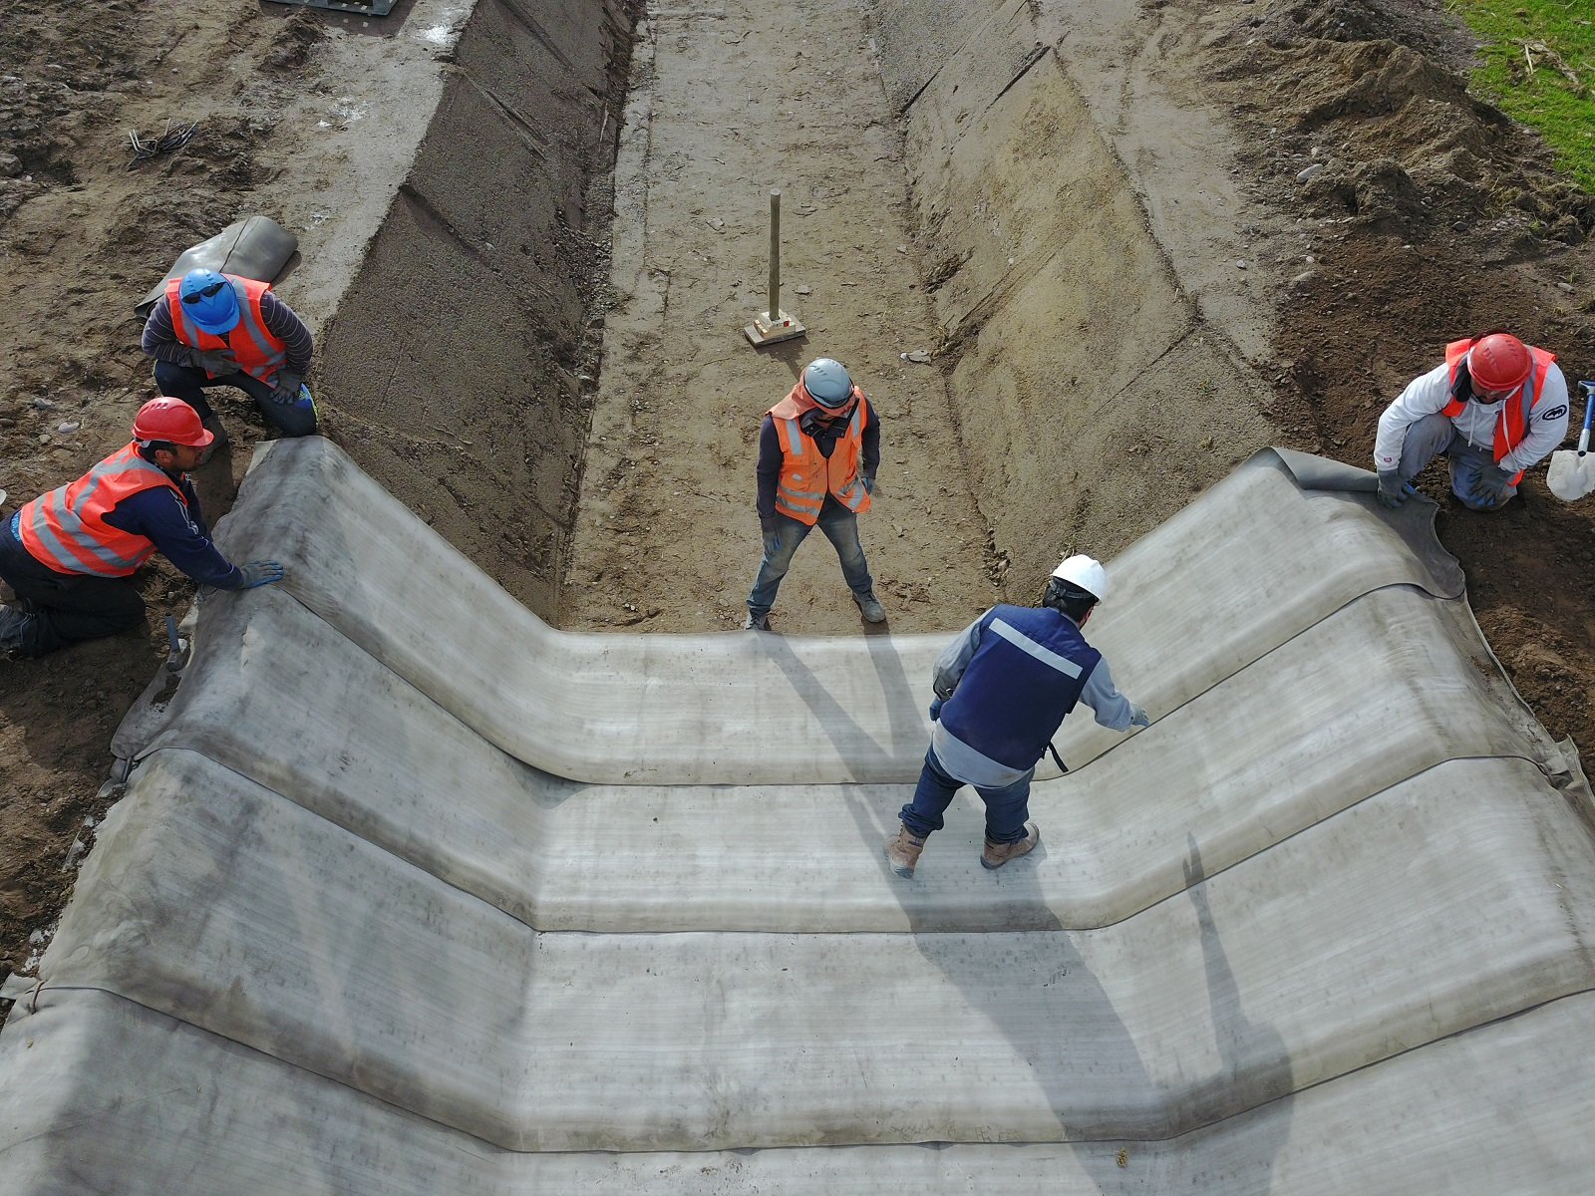

Concrete Canvas is a flexible concrete impregnated fabric that hardens on hydration to form a thin, durable, waterproof concrete layer.
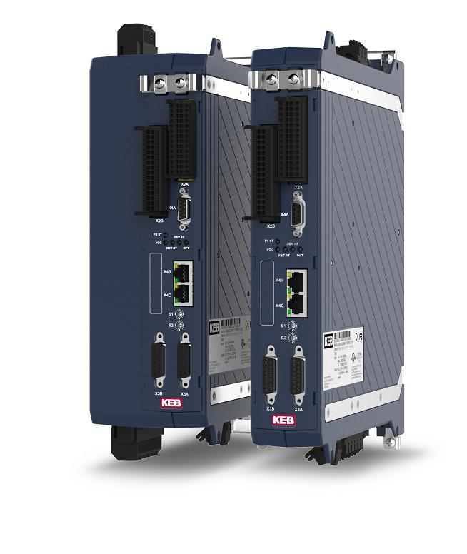

The COMBIVERT S6 drive controller from KEB.

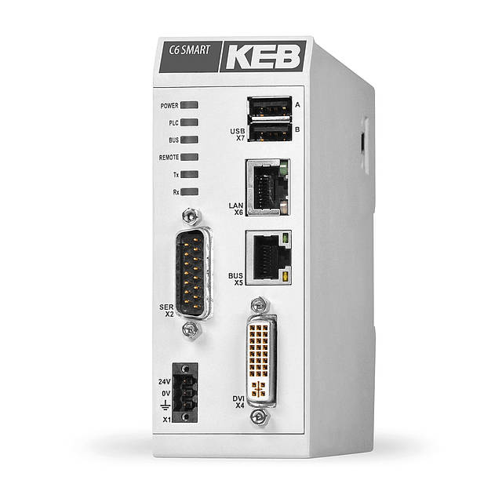

The C6 smart controller from KEB.

Contact information
For more information, please contact:

Mark Checkley
Sales & Marketing Manager,
KEB (UK) Ltd.
5 Morris Close,
Park Farm Industrial Estate,
Wellingborough, Northants, NN8 6XF
Tel: +44 (0) 1933 402 220
Mobile: +44 (0) 7810 568056
Email: mark.checkley@keb.co.uk
Website: www.keb.co.uk

Press Release Issued by:
Dean Palmer,
Director,
SilverBullet PR Ltd,
19, Glen Crescent, Stamford,
Lincolnshire, UK.
PE9 1SW
Tel: +44 (1780) 764 254
Mobile: +44 (7703) 023771
Email: dean@silverbulletpr.co.uk
Website: www.silverbulletpr.co.uk
High resolution images are available on request from SilverBullet PR.

