Date
5th February 2020 | Page 1 of 1

For immediate release


KEB Automation and ISG cooperation results in seamless, integrated CNC solutions

In cooperation with German company ISG (Industrial Control Technology), the ISG-CNC core is now implemented in the KEB automation system – with individual possibilities for many industries, from woodworking and robotics, to motion control, CNC and the manufacture of dental prostheses.
KEB’s complete solution enables CNC machine tool manufacturers to create their technologies with ‘open’ automation tools without compromising on CNC functionality. The user can put together the required hardware from KEB’s wide portfolio of control, drives, automation and safety technology. The respective software package, which consists of an integrated CNC core for movement, as well as visualisation and a user-friendly HMI interface, is scalable according to user requirements.
The cooperation between ISG and KEB Automation results in numerous options and opportunities that go far beyond the ISG-CNC basis. This means that customers can use additional features for different applications – depending on their individual needs.

The basic package includes the following functions:

- Speed and acceleration pre-control, jerk limitation.
- Powerful, tactile-synchronous CNC-PLC interface.
- Coupling functions, gantry axis functions, measuring functions.
- Look-ahead function.
- Linear, circular, spiral interpolation.
- DIN 66025 program syntax with high-level language extension.
- Sub-program technology, macro definitions, coordinate systems, spindle and additional functions.
- Operation with automatic mode, manual mode, single block mode, referencing, block advance, handwheel operation mode.
- Tool management.
An expansion package is available which includes the additional features:
- CNC Channels – up to 12 expandable channels, channel synchronisation, axis exchange between the channels.
- Transformation (trafo) – expansion of all CNC channels through kinematic transformation.
- High-Speed Cutting (HSC) – faster machining times, higher accuracy, better surface quality.
- Spline – use of gearing (AKIMA, B-Spline) for geometry optimisation.
- Cutting – CNC technology extension for cutting (e.g. laser, plasma, oxyfuel, water jet).
- Volumetric compensation (vol. comp.) - effective method of increasing machine accuracy.

CNC features in detail
“Almost 100 kinematics are already stored in the Transformation feature. In the near future, it will also be possible to create your own kinematics,” says Michael Zacharewicz, Head of Control & Automation at KEB. This feature is used wherever individual kinematics are required by the application.
The High Speed Cutting feature is used when high quality demands are required on surfaces. A very high speed results in significantly lower cutting forces, which makes it possible to manufacture very precise tools, for example, for plastic injection moulding machines.
The Spline feature can be used to calculate optimal paths for the user. “This enables us to run perfect path radii that are either designed for high precision or production speed,” explains Zacharewicz.
In order to further optimise the accuracy of a CNC machine, the Volumetric Compensation feature offers the possibility of compensating machine tolerances using software.
The Channel feature is suitable for parallel machining of workpieces. Here, a workpiece is often machined by several kinematics or sorted using a ‘pick-and-place’ application. The feature allows up to 12 kinematics to be controlled simultaneously on a single IPC with a single CNC core.

Open tools
“With our features in the CNC core, we can satisfy applications in any industry and now offer everything from the axes to the HMI interface that customers need for their projects,” says Michael Zacharewicz. The integration of the ISG kernel into the KEB complete solution results in a high level of usability, as the system is set up using the COMBIVIS studio 6 automation tool. Its object-oriented design supports the user in configuring the axes and channels. In addition, PLC and machine functions can be easily extended via the IEC61131 standard.
In addition to the software core for CNC (ISG kernel) used by KEB, ISG also owns real-time simulation software for virtual commissioning (ISG virtous), in which the first KEB products have already been implemented as ‘digital twins’. ISG also has a test automation software tool for control software (ISG dirigent).

For more information, please visit www.keb.co.uk

About KEB Automation KG
KEB provides a complete Automation Solution from gear shaft to HMI screen, including motion control up to CNC level, safety systems with FsoE (Failsafe over EtherCAT) and visualisation. KEB’s aim is always to find the optimum drive and control solution tailored to suit a customer’s precise requirements.
Headquartered in Barntrup, Germany, KEB is a medium-sized global business with a workforce in excess of 1,400 worldwide, with more than 10% of these working in research and development. With structured growth over the last 40 years, the company’s motto is ‘reliability creates trust’. Every day, the quality and performance levels of KEB solutions are reflected in its customers’ machines and installations.
KEB group consists of 10 subsidiary companies worldwide, including KEB (UK) Ltd. and Sales & Service Centres in a further 23 countries to support its growing customer base.

Photographs and Captions:

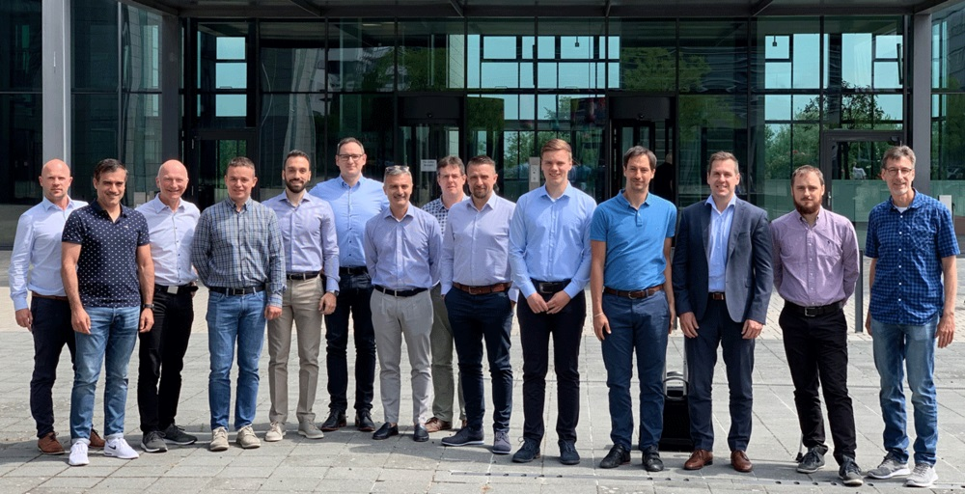

The KEB team around Michael Zacharewicz (6th from the right) was brought up to date with the latest CNC possibilities by ISG colleagues.

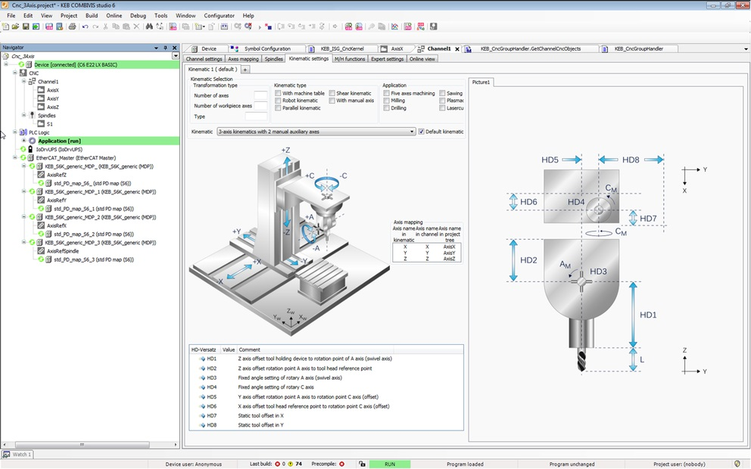
COMBIVIS studio 6 for configuring the CNC kernel.

Contact information
For more information, please contact:

Mark Checkley
Sales & Marketing Manager,
KEB (UK) Ltd.
5 Morris Close,
Park Farm Industrial Estate,
Wellingborough, Northants, NN8 6XF
Tel: +44 (0) 1933 402 220
Mobile: +44 (0) 7810 568056
Email: mark.checkley@keb.co.uk
Website: www.keb.co.uk

Press Release Issued by:
Dean Palmer,
Director,
SilverBullet PR Ltd,
19, Glen Crescent, Stamford,
Lincolnshire, UK.
PE9 1SW
Tel: +44 (1780) 764 254
Mobile: +44 (7703) 023771
Email: dean@silverbulletpr.co.uk
Website: www.silverbulletpr.co.uk
High resolution images are available on request from SilverBullet PR.

