Date
21st May 2020 | Page 1 of 1

For immediate release


Machines & Controls Ltd chooses KEB drives and controllers for special purpose stone and slate cutting machines

KEB Automation has supplied a variety of drives and control equipment to a UK-based machine builder for use on special purpose cutting machines for stone tiles and roof slates. KEB provided a complete solution from a single source and provided engineering support all the way through the machine design and build process.

Based in Bridgnorth, Shropshire, Machines & Controls Ltd is a small, privately owned business that designs and manufactures special purpose machines. Established in 2018, the business specialises in the design and build of special purpose machines, including robotics and associated controls.

Alex Wilson, Managing Director at Machines & Controls Ltd, states: “In 2018, we received an order for a stone façade cutting machine. The machine is a 5-axis CNC sawing machine that cuts stone tiles and cladding for buildings. Around the same time, we also received an order from another customer for two special purpose cutting machines for roof slates.”

Both types of machine required a range of drives and control equipment and so Alex Wilson conducted a thorough supplier evaluation process. “In the end, I chose KEB Automation, as they were able to provide all the drives, controllers, gear motors and HMIs from a single source and were willing to provide engineering support through the machine design and build phases, which you don’t always get from other suppliers,” adds Wilson.

The stone facade cutting machine
For the 5-axis stone facade cutting machine, KEB supplied four COMBIVERT S6 drives, four servo motors, two gear motors and a COMBIVERT F5 inverter. All the control equipment is housed in a control cabinet which has an integrated HMI touchscreen display from KEB.

With dimensions of approximately 3m square by 2m in height, the machine comprises two conveyor bands with a bridge over and two 4kW powered saw blades in the X-Y axis. As the stone is moved down the conveyor, the saw blades can be programmed to add chamfers and slots in the stone. Each saw blade has two axes of motion (up and down/in and out). The machine is fairly low speed (up to 1.5 metres per minute), but is precise and accurate. Two KEB gear motors drive the conveyor bands. Four KEB servo motors (two per head) move the cutting heads. A KEB COMBIVERT F5 inverter controls the two geared motors for the conveyors. The machine is totally enclosed by protective guarding. All control equipment is housed in a control cabinet with KEB touchscreen HMI.

As Wilson explains: “All the control programs were written by KEB using its COMBIVIS software. This meant we had KEB’s support through the design and build stages of the project, which was really crucial for us. We delivered the machine to the customer in February 2019, who is extremely happy with it. Since installing the machine, the customer has reported no issues at all.”

The two slate cutting machines
The two identical slate cutting machines, which have dimensions of around 2m x 1m square, are inclined at 30 degrees and comprise of a pair of conveyors, each driven by a KEB servo gear motor. The conveyors pass over two cutter blades, which cut (‘hammer’) the slate to size. KEB COMBIVERT S6 drives control the position of the upper cutting blades, with two KEB servo motors driving the cutter heads. All controls for the two machines are housed in a single control cabinet with operator control joysticks

Wilson concludes: “On both machine projects, I was particularly impressed with KEB in terms of their technical capabilities and engineering support. They have been very helpful and have always responded promptly when I’ve needed support on resolving any issues. I look forward to working with KEB on future machine projects.”
Drives, controllers and gear motors
Compact, flexible and powerful, the COMBIVERT S6 range of servo drives is suitable for a wide range of highly dynamic servo applications, including highly automated, safety-oriented machines. The drives provide optimal motor control in real time, integrated safety functionality and are designed in a compact, space-saving book-style format for easier mounting in control cabinets where space can be limited. The COMBIVERT S6 range is 100% in-house designed and built by KEB. The drives are available in two different enclosure sizes across motor power sizes from 0.75kW up to 5.5kW or electrical currents from 2.6A to 12.0A, with overload to 250%. The drives can be customised with a variety of design options to suit the specific application. Safety functionality can be selected from three modules to suit the requirements of the machine.

In combination with its control systems and drive controllers, KEB also offers a wide range of servo motors and geared motors, including three-phase motors, servo motors, helical geared motors, shaft mounted helical geared motors, helical worm geared motors and helical bevel geared motors.
For more information, please visit www.keb.co.uk

About KEB Automation KG
KEB provides a complete Automation Solution from gear shaft to HMI screen, including motion control up to CNC level, safety systems with FsoE (Failsafe over EtherCAT) and visualisation. KEB’s aim is always to find the optimum drive and control solution tailored to suit a customer’s precise requirements.
Headquartered in Barntrup, Germany, KEB is a medium-sized global business with a workforce in excess of 1,400 worldwide, with more than 10% of these working in research and development. With structured growth over the last 40 years, the company’s motto is ‘reliability creates trust’. Every day, the quality and performance levels of KEB solutions are reflected in its customers’ machines and installations.
KEB group consists of 10 subsidiary companies worldwide, including KEB (UK) Ltd. and Sales & Service Centres in a further 23 countries to support its growing customer base.

Photographs and Captions:

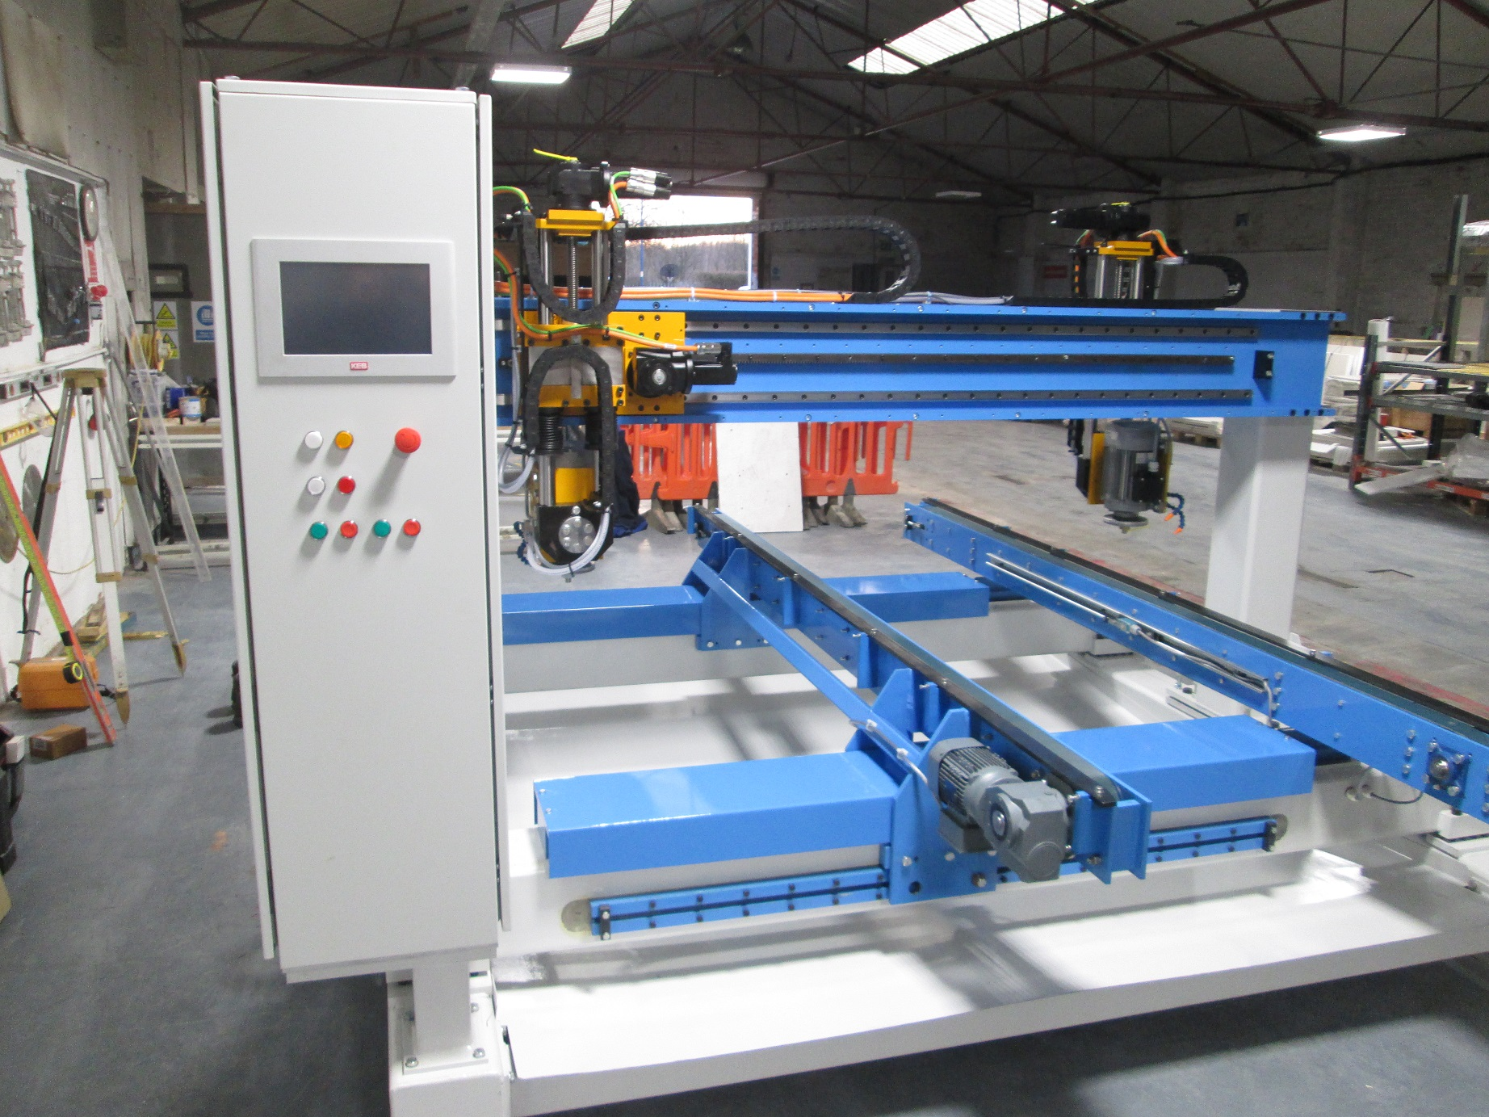

The stone façade cutting machine (without safety guarding) showing the control cabinet with KEB HMI and servo gear motor.
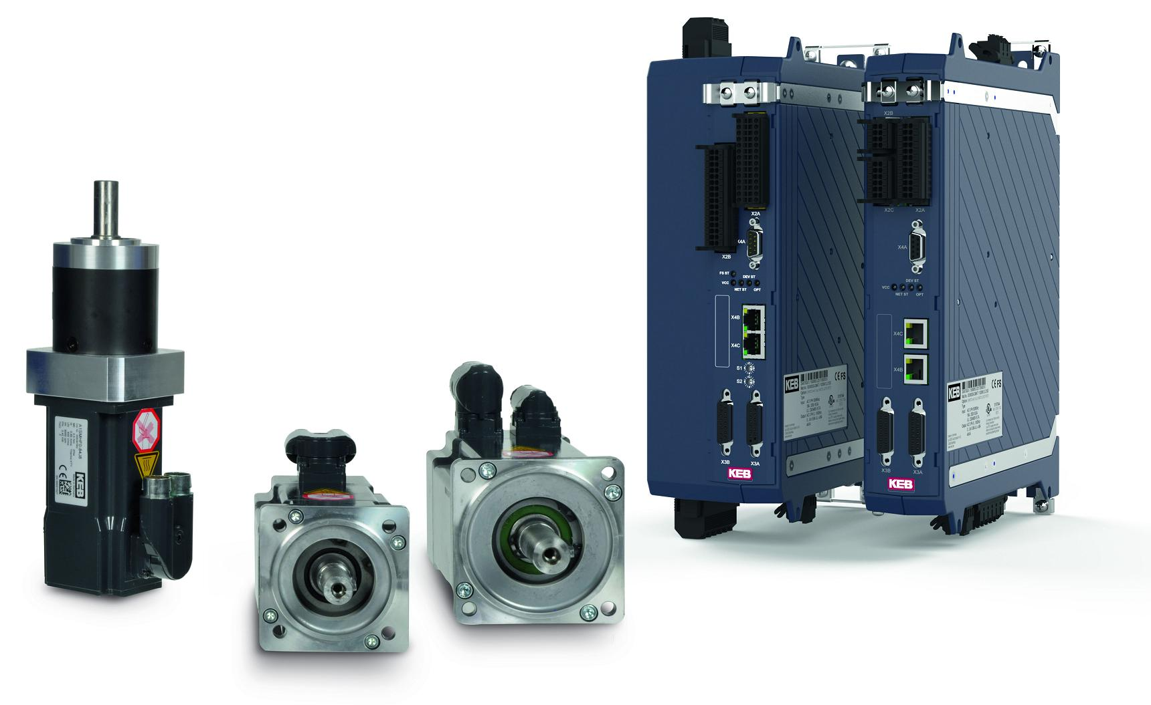
KEB Automation supplied a range of drives and controllers for the machine, including gear motors, servo motors and the COMBIVERT S6 drive controller.

Contact information
For more information, please contact:

Mark Checkley
Sales & Marketing Manager,
KEB (UK) Ltd.
5 Morris Close,
Park Farm Industrial Estate,
Wellingborough, Northants, NN8 6XF
Tel: +44 (0) 1933 402 220
Mobile: +44 (0) 7810 568056
Email: mark.checkley@keb.co.uk
Website: www.keb.co.uk

Press Release Issued by:
Dean Palmer,
Director,
SilverBullet PR Ltd,
19, Glen Crescent, Stamford,
Lincolnshire, UK.
PE9 1SW
Tel: +44 (1780) 764 254
Mobile: +44 (7703) 023771
Email: dean@silverbulletpr.co.uk
Website: www.silverbulletpr.co.uk
High resolution images are available on request from SilverBullet PR.

