Date
15th July 2020 | Page 1 of 1

For immediate release


Drive controllers and filters minimise power losses in high speed machine tool spindles and turbo blowers

New drive controllers and motor filters for high frequency (HF) applications from KEB Automation are helping customers develop highly efficient machine concepts for turbo blowers and CNC machine tool spindles. The objective is to increase performance and protect the motor windings at output frequencies up to 2,000 Hz.
“For industrial high speed applications, we have developed particularly powerful drive controllers, which our customers are using to operate all common high frequency spindles and high speed motor types,” explains Fabian Fischer, Team Leader Application Sales at KEB Automation.
The associated motor filter technology is an important part of the drive package. HF motor chokes, input/output filters and sinusoidal filters based on the latest core materials, ensure the long operating life of CNC main spindles and high speed compressors.
The two main features are based on the winding protection and the stabilisation of the thermal balance of the HF motors. As Fischer states: “By using a specially designed HF motor choke, both the voltage level in the winding and the rate of voltage rise [dU/dt] can be reduced to below 500 V/µs.”
Both are main factors that affect the lifetime of the insulation. In addition, there is a noticeable reduction in the high frequency spectrum and therefore an improvement in the power loss balance in the motor.
For very thermally-sensitive systems such as air bearing spindles or the electromagnetic bearing of the rotor in blower motors – both the current and the phase voltage must be reduced to the torque-forming fundamental frequency. This requires the use of a sine filter.
Comparison – Switching frequency and Filter technique vs power losses
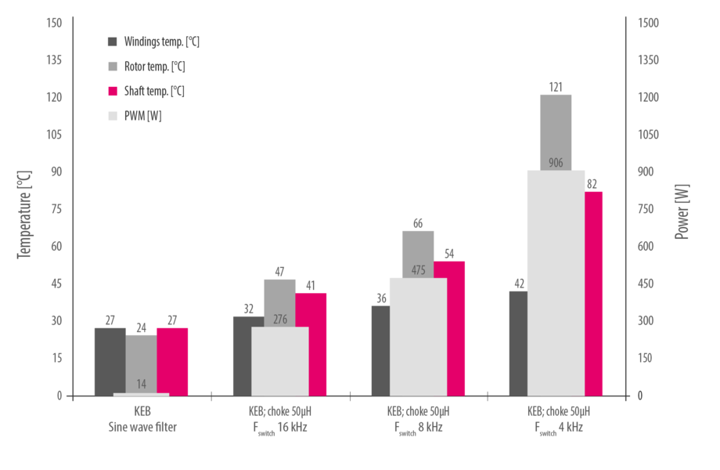
By using a motor filter, the physical properties and therefore the equivalent circuit diagram of the motor is significantly changed due to the filter’s own inductance. As Fischer says: “In order to adjust the components in the system in such a way that control dynamics, torque and shaft power on the motor side are not significantly reduced, we start at two points: firstly, through our own filter development, production and EMC test environment, and secondly, through additional control routines in the drive controllers.”
Asynchronous motor – without and with different types of motor choke
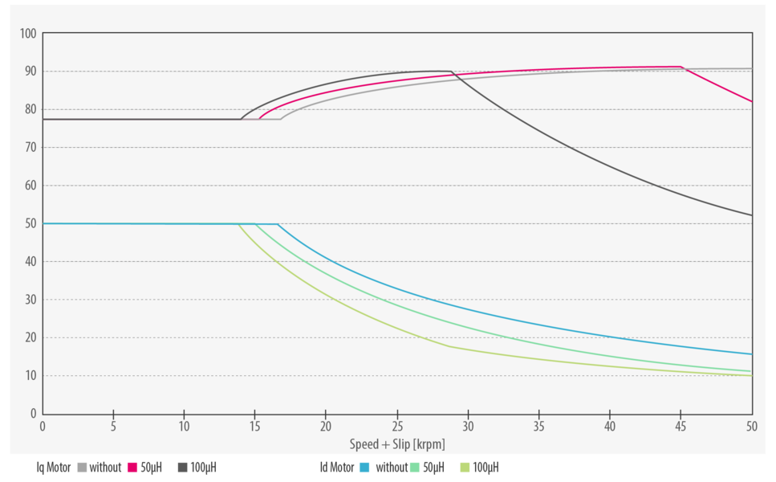

Resonance-free operation
For correct operation of the sine filter, the output circuit can be checked for the natural frequency and the filter-internal components can be dimensioned for resonance-free operation. For large series, it is possible to tune an application-specific sine filter to the operating point of the customer’s machine.
“Here, the power loss balance can be optimised in a way that would not be possible with any currently known modulation method and none of the common power stage topologies on the inverter side,” explains Fischer.
In addition, the motor / sinusoidal filter output network can be adjusted in such a way that the power loss balance is improved by increasing the voltage at the motor terminals, respectively an increase in power at the motor shaft is achieved.
The COMBIVERT F6 and S6 drive controllers from KEB feature software notch filters that generate resonance-free modulation for all speed-controlled operating modes, whether with or without an encoder.

Synchronous motor – with/without sine filter.
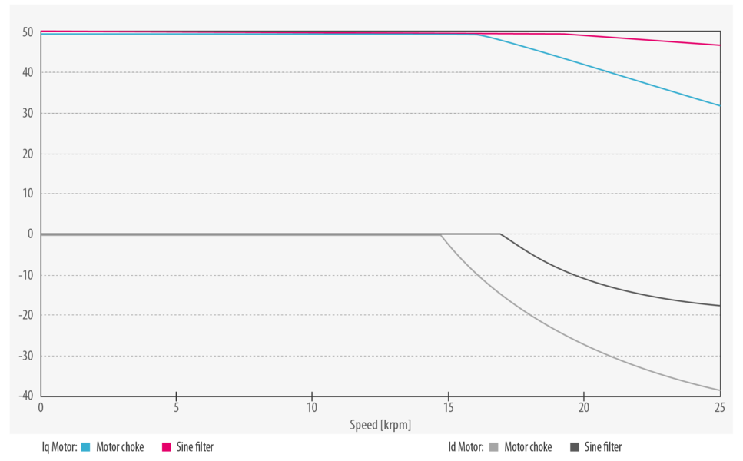

For more information on drive controllers and motor filter technologies from KEB, please visit www.keb.co.uk

About KEB Automation KG
KEB provides a complete Automation Solution from gear shaft to HMI screen, including motion control up to CNC level, safety systems with FsoE (Failsafe over EtherCAT) and visualisation. KEB’s aim is always to find the optimum drive and control solution tailored to suit a customer’s precise requirements.
Headquartered in Barntrup, Germany, KEB is a medium-sized global business with a workforce in excess of 1,400 worldwide, with more than 10% of these working in research and development. With structured growth over the last 40 years, the company’s motto is ‘reliability creates trust’. Every day, the quality and performance levels of KEB solutions are reflected in its customers’ machines and installations.
KEB group consists of 10 subsidiary companies worldwide, including KEB (UK) Ltd. and Sales & Service Centres in a further 23 countries to support its growing customer base.

Photographs and Captions:

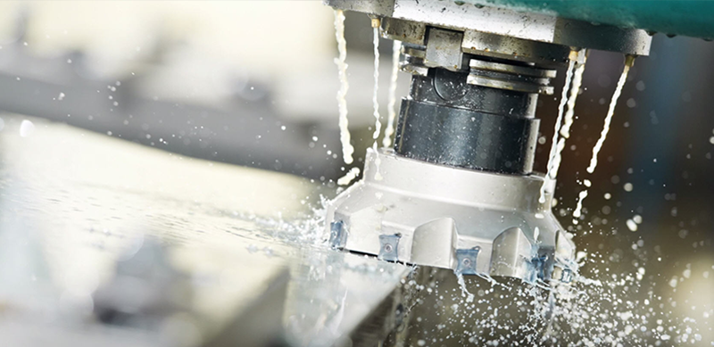

A high speed spindle (photo copyright Alfred Jager GmbH).

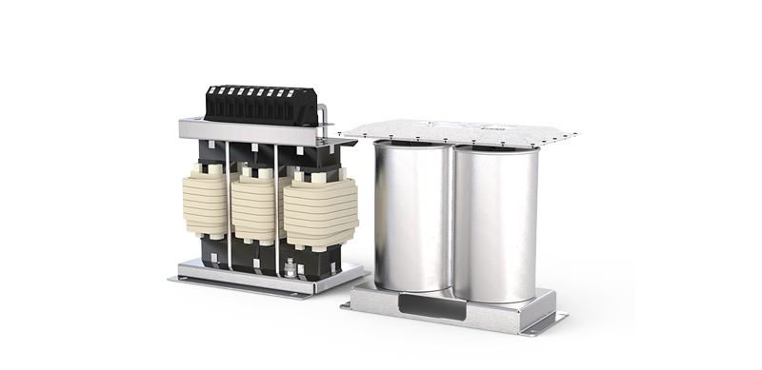
HF motor chokes, sine filters and input/output filters from KEB ensure a long operating life of high speed spindles and compressors.

Contact information
For more information, please contact:

Mark Checkley
Sales & Marketing Manager,
KEB (UK) Ltd.
5 Morris Close,
Park Farm Industrial Estate,
Wellingborough, Northants, NN8 6XF
Tel: +44 (0) 1933 402 220
Mobile: +44 (0) 7810 568056
Email: mark.checkley@keb.co.uk
Website: www.keb.co.uk

Press Release Issued by:
Dean Palmer,
Director,
SilverBullet PR Ltd,
19, Glen Crescent, Stamford,
Lincolnshire, UK.
PE9 1SW
Tel: +44 (1780) 764 254
Mobile: +44 (7703) 023771
Email: dean@silverbulletpr.co.uk
Website: www.silverbulletpr.co.uk
High resolution images are available on request from SilverBullet PR.

