Date
27th February 2023 | Page 1 of 1

For immediate release
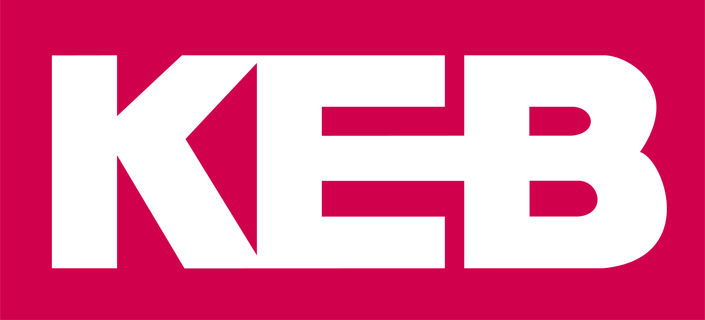

Drive system solution from KEB helps Merz packaging machine achieve 900 sachets per minute

Creams, tablets or tobacco: the list of products that are packaged and filled with the help of machines from Merz goes on and on. The company focuses on high quality packaging machines and special machines for stick packs. The drive solutions required for this need to provide high dynamics, high reliability and high efficiency.
The goods need to be protected from damage, remain fresh for a long time and free of any contamination. The machines required for packaging and filling are manufactured by Merz Verpackungsmaschinen based in Lich, Germany. 90 employees are responsible for designing, developing, manufacturing and selling packaging machines and special machines for stick packs, as well as 3- and 4-side sealed bags. Founded in 1971 as a design office, Merz today supplies industries that are as diverse as the machine portfolio itself. Customers from the pharmaceuticals, cosmetics, chemicals, tobacco and food industries rely on its machines.

The cooperation with KEB Automation has proven its value over the last two decades. For example, many machines contain entire systems from KEB and ensure reliable, highly efficient performance with drive controllers and control systems, among other things – as the ‘heart’ of the machine. The SB18-2T snus packaging machine, for example, is a form, fill and seal machine for smokeless oral tobacco portion packs in filter foil.

Tobias Merte, head of PLC programming at Merz comments: "The SB18-2T operates fully automatically and processes types of fleece from the flat film roll. Since it has an output of up to 900 sachets per minute, we need a system solution in which individual components are matched to each other and work smoothly. In the machine, we therefore rely not only on the C6 Smart control system, but also on the S6 servo drives, servo motors and the C6 routers from KEB Automation."

Packaging machines require high dynamics
Artur Albring, sales engineer at KEB adds: "Typically, a control system as well as at least three servo drives and three servo motors from KEB are always used in the machines from Merz. We work out the desired drive solution together in order to meet the requirements of the machines in the best possible way."

These requirements include, for example, the operation of the servo drives, high dynamics and the powerful performance of the drives. It is also important to keep the control cabinet as compact as possible. The book format of the KEB drives is suitable for this, enabling several drive controllers to be arranged next to each other in a space-saving manner. The control system is also responsible for several tasks. As Albring explains: "The C6 Smart control system handles communication via Profinet and enables machine control and operation. Above all, however, the C6 control system is responsible for motion control and cyclical positioning in Merz packaging machines. For example, in the SBL50-2 stick pack machine."

The safety aspect, which is important for Merz machines, is also mapped with the STO (Safe Torque Off) function via the drive controllers.

Volker Hedrich, Head of Electrical at Merz comments: "We put our packaging and dosing machines into operation in numerous industries worldwide. This also means that the requirements placed on our machines sometimes differ significantly. It is then a great advantage for us that we can fall back on customised drive solutions from KEB."

For more information, please visit www.keb.co.uk

About KEB Automation KG
KEB provides a complete Automation Solution from gear shaft to HMI screen, including motion control up to CNC level, safety systems with FsoE (Failsafe over EtherCAT) and visualisation. KEB’s aim is always to find the optimum drive and control solution tailored to suit a customer’s precise requirements.
Headquartered in Barntrup, Germany, KEB is a medium-sized global business with a workforce in excess of 1,400 worldwide, with more than 10% of these working in research and development. With structured growth over the last 40 years, the company’s motto is ‘reliability creates trust’. Every day, the quality and performance levels of KEB solutions are reflected in its customers’ machines and installations.
KEB group consists of 10 subsidiary companies worldwide, including KEB (UK) Ltd. and Sales & Service Centres in a further 23 countries to support its growing customer base.

Photographs and Captions:

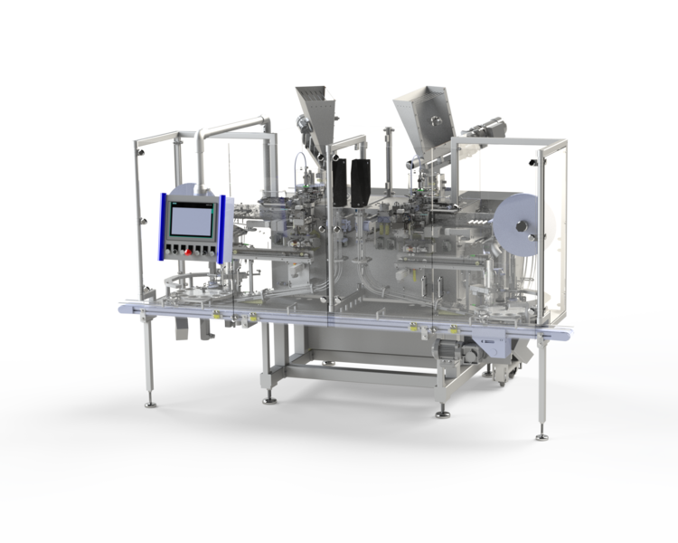
KEB system solution for the snus packaging machine SB18-2T from Merz.

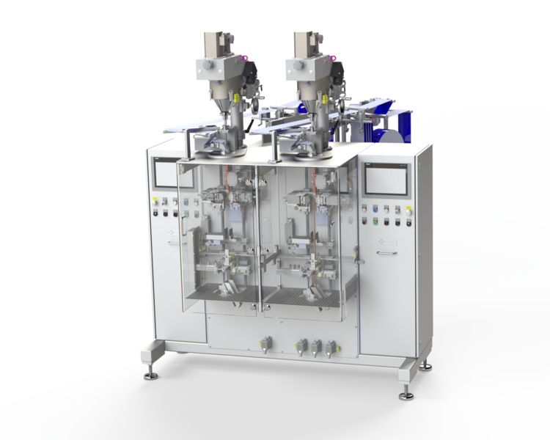
The SBL50-2 stick pack machine features the compact C6 Smart automation system from KEB.

Contact information
For more information, please contact:

Mark Checkley
Managing Director,
KEB (UK) Ltd.
5 Morris Close,
Park Farm Industrial Estate,
Wellingborough, Northants, NN8 6XF
Tel: +44 (0) 1933 402 220
Mobile: +44 (0) 7810 568056
Email: mark.checkley@keb.co.uk
Website: www.keb.co.uk

Press Release Issued by:
Dean Palmer,
Director,
SilverBullet PR Ltd,
19, Glen Crescent, Stamford,
Lincolnshire, UK.
PE9 1SW
Tel: +44 (7703) 023771
Email: dean@silverbulletpr.co.uk
Website: www.silverbulletpr.co.uk
High resolution images are available on request from SilverBullet PR.

