Date
28th February 2024 | Page 1 of 1

For immediate release


Drive controllers for every application
The COMBIVERT F6 and S6 drive controllers from KEB are often mentioned in the same breath, as they are both modern frequency inverters, drive a wide range of motor technologies and have safety features directly in the drive. So what separates and unites the two drive controllers?
If plant and machine builders are looking for frequency inverters that not only cover a wide power range, but also reliably drive synchronous, asynchronous, PM or IPM motors from KEB and third-party suppliers, the COMBIVERT F6 and S6 drive controllers are often the first choice. The F6 combines the advantages of a frequency inverter and a servo drive in just one device, controlling motors with or without an encoder, just as the system or machine requires. This is also possible with the S6 drive controller, which was specially developed for servo applications.

Both drive controllers have scalable safety functions directly in the drive. Flexible utilisation of the safety functions and limit values via digital I/Os and/or the ‘Safety over EtherCAT’ (FSoE) or PROFIsafe safety profile is possible as required. The COMPACT version comes with STO as standard, while the APPLICATION and PRO versions feature STO, SBC and optional encoder-based speed/position-dependent safety functions. Precision and maximum repeat accuracy, as well as functional consistency across the entire power range, are further aspects in which the F6 and S6 are equal.

However, in addition to their many similarities, the F6 and S6 drive controllers differ in some aspects:

Product range
The COMBIVERT F6 covers a range from 2.2 kW to 450 kW and is designed for a rated current of
9.5 A to 800 A. The COMBIVERT S6, on the other hand, is designed for a rated current of 2.6 A to 16.5 A, and with a power range of 0.75 to 7.5 kW is designed for applications that require comparatively lower power. With a high overload capacity, the S6 ensures optimum dynamics.

Housing sizes
The S6 servo controller is available in two housing sizes. There is more choice with the F6: users can choose between seven housing sizes for the inverter.

Dimensions
The difference in size between the two devices is recognisable at first glance. This is because the S6 servo drives are only available in a compact book format, creating the ideal conditions for space-saving control cabinet installation. Due to their modular design, however, the F6 drive controllers are also ideal for efficient installation.

Sub-mounted braking resistor
Starting with frame size 4 of the F6, sub-mounted braking resistors are available that are mounted on the rear of the inverter heat sink. This saves space in the control cabinet and eliminates the wiring work that would otherwise be required by the user. The F6 also has an integrated temperature model that protects the braking resistors from overheating.

Different cooling concepts
These ensure that the KEB drive controllers are highly scalable. The F6 is available as an air-cooled or liquid-cooled built-in or push-through variant. The S6 is available to system and machine builders as an air-cooled built-in version. One of the advantages of liquid cooling is the particularly high efficiency and increased service life of the inverter, as it can be operated cooler and more evenly. The advantage of air cooling, on the other hand, is that the user can change the fans as required.

All in all, the F6 and S6 are two powerful and flexible drive controllers that ensure highly efficient drives in numerous application areas. Due to the different power ranges and the variance in device sizes, users will always find the ideal drive solution in the KEB portfolio.

For more information, please visit www.keb.co.uk

About KEB Automation KG
KEB provides a complete Automation Solution from gear shaft to HMI screen, including motion control up to CNC level, safety systems with FsoE (Failsafe over EtherCAT) and visualisation. KEB’s aim is always to find the optimum drive and control solution tailored to suit a customer’s precise requirements.
Headquartered in Barntrup, Germany, KEB is a medium-sized global business with a workforce in excess of 1,400 worldwide, with more than 10% of these working in research and development. With structured growth over the last 40 years, the company’s motto is ‘reliability creates trust’. Every day, the quality and performance levels of KEB solutions are reflected in its customers’ machines and installations.
KEB group consists of 10 subsidiary companies worldwide, including KEB (UK) Ltd. and Sales & Service Centres in a further 23 countries to support its growing customer base.

Photos and captions:

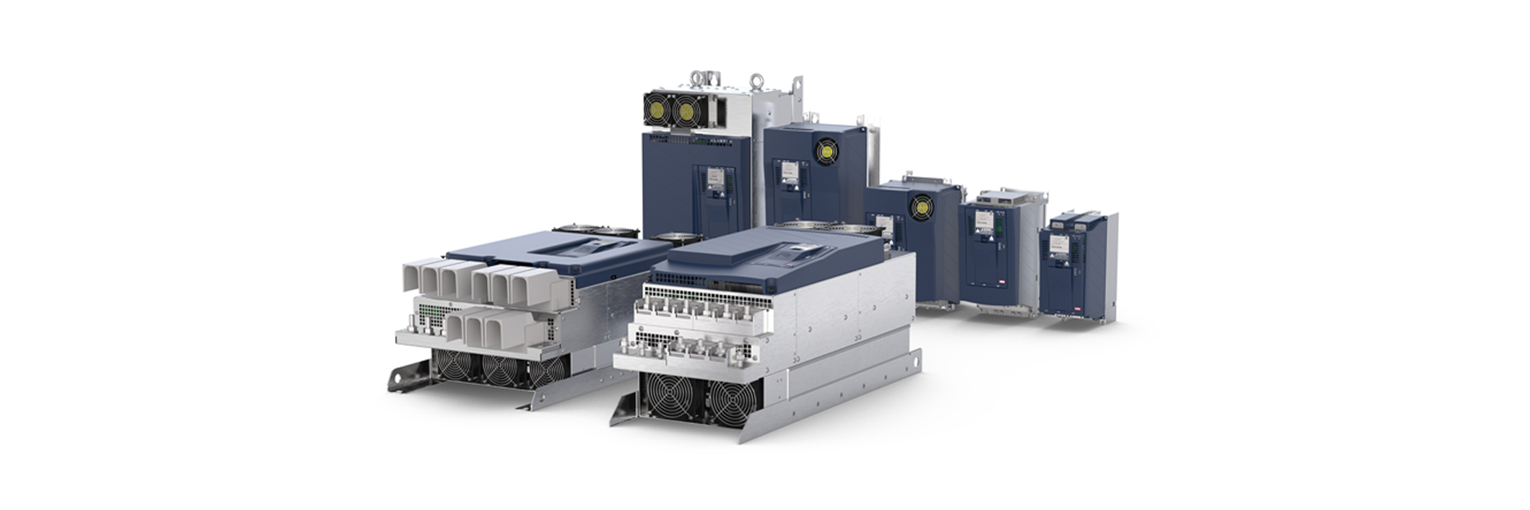

The COMBIVERT F6 range of drive controllers from KEB Automation.



The COMBIVERT S6 range of drive controllers from KEB Automation.

Contact information
For more information, please contact:

Mark Checkley
Managing Director,
KEB (UK) Ltd.
5 Morris Close,
Park Farm Industrial Estate,
Wellingborough, Northants, NN8 6XF
Tel: +44 (0) 1933 402 220
Mobile: +44 (0) 7810 568056
Email: mark.checkley@keb.co.uk
Website: www.keb.co.uk

Press Release Issued by:
Dean Palmer,
Director,
SilverBullet PR Ltd,
19, Glen Crescent, Stamford,
Lincolnshire, UK.
PE9 1SW
Tel: +44 (7703) 023771
Email: dean@silverbulletpr.co.uk
Website: www.silverbulletpr.co.uk
High resolution images are available on request from SilverBullet PR.

