Ref. ME352 24th July 2020

New handheld capacitive gap measurement device from Micro-Epsilon is robust, lightweight and measures to micron accuracy
Precision sensor manufacturer Micro-Epsilon has launched a new capacitive measuring device for mobile, high precision gap and distance measurements. Robust, lightweight and easy to use, the capaNCDT MD6-22 dual channel handheld gauge is suitable for use in industrial commissioning, service and maintenance tasks.

The capaNCDT MD6-22 measures gaps to micron accuracy. Measurements are possible on all electrically conductive targets. The robust design of the device makes it ideally suited for use in environments where magnetic fields are present. Typical applications include maintenance of turbines and engines, rotor gap monitoring in wind turbines, airframe construction and joining processes in the automotive industry, as well as alignment of rollers in web processing lines such as paper and plastics.

The complete measuring system weighs just 500g and consists of a dual channel handheld gauge, a capacitive capaNCDT sensor with integrated cable (up to 4m in length), carry case, power supply and magnetic holder for on-site mounting. The device is compatible with any capacitive sensor from the Micro-Epsilon product range. Battery life is up to five hours.

The capaNCDT MD6-22 provides a touchscreen display and is supplied with pre-programmed features such as single sided or double sided measurement and automatic gap detection, which simplifies the parallel alignment of flat sensors for double-sided measurements. The memory function ensures increased flexibility, enabling the user to determine the measurement values at different locations, store them on a micro SD card (not included) and use this data for future evaluation or to identify trends for condition monitoring tasks.

Inserted into a gap, the flat sensors determine the gap width based on the active measuring area. Gaps up to 12mm can be detected reliably. The device offers three different measuring modes: gap measurement (single-sided), where one or two flat sensors are used; gap measurement (double-sided), where one flat sensor is used; and raw measurement, where two distance sensors can be evaluated together.

For more information on the capaNCDT MD6-22, please call the Micro-Epsilon sales department on 0151 355 6070 or email info@micro-epsilon.co.uk

– ENDS – [349 words]

Photos and captions:

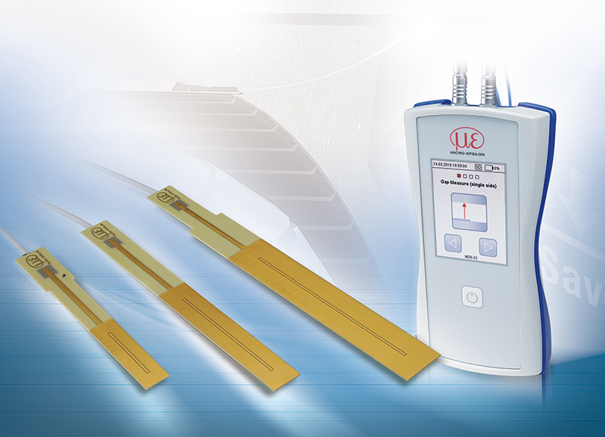
The capaNCDT MD6-22 is a capacitive measuring device designed for mobile, high precision gap and distance measurements.
Note to Editors:
Manufacturing processes throughout all industries are evolving at a rapid pace, and the quality and tolerances expected from the end user are forever increasing. Thus, the need for smarter measurement solutions is continuously growing. Micro-Epsilon (www.micro-epsilon.co.uk) is renowned globally for being at the forefront of measurement technology.
For more than 50 years, we have continuously offered reliable, high performance, unique solutions particularly when high precision measurement or inspection is required. Our product range covers sensors for the measurement of distance and displacement, sensors for IR temperature measurement and colour detection, as well as turnkey systems for dimensional measurement and defect detection.
We understand that our customers are our business partners and aim to develop long term relationships with them.
We work closely with our customers to fully understand their requirements; our salespeople are engineers and understand more than just the sensor performance. We are problem solvers.
We operate a fair working policy, which results in excellent customer service and support even post sale.
Our high performance products and way of working provide our customers with a genuine competitive advantage.
To download high resolution images for this article, please go to www.silverbulletpr.co.uk/press . Alternatively, you can request an image by contacting:

Issued by: Dean Palmer
Director
SilverBullet PR Ltd
19, Glen Crescent, Stamford,
Lincolnshire PE9 1SW
Tel: 01780 754 254
Mobile: 07703 023771
Email: dean@silverbulletpr.co.uk

Reader Enquiries/
Advertising:
Glenn Wedgbrow,
Business Development Manager,
Micro-Epsilon UK Ltd
1, Shorelines Building,
Shore Road
Birkenhead
Cheshire CH41 1AU
Tel: +44 (0) 151 355 6070
Fax: +44(0) 151 355 6075
Email: glenn.wedgbrow@micro-epsilon.co.uk

