Ref. ME353 15th January 2020

Bringing thermal imaging advantages to the single point pyrometer market
Precision sensor manufacturer Micro-Epsilon has introduced two thermal imagers for industrial environments that are both compact and robust, offering advanced thermal imaging functions at a price level normally associated with single point pyrometers.

The entry level thermoIMAGER TIM 8 features an 80x80 pixel resolution, 50Hz frame rate and autonomous operation that offers automatic hot or cold spot detection. As an imager, the TIM8 gives more freedom to check and look for faults. It isn’t reliant on the target being in the same place and can detect hot (cold) spots anywhere within its field of view. Once set up and configuration are complete by the included software, the TIM 8 is then capable of standalone operation without a PC connected, combining the advantages of a robust pyrometer with those of an infrared thermal imaging camera.

Automatic hot and cold spot detection in automation, machine building and plant monitoring increases process reliability. The thermoIMAGER TIM 8 is specially designed for these types of application. The measured temperature can be output directly as an analogue signal or as a digital alarm output. Another feature of the camera is its integrated lens and motorised focus. The focus adjustment is software-controlled enabling the operator to set the target in focus without having to touch the camera – ideal if it is mounted in a hard-to-reach area.

With three selectable temperature measurement ranges from -20°C to +900°C, the TIM 8 can be used, for example, to monitor the temperature in control cabinets, process control in production lines or to detect overheated, baked goods. When the pre-defined alarm threshold is reached, an alert signal is output via the integrated process interface.

Setup is intuitive via the well-established TIMConnect configuration software, available as a free download from the Micro-Epsilon website. Communication with the camera is made by USB or Ethernet connection. A range of accessories are also available including air purge collars, protective windows and cooling housings, which enable the TIM 8 device to be installed in a wide range of industrial environments and is ideal for OEM customers looking to integrate more than just a pyrometer.

For users who require an even greater optical resolution and frame rates for temperature monitoring of high speed thermal processes, Micro-Epsilon has also introduced the thermoIMAGER TIM 40 to its range. This robust industrial camera offers excellent optical resolution (382 x 288 pixels), a frame rate of 80Hz and an effective distance-to-spot-size ratio of 390:1. Selectable temperature ranges are from -20°C to +100°C/ 0 to 250°C/ 150°C to 900°C.

The TIM 40 also incorporates a motorised focus for easy adjustments on targets via remote control. Power supply and operation are via USB connection. With multiple measurement outputs available via the optional industrial process interface, this also makes the camera ideal for high volume OEM applications.

For more information on the thermoIMAGER TIM 8 and TIM 40, please call the Micro-Epsilon sales department on 0151 355 6070 or email info@micro-epsilon.co.uk

– ENDS – [497 words]

Photos and captions:

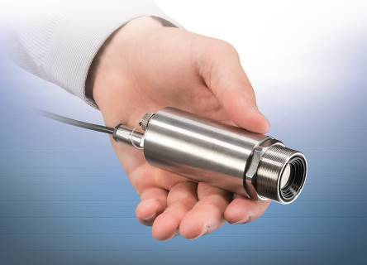
The thermoIMAGER TIM 8 combines the advantages of a robust pyrometer with a thermal imaging camera.

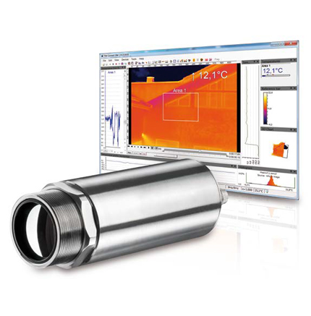
The thermoIMAGER TIM 40 is used for monitoring of high speed thermal processes.

Note to Editors:
Manufacturing processes throughout all industries are evolving at a rapid pace, and the quality and tolerances expected from the end user are forever increasing. Thus, the need for smarter measurement solutions is continuously growing. Micro-Epsilon (www.micro-epsilon.co.uk) is renowned globally for being at the forefront of measurement technology.
For more than 50 years we have continuously offered reliable, high performance, unique solutions particularly when high precision measurement or inspection is required. Our product range covers sensors for the measurement of distance and displacement, sensors for IR temperature measurement and colour detection, as well as turnkey systems for dimensional measurement and defect detection.
We understand that our customers are our business partners and aim to develop long term relationships with them.
We work closely with our customers to fully understand their requirements; our salespeople are engineers and understand more than just the sensor performance. We are problem solvers.
We operate a fair working policy, which results in excellent customer service and support even post sale.
Our high-performance products and way of working provide our customers with a genuine competitive advantage.
To download high resolution images for this article, please go to www.silverbulletpr.co.uk/press . Alternatively, you can request an image by contacting:

Issued by: Dean Palmer
Director
SilverBullet PR Ltd
19, Glen Crescent, Stamford,
Lincolnshire PE9 1SW
Tel: 01780 754 254
Mobile: 07703 023771
Email: dean@silverbulletpr.co.uk

Reader Enquiries/Advertising:
Glenn Wedgbrow,
Business Development Manager,
Micro-Epsilon UK Ltd
1, Shorelines Building,
Shore Road
Birkenhead
Cheshire CH41 1AU
Tel: +44 (0) 151 355 6070
Fax: +44(0) 151 355 6075
Email: glenn.wedgbrow@micro-epsilon.co.uk

