Ref. ME356 12th February 2020

New interface module connects sensors with PROFINET controllers
Precision sensor manufacturer Micro-Epsilon has introduced an interface module that expands the range of connectivity options available for its sensors and measurement systems. The IF2030/PNET module allows simple integration of compatible sensors to a PROFINET network.

The IF2030/PNET interface module is a single channel system that is compatible with Micro-Epsilon sensors that output data via their RS422 or RS485 interface. Screw terminals allow the sensors to be connected to the module directly via RS422/RS485 interfaces. Two network connections are provided for different network topologies. The interface module supports data rates up to 4 MBaud and can be installed in switching cabinets via a DIN rail.

Four status LEDs are provided on the front of the module (system, status, COM0 and COM1). Synchronisation output (TTL, HTL) is possible for RS422 sensors. Software integration into a PLC is achieved via a GSDML file.

A range of sensors and measurement systems from Micro-Epsilon are compatible with the IF2030 interface module. These include:

- Optical laser displacement sensors – optoNCDT 1320 and 1420, optoNCDT 1750 and optoNCDT 2300.
- Confocal displacement controllers – confocalDT 242x, confocalDT 24x1.
- Optical micrometers – optoCONTROL 2520.
- Colour measuring system – colorCONTROL ACS7000.
- Capacitive displacement controller – capaNCDT 6120.

For more information on the IF2030/PNET interface module, please call the Micro-Epsilon sales department on 0151 355 6070 or email info@micro-epsilon.co.uk

– ENDS – [222 words]

Photos and captions:

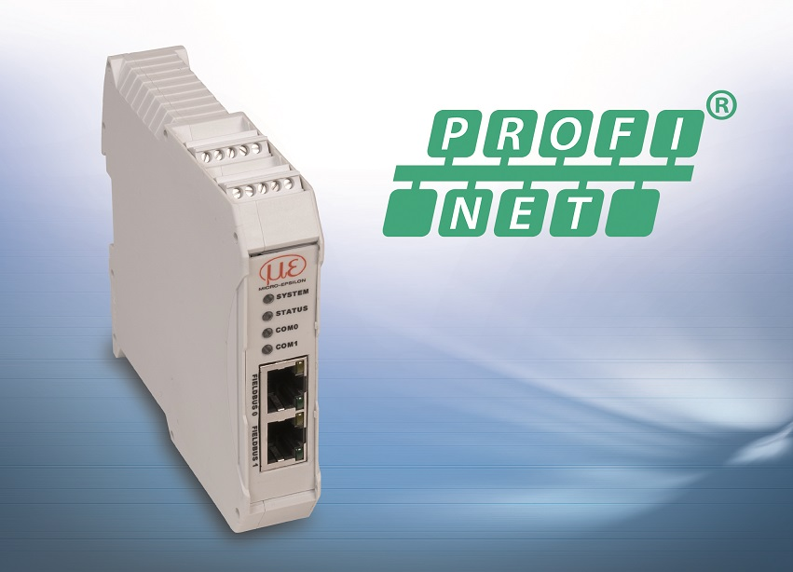
The IF2030/PNET module allows simple integration of compatible sensors to a PROFINET network.

Note to Editors:
Manufacturing processes throughout all industries are evolving at a rapid pace, and the quality and tolerances expected from the end user are forever increasing. Thus, the need for smarter measurement solutions is continuously growing. Micro-Epsilon (www.micro-epsilon.co.uk) is renowned globally for being at the forefront of measurement technology.
For more than 50 years, we have continuously offered reliable, high performance, unique solutions particularly when high precision measurement or inspection is required. Our product range covers sensors for the measurement of distance and displacement, sensors for IR temperature measurement and colour detection, as well as turnkey systems for dimensional measurement and defect detection.
We understand that our customers are our business partners and aim to develop long term relationships with them.
We work closely with our customers to fully understand their requirements; our salespeople are engineers and understand more than just the sensor performance. We are problem solvers.
We operate a fair working policy, which results in excellent customer service and support even post sale.
Our high performance products and way of working provide our customers with a genuine competitive advantage.
To download high resolution images for this article, please go to www.silverbulletpr.co.uk/press . Alternatively, you can request an image by contacting:

Issued by: Dean Palmer
Director
SilverBullet PR Ltd
19, Glen Crescent, Stamford,
Lincolnshire PE9 1SW
Tel: 01780 754 254
Mobile: 07703 023771
Email: dean@silverbulletpr.co.uk

Reader Enquiries/Advertising:
Glenn Wedgbrow,
Business Development Manager,
Micro-Epsilon UK Ltd
1, Shorelines Building,
Shore Road
Birkenhead
Cheshire CH41 1AU
Tel: +44 (0) 151 355 6070
Fax: +44(0) 151 355 6075
Email: glenn.wedgbrow@micro-epsilon.co.uk

