Ref. ME357 19th February 2020

New laser profile sensors from Micro-Epsilon offer even higher performance and improved software integration features
Precision sensor manufacturer Micro-Epsilon has extended its scanCONTROL range of laser profile sensors (laser scanners) with two new versions that offer even better performance and improved software integration capabilities to meet the growing demands of automation, robotics, quality control, production and process monitoring applications.

The scanCONTROL 30xx sensor is among the highest performing laser scanners in terms of its size, accuracy and measuring rate. The sensor has a compact housing with integrated controller, allowing fast integration into confined spaces. Available with either red or blue laser technology and with measuring ranges of 25mm and 50mm, the sensor provides calibrated 2D profile data with up to 5.5 million points per second. A maximum profile frequency of 10kHz and innovative exposure control enable precise profile measurements in high speed, dynamic processes. A high resolution sensor matrix offers a resolution of 2,048 points per profile with an ultimate point distance spacing of just 12µm, allowing measurements of extremely fine surface/geometrical details.

The user can choose from three predefined operating modes to suit each measurement task. The ‘High Resolution’ mode is for maximum precision measurements. The ‘High Dynamic Range’ (HDR) mode is for optimal profile detection on difficult/inhomogeneous surfaces and the ‘High Speed’ mode is for ultra-fast measurements on rapidly moving objects. Target markets for the scanCONTROL 30xx include almost all industry sectors, from automotive manufacturing to electronics production and machine building.

Also new to the scanCONTROL range is the scanCONTROL 25xx, which is designed for high volume OEM industrial measurement applications. With its compact design, versatility and high signal stability, the sensor offers users an excellent price-performance ratio and good all-round capabilities. Measurement speed is up to 300Hz and measuring rate 192,00 points per second. Three measuring ranges are available, as well as a range of accessories that include protective housings, different cable types and interface adapters, making the sensor ideal for high volume integration in production lines and OEM/machine building.

New software features
The latest version of Micro-Epsilon’s scanCONTROL Configuration Tools (v6.3) includes the following new features for the scanCONTROL 30xx laser scanner:

- Circle measurements – for radius, centre point and vertex measurements.
- Display sensor matrix (reduced or full resolution) – the resolution of the transmitted sensor matrix can be set to ‘reduced’. This means a 100 Mbit-Ethernet connection is sufficient to display the sensor matrix image. For full resolution, the scanCONTROL 30xx requires a Gigabit-Ethernet connection.
- Multiple measurement field selection – rather than choosing a single measuring field in the sensor matrix, two measuring fields and a region of “no interest” can now be selected to hide defined areas.
- Selection of operating modes – three operating modes (high resolution, high speed and high contrast (HDR).
- Improved auto exposure – limits can now be set within which the exposure time should regulate itself.
- More digital inputs with higher flexibility – the scanCONTROL 30xx has four rather than three inputs, allowing for more different functions to be used or combined.
- Writing measurement values into the profile data – activating this function attaches the measurement results to the transferred profile data, which means these can be read out directly using an SDK function in customer-specific software. Selection of the transferred measurement results is independent of the values transferred.

For more information on the scanCONTROL 30xx and 25xx laser scanners, please call the Micro-Epsilon sales department on 0151 355 6070 or email info@micro-epsilon.co.uk

– ENDS – [551 words]

Photos and captions:

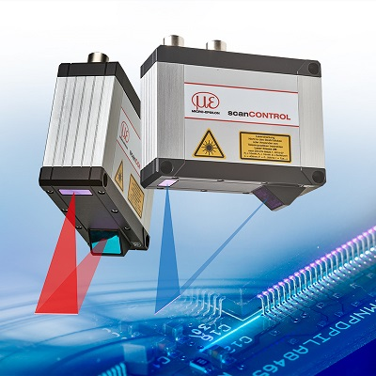

The scanCONTROL 30xx laser scanner is available with red or blue laser technology.

Note to Editors:
Manufacturing processes throughout all industries are evolving at a rapid pace, and the quality and tolerances expected from the end user are forever increasing. Thus, the need for smarter measurement solutions is continuously growing. Micro-Epsilon (www.micro-epsilon.co.uk) is renowned globally for being at the forefront of measurement technology.
For more than 50 years, we have continuously offered reliable, high performance, unique solutions particularly when high precision measurement or inspection is required. Our product range covers sensors for the measurement of distance and displacement, sensors for IR temperature measurement and colour detection, as well as turnkey systems for dimensional measurement and defect detection.
We understand that our customers are our business partners and aim to develop long term relationships with them.
We work closely with our customers to fully understand their requirements; our salespeople are engineers and understand more than just the sensor performance. We are problem solvers.
We operate a fair working policy, which results in excellent customer service and support even post sale.
Our high performance products and way of working provide our customers with a genuine competitive advantage.
To download high resolution images for this article, please go to www.silverbulletpr.co.uk/press . Alternatively, you can request an image by contacting:

Issued by: Dean Palmer
Director
SilverBullet PR Ltd
19, Glen Crescent, Stamford,
Lincolnshire PE9 1SW
Tel: 01780 754 254
Mobile: 07703 023771
Email: dean@silverbulletpr.co.uk

Reader Enquiries/Advertising:
Glenn Wedgbrow,
Business Development Manager,
Micro-Epsilon UK Ltd
1, Shorelines Building,
Shore Road
Birkenhead
Cheshire CH41 1AU
Tel: +44 (0) 151 355 6070
Fax: +44(0) 151 355 6075
Email: glenn.wedgbrow@micro-epsilon.co.uk

