Ref. ME358 4th March 2020

New ratio pyrometer has a lower temperature start point and a faster response time
Precision sensor manufacturer Micro-Epsilon has extended its range of high performance, non-contact temperature sensors to include a new compact infrared ratio temperature sensor (two-colour ratio pyrometer) that is ideal for use in high temperature, high speed metal processing environments, including casting, forging and secondary metal processing applications such as induction heating.

The thermoMETER CTRatio series has been extended to include two new updated versions, the CTRatioM1 and CTRatioM2. These two-colour ratio infrared temperature sensors offer users a much wider temperature measuring range, starting at 250°C (its predecessor’s start point was 700°C) up to 3,000°C. Response times have also been improved, from 5ms down to 1ms. Fast signal processing means the sensors are suitable for use in high speed processes. Due to their rugged sensor heads, the thermometers can operate in ambient temperatures up to 200°C without requiring any additional cooling.

The compact sensor head of the ratio pyrometer enables it to be mounted into tight, restricted spaces in production lines and machines. In addition, the sensor is equipped with a green laser for sighting purposes, ideal for seeing where the sensor is looking, especially on red glowing surfaces. A fibre optic cable connects the optical sensor head to the electronics. By using a fibre optic cable, the device is insensitive to electromagnetic interference (EMI) normally found in induction-based heat treatment processes.

The sensor is also insensitive to dust, dirt, smoke fumes and steam. Using the ratiometric measuring principle, the sensor minimises measurement errors caused by unknown emissivity values and partial spot size coverage. Even in cases where the infrared radiation from the target surface is weakened to 95% of its original intensity due to smoke, steam or a dirty viewing window, the ratio pyrometer still provides faultless, reliable measurements.

With optical resolutions of 38:1, 50:1 and 100:1 and an adjustable focus from 300mm to infinity, thermoMETER CTRatio uses a short wavelength range of 0.8 to 1.75µm and is ideal for measuring high temperatures on metals and for monitoring fast-moving, high-speed production processes.

Glenn Wedgbrow, Business Development Manager at Micro-Epsilon (UK) Ltd comments: “A ratio pyrometer works differently to a conventional pyrometer in that it does not require the whole spot to be located on the target to obtain a reliable measurement. In fact, only 5 per cent of the sensor spot needs to be able to see the target in order to achieve reliable readings. This makes it beneficial for thin or narrow targets such as wire, where the target might move around or vibrate.”

“The thermoMETER CTRatio is a market leading product that technically meets and exceeds the performance of all ratio pyrometers in the marketplace today. It also has an extremely attractive price level compared to other ratio pyrometers.”

The electronics enable the programming of the sensor, display of temperature measurements and easy wiring of the analogue outputs 0/4-20mA and 0-5/10V for the transmission of signals into industrial control cabinets. Programmable signal processing ensures complete flexibility for different production processes. The controller has an integrated USB-C port for quick connection to a PC.

Micro-Epsilon also offers its user-friendly software that provides graphical interface and display, the logging of temperature readings of all output channels and signal characteristics over time. The user can also configure parameters and set up alarms such as ‘dirty lens’ alarms.

For more information on the thermometer CTRatio, please call the Micro-Epsilon sales department on 0151 355 6070 or email info@micro-epsilon.co.uk

– ENDS – [566 words]

Photos and captions:

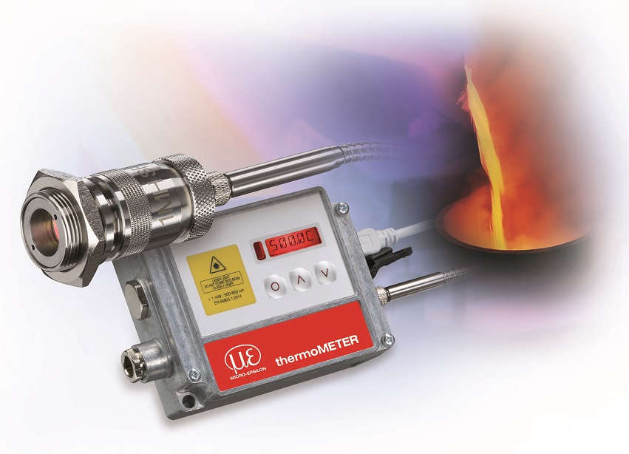

The thermoMETER CTRatio M1/M2 ratio pyrometers offer a lower temperature measurement start point of 250°C and a faster response time of 1ms.

Note to Editors:
Manufacturing processes throughout all industries are evolving at a rapid pace, and the quality and tolerances expected from the end user are forever increasing. Thus, the need for smarter measurement solutions is continuously growing. Micro-Epsilon (www.micro-epsilon.co.uk) is renowned globally for being at the forefront of measurement technology.
For more than 50 years, we have continuously offered reliable, high performance, unique solutions particularly when high precision measurement or inspection is required. Our product range covers sensors for the measurement of distance and displacement, sensors for IR temperature measurement and colour detection, as well as turnkey systems for dimensional measurement and defect detection.
We understand that our customers are our business partners and aim to develop long term relationships with them.
We work closely with our customers to fully understand their requirements; our salespeople are engineers and understand more than just the sensor performance. We are problem solvers.
We operate a fair working policy, which results in excellent customer service and support even post sale.
Our high performance products and way of working provide our customers with a genuine competitive advantage.
To download high resolution images for this article, please go to www.silverbulletpr.co.uk/press . Alternatively, you can request an image by contacting:

Issued by: Dean Palmer
Director
SilverBullet PR Ltd
19, Glen Crescent, Stamford,
Lincolnshire PE9 1SW
Tel: 01780 754 254
Mobile: 07703 023771
Email: dean@silverbulletpr.co.uk

Reader Enquiries/Advertising:
Glenn Wedgbrow,
Business Development Manager,
Micro-Epsilon UK Ltd
1, Shorelines Building,
Shore Road
Birkenhead
Cheshire CH41 1AU
Tel: +44 (0) 151 355 6070
Fax: +44(0) 151 355 6075
Email: glenn.wedgbrow@micro-epsilon.co.uk

