Ref. ME359 17th April 2020

New robust eddy current controller is designed for use with miniature
eddy current sensor range
The eddyNCDT 3070 is a new, powerful eddy current measurement system from Micro-Epsilon that is suitable for high precision displacement, distance, position, runout, extension, thermal expansion and oil film thickness measurements in harsh industrial environments. The system is designed to work with the sub-miniature range of sensors that offer measuring ranges of less than 1mm and that measure to sub-micron accuracies at a frequency response up to 20kHz.

The system comprises a compact controller, sensor and sensor cable and can be factory-calibrated for ferrous and non-ferrous materials. The eddyNCDT 3070 is dust-proof and protected against immersion in water for a short period of time (IP67). The sensors are designed for ambient temperatures up to +200°C and ambient pressure up to 700 bar. Active temperature compensation is provided for the sensor and controller, which ensures high temperature stability of the complete measurement system. The compact and robust design, as well as its compatibility with Micro-Epsilon’s range of sub-miniature sensors, means the eddyNCDT 3070 is ideal for installation in confined spaces on machines and in OEM system applications.

The eddyNCDT 3070 is highly adaptable to suit almost any industrial displacement, distance and position measurement application. The DT3071 controller provides enhanced features such as five-point calibration, setting of switching and temperature outputs, as well as storage of multiple characteristic curves. If two or more systems operate next to each other, they do not need to be synchronised – a new frequency separation feature enables these systems to operate in parallel without influencing one another.
Typical applications include the measurement of shaft movement (lateral and axial runout), lubrication gap (oil film thickness), thermal expansion, and the monitoring of machines in high-speed, automated production environments. Furthermore, due to the controller’s storage feature for multiple characteristic curves, the system is highly suited to test bench, R&D and laboratory applications.
The industrial-grade M12 Ethernet interface enables modern fieldbus connectivity. Due to the controller’s compact, die cast aluminium design and the fieldbus connection, the measurement system is suitable for integration into a variety of production plant, machines and systems. An easy-to-use web interface simplifies set up and configuration.
Glenn Wedgbrow, Business Development Manager at Micro-Epsilon (UK) Ltd comments: “The eddyNCDT 3070 offers some very distinct performance advantages, particularly in terms of its unique combination of resolution, linearity and temperature stability. The system is compact, robust and reliable in harsh industrial conditions. It is equipped with smart signal processing and fieldbus interfaces, which simplify integration into machines and automated production systems. High application versatility is provided with over 100 different compatible sensors.”

For more information on the eddyNCDT 3070, please call the Micro-Epsilon sales department on 0151 355 6070 or email info@micro-epsilon.co.uk

– ENDS – [442 words]

Photos and captions:

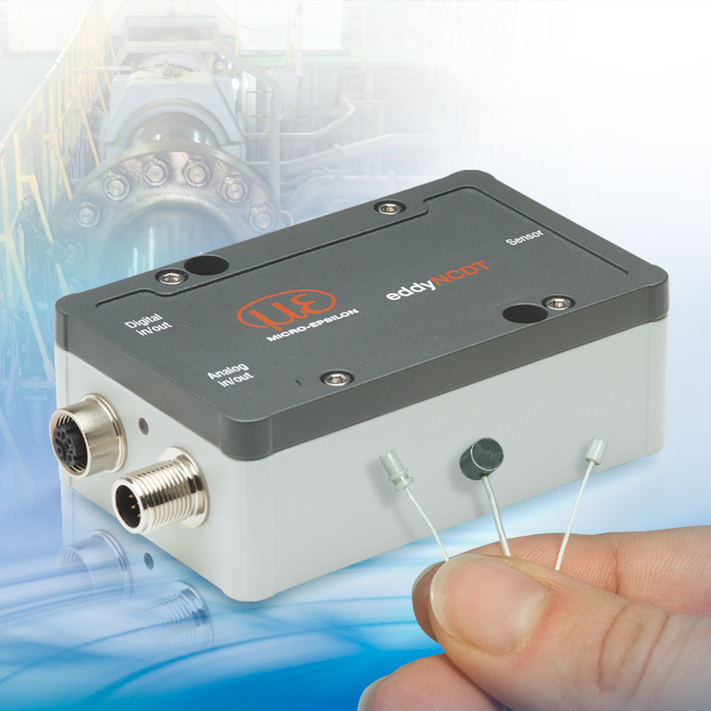

The eddyNCDT 3070 is a powerful eddy current displacement measurement system for measuring ranges below 1mm.

Note to Editors:
Manufacturing processes throughout all industries are evolving at a rapid pace, and the quality and tolerances expected from the end user are forever increasing. Thus, the need for smarter measurement solutions is continuously growing. Micro-Epsilon (www.micro-epsilon.co.uk) is renowned globally for being at the forefront of measurement technology.
For more than 50 years, we have continuously offered reliable, high performance, unique solutions particularly when high precision measurement or inspection is required. Our product range covers sensors for the measurement of distance and displacement, sensors for IR temperature measurement and colour detection, as well as turnkey systems for dimensional measurement and defect detection.
We understand that our customers are our business partners and aim to develop long term relationships with them.
We work closely with our customers to fully understand their requirements; our salespeople are engineers and understand more than just the sensor performance. We are problem solvers.
We operate a fair working policy, which results in excellent customer service and support even post sale.
Our high performance products and way of working provide our customers with a genuine competitive advantage.
To download high resolution images for this article, please go to www.silverbulletpr.co.uk/press . Alternatively, you can request an image by contacting:

Issued by: Dean Palmer
Director
SilverBullet PR Ltd
19, Glen Crescent, Stamford,
Lincolnshire PE9 1SW
Tel: 01780 754 254
Mobile: 07703 023771
Email: dean@silverbulletpr.co.uk

Reader Enquiries/Advertising:
Glenn Wedgbrow,
Business Development Manager,
Micro-Epsilon UK Ltd
1, Shorelines Building,
Shore Road
Birkenhead
Cheshire CH41 1AU
Tel: +44 (0) 151 355 6070
Fax: +44(0) 151 355 6075
Email: glenn.wedgbrow@micro-epsilon.co.uk

