Ref. ME362 14th April 2020

New IP69(K) draw-wire displacement sensors can be customised to suit a range of high volume OEM industrial applications
Precision sensor manufacturer Micro-Epsilon has launched a range of compact, robust draw-wire displacement sensors designed specifically for high volume OEM industrial applications with IP69(K) ingress rating.

The wireSENSOR WPS-K100 series draw-wire displacement sensors measure distance and position precisely, combining high performance for outdoor use with an excellent price/performance ratio. With measuring ranges of 2300mm and 5,000mm, the sensors are ideal for a wide range of applications, including off-highway vehicles, mobile machinery, mobile cranes and lifting technology (e.g. lifting platforms and tables).

The compact K100 series draw-wire sensors are protected by a glass fibre-reinforced plastic housing, as well as separate drum and spring spaces, making the sensors extremely robust (IP69K) against external influences. Custom versions of the sensors are available in different measuring ranges, wire thicknesses and outputs to suit OEM requirements.

Glenn Wedgbrow, Business Development Manager at Micro-Epsilon UK comments: “In addition to its compact design relative to its measuring range, the wireSENSOR WPS-K100 is also extremely robust, allowing its use in a wide variety of industrial environments and test bench applications. Due to its modular design, the sensor is particularly well suited to high volume OEM applications, as we can quickly and easily customise the sensors to suit the customer’s application.”

Depending on the industry and application, draw wire position sensors are commonly referred to as cable transducers, cable-extension transducers, string potentiometers, yo yo pots, linear position string pots, and string encoders. Using a draw-wire sensor, a linear movement is transformed into a rotary movement. The free end of the wire is fixed to the moving object. An encoder or potentiometer translates the rotary movement created by the extension of the wire into an electronic signal. The sensor works like a tape measure, except with a draw-wire sensor the user does not have to read off the measurement of the extended tape. The rotation of the drum on which the steel wire is wound is measured automatically and the measurement signal is output in either analogue or digital formats.

For more information on the wireSENSOR WPS-K100 series, please call the Micro-Epsilon sales department on 0151 355 6070 or email info@micro-epsilon.co.uk

– ENDS – [351 words]

Photos and captions:

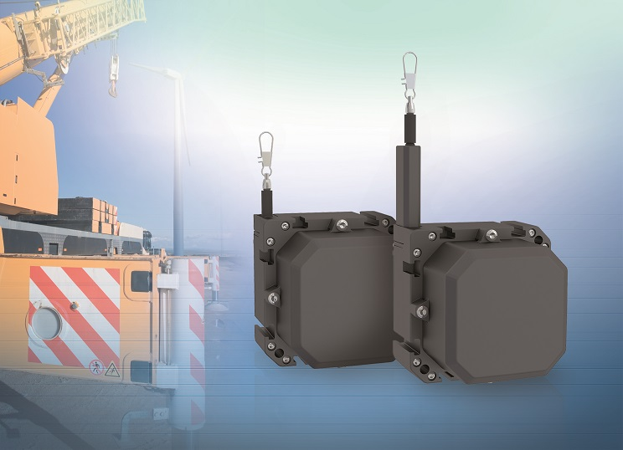

The wireSENSOR WPS-K100 draw-wire displacement sensors are designed specifically for high volume OEM industrial applications – for both indoor and outdoor use.

Note to Editors:
Manufacturing processes throughout all industries are evolving at a rapid pace, and the quality and tolerances expected from the end user are forever increasing. Thus, the need for smarter measurement solutions is continuously growing. Micro-Epsilon (www.micro-epsilon.co.uk) is renowned globally for being at the forefront of measurement technology.
For more than 50 years, we have continuously offered reliable, high performance, unique solutions particularly when high precision measurement or inspection is required. Our product range covers sensors for the measurement of distance and displacement, sensors for IR temperature measurement and colour detection, as well as turnkey systems for dimensional measurement and defect detection.
We understand that our customers are our business partners and aim to develop long term relationships with them.
We work closely with our customers to fully understand their requirements; our salespeople are engineers and understand more than just the sensor performance. We are problem solvers.
We operate a fair working policy, which results in excellent customer service and support even post sale.
Our high performance products and way of working provide our customers with a genuine competitive advantage.
To download high resolution images for this article, please go to www.silverbulletpr.co.uk/press . Alternatively, you can request an image by contacting:

Issued by: Dean Palmer
Director
SilverBullet PR Ltd
19, Glen Crescent, Stamford,
Lincolnshire PE9 1SW
Tel: 01780 754 254
Mobile: 07703 023771
Email: dean@silverbulletpr.co.uk

Reader Enquiries/Advertising:
Glenn Wedgbrow,
Business Development Manager,
Micro-Epsilon UK Ltd
1, Shorelines Building,
Shore Road
Birkenhead
Cheshire CH41 1AU
Tel: +44 (0) 151 355 6070
Fax: +44(0) 151 355 6075
Email: glenn.wedgbrow@micro-epsilon.co.uk

