Ref. ME363 21st April 2020

New circular sensors offer extremely high colour accuracy and are suitable for use on structured and shiny, metallic surfaces
Conventional fibre optic colour sensors provide a single, bundled light beam, which is not sufficient to properly measure structured and shiny (reflective), metallic surfaces. Precision sensor manufacturer Micro-Epsilon has introduced a range of circular fibre optic colour recognition sensors that enable uniform (homogeneous) illumination around the measurement spot. This means measurement results are not only more stable and reliable, but also more precise, allowing the slightest colour differences to be detected during manufacturing and assembly processes.

The colorSENSOR CFS2-Mxx series of circular sensors from Micro-Epsilon can be combined with the colorSENSOR CFO controllers to open up new fields of application such as the distinction of different shades of white and different metallic colours. This compact combination of sensor and controller can also be customised to suit specific customer applications. Potential applications for the sensors are diverse, including measurement tasks in automotive, plastics, paper and textiles. In combination with the CFO controllers, the sensors enable colour deviations to be detected to an accuracy of ΔE ≤ 0.3 (typically 3 times better than the average human eye).

Two circular sensors are available in the series: the colorSENSOR CFS2-M11 and the colorSENSOR CFS2-M20. Due to their standard class F_{A} connections, the fibre optics are also compatible with other controllers. The CFS2-M11 provides a 67° measurement geometry and a light spot diameter from 12mm up to 114mm. The CFS2-M20 provides a 22° measurement geometry with a light spot diameter of 10mm to 66mm. Object distance for both sensors is 10mm to 100mm (30mm is the ideal distance). Switching frequency is up to 30kHz (with the CFO200 controller).

Glenn Wedgbrow, Business Development Manager at Micro-Epsilon UK comments: “The colorSENSOR CFS2 series sensors offer an unbeatable price-performance ratio, with no other competing supplier currently able to offer fibre optics with circular illumination as a standard sensor model. The sensors combine the advantages of fixed lens sensors with those of an external controller.”

As well as measuring colour on structured and shiny, metallic surfaces, the sensors can also be used for colour recognition on common materials and surfaces. In addition to relative colour measurement or colour inspection, the CFS2 colour sensors are also suitable for intensity measurements, completeness checks (presence and absence), determination of surface properties and texture, material recognition and position determination.

For more information on the colorSENSOR CFS2-Mxx series, please call the Micro-Epsilon sales department on 0151 355 6070 or email info@micro-epsilon.co.uk

– ENDS – [397 words]

Photos and captions:

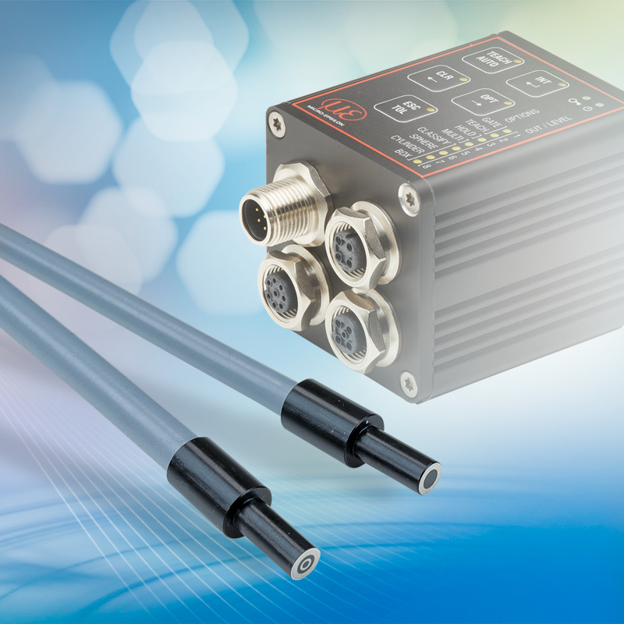

The colorSENSOR CFS2-Mxx series of circular colour recognition sensors provide uniform illumination of the target surface and very high colour accuracy.

Note to Editors:
Manufacturing processes throughout all industries are evolving at a rapid pace, and the quality and tolerances expected from the end user are forever increasing. Thus, the need for smarter measurement solutions is continuously growing. Micro-Epsilon (www.micro-epsilon.co.uk) is renowned globally for being at the forefront of measurement technology.
For more than 50 years, we have continuously offered reliable, high performance, unique solutions particularly when high precision measurement or inspection is required. Our product range covers sensors for the measurement of distance and displacement, sensors for IR temperature measurement and colour detection, as well as turnkey systems for dimensional measurement and defect detection.
We understand that our customers are our business partners and aim to develop long term relationships with them.
We work closely with our customers to fully understand their requirements; our salespeople are engineers and understand more than just the sensor performance. We are problem solvers.
We operate a fair working policy, which results in excellent customer service and support even post sale.
Our high performance products and way of working provide our customers with a genuine competitive advantage.
To download high resolution images for this article, please go to www.silverbulletpr.co.uk/press . Alternatively, you can request an image by contacting:

Issued by: Dean Palmer
Director
SilverBullet PR Ltd
19, Glen Crescent, Stamford,
Lincolnshire PE9 1SW
Tel: 01780 754 254
Mobile: 07703 023771
Email: dean@silverbulletpr.co.uk

Reader Enquiries/Advertising:
Glenn Wedgbrow,
Business Development Manager,
Micro-Epsilon UK Ltd
1, Shorelines Building,
Shore Road
Birkenhead
Cheshire CH41 1AU
Tel: +44 (0) 151 355 6070
Fax: +44(0) 151 355 6075
Email: glenn.wedgbrow@micro-epsilon.co.uk

