Ref. ME365 12th May 2020

Complete range of miniature controllers for inductive displacement sensors covers all application requirements
Precision sensor manufacturer Micro-Epsilon has extended its range of miniature controllers for inductive displacement sensors with two new multi-channel models. Together, the complete range of controllers opens up a wide field of potential applications from test & development, machine building and automation tasks.

In addition to its induSENSOR MSC7401 single channel miniature controller, the new induSENSOR MSC7602 and induSENSOR MSC7802 controllers both offer two integrated measurement channels. Furthermore, 62 modules of the MSC7602 can be combined on a DIN rail to create 124 available measurement channels. All three controllers are designed to operate with LVDT and LDR measuring gauges and displacement sensors. With measurement ranges up to 50mm, they are primarily used for measuring displacement, distance, position, gauge and thickness in jigs and fixtures. All controllers are equipped with current and voltage outputs and an RS485 interface. Parameter set up is carried out via a keypad and LED display or by using the Sensor Tool software provided. Depending on the intended application, the controllers are available with either a robust aluminium housing (IP67) or with a plastic housing for DIN rail mounting in control cabinets.

The performance of the three controllers is impressive, with resolution up to 13 bits (depending on the connected sensor and chosen frequency) and a high linearity of 0.02% FSO. The complete controller range offers high application versatility for measurement tasks in automation, machine building, positioning tasks, quality inspection, material testing, test benches, hydraulics and automotive technologies.

Low volume inspection and R&D
The induSENSOR MSC7401 controller is a robust, reliable, universal, single channel controller that is ideal for low volume industrial measurement tasks. A wide variety of compatible, inductive displacement sensors and gauges combined with an optimised price-performance ratio opens up numerous fields of application in automation and machine building.

Multi-channel controllers for medium- and high volume applications
The induSENSOR MSC7802 two-channel controller is designed to operate with LVDT and LDR measuring gauges and displacement sensors. The controller is ideal for medium volume inspection and test bench applications. Compared to the MSC7401 single channel controller, the MSC7802 controller offers reduced wiring effort.

The induSENSOR MSC7602 two-channel controller is for high volume OEM machine build and automation tasks. The controller is ideal for multi-channel applications and synchronous operation with up to 124 measurement channels. A bus connector is available to minimise wiring effort. The controller comes in a standard plastic housing for DIN rail mounting in control cabinets.

For more information on the induSENSOR MSC7xxx controllers, please call the Micro-Epsilon sales department on 0151 355 6070 or email info@micro-epsilon.co.uk

– ENDS – [435 words]

Photos and captions:

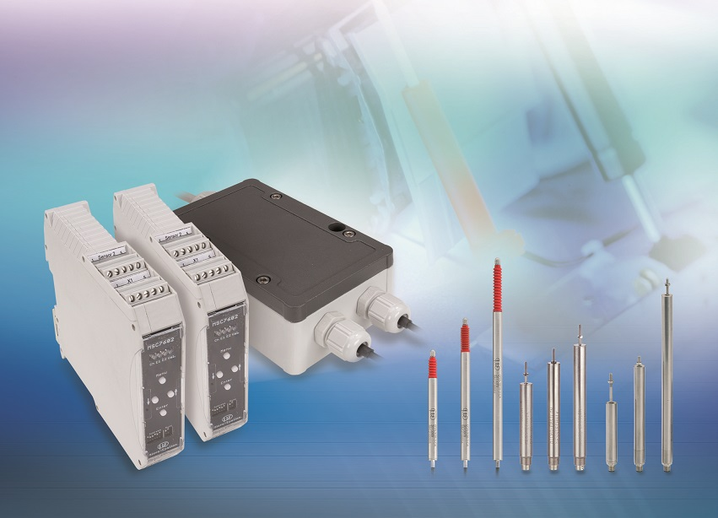
Micro-Epsilon has extended its range of miniature controllers for inductive displacement sensors with two new multi-channel models.

Note to Editors:
Manufacturing processes throughout all industries are evolving at a rapid pace, and the quality and tolerances expected from the end user are forever increasing. Thus, the need for smarter measurement solutions is continuously growing. Micro-Epsilon (www.micro-epsilon.co.uk) is renowned globally for being at the forefront of measurement technology.
For more than 50 years, we have continuously offered reliable, high performance, unique solutions particularly when high precision measurement or inspection is required. Our product range covers sensors for the measurement of distance and displacement, sensors for IR temperature measurement and colour detection, as well as turnkey systems for dimensional measurement and defect detection.
We understand that our customers are our business partners and aim to develop long term relationships with them.
We work closely with our customers to fully understand their requirements; our salespeople are engineers and understand more than just the sensor performance. We are problem solvers.
We operate a fair working policy, which results in excellent customer service and support even post sale.
Our high performance products and way of working provide our customers with a genuine competitive advantage.
To download high resolution images for this article, please go to www.silverbulletpr.co.uk/press . Alternatively, you can request an image by contacting:

Issued by: Dean Palmer
Director
SilverBullet PR Ltd
19, Glen Crescent, Stamford,
Lincolnshire PE9 1SW
Tel: 01780 754 254
Mobile: 07703 023771
Email: dean@silverbulletpr.co.uk

Reader Enquiries/
Advertising:
Glenn Wedgbrow,
Business Development Manager,
Micro-Epsilon UK Ltd
1, Shorelines Building,
Shore Road
Birkenhead
Cheshire CH41 1AU
Tel: +44 (0) 151 355 6070
Fax: +44(0) 151 355 6075
Email: glenn.wedgbrow@micro-epsilon.co.uk

