Ref. ME367 28th May 2020

Factors to consider when specifying a thermal imaging camera
for COVID-19 fever screening
The coronavirus epidemic has created a worldwide demand for infrared cameras that are able to screen humans for a fever condition. But how can you be sure the camera you choose can actually do the job it is supposed to do, asks Glenn Wedgbrow, Business Development Manager at Micro-Epsilon UK.
Viral epidemics such as the current coronavirus (COVID-19) have created a global demand for infrared cameras that are able to screen for a fever condition in humans. Many businesses have, or are considering, the installation of appropriate fever screening systems to protect their most important assets, their people. Now that staff and employees of some companies are allowed to return to work after protective measures have been lifted, it is vital for these companies to ensure that the health of returning workers is not put at risk by workers who may have become infected with a virus outside the company.

A key part of any automated fever screening system is an infrared (thermal imaging) camera. This should be easy to integrate into a fever screening system, which can then be used in real time at point-of-entry into establishments such as factories, offices, public buildings, warehouses, supermarkets, airports and schools, to prevent people with elevated body temperatures entering.

The basis for the effectiveness of thermal imaging cameras as a fever screening tool lies in the correlation of the outside skin surface temperature with the internal or core body temperature. There are two main approaches to fever screening: crowd-based and individual. In crowd-based fever screening, the IR camera monitors a crowd of people at once or sequentially. Assuming that the majority of the measured maximum head temperature values are coming from healthy individuals, the exceptions with an elevated body temperature can be detected.

In individual fever screening, which is primarily used at security gates and controlled entrances, the IR camera is used to measure an individual person, one at a time. The Medial Canthus (tear duct) provides the strongest correlation between outside skin temperature and core body temperature and is measured more precisely from a close distance. The tear duct is located in both eyes in the corner next to the nose, where the upper and lower eyelids meet. This "hot spot" is ideally suited as a measurement point. This measuring range has a diameter of approx. 3-4mm.

Absolute temperature measurement accuracy
With numerous IR camera suppliers out there to choose from, it is important to select a camera that is fit-for-purpose, reliable and accurate for your specific application.

Most IR cameras with a spectral response of 8-14 µm are specified with an accuracy of
± 2°C or 2% of the measurement reading, whichever is greater based on deployments in industrial environments in a wide variety of ambient conditions from 0°C to +50°C.

Many IR cameras are being promoted today with accuracies of ± 0.5°C or better. However, these accuracies cannot be achieved without the use of a black body reference source. The source needs to be stable, have high emissivity and should be positioned in close proximity to the person to be scanned (normally, the black body is wall-mounted and placed directly behind the person to be scanned). By doing this, camera uncertainties resulting from device adjustment, ambient temperature drift and short term stability can be reduced and a system accuracy of ± 0.5°C (with a confidence interval of 95% or better) can be achieved.

The real ability of an IR camera-based screening system to detect humans with fever lies more in its ability to discern which external face temperatures, as measured at the tear duct, are significantly higher than those in a given population exposed to similar ambient temperature conditions.

In order to achieve the best possible measurement results, the following factors should be considered before deployment of the IR camera:
- Use a camera with a spatial resolution of 382 x 288 pixels or better and with a NETD of 80 mK or better.
- Combine the camera with an external black body reference source. The accuracy of the measurement can be increased to ± 0.5°C.
- Select the right optics. Check the Field of View (FOV) and Measurement Field of View (MFOV) which defines the smallest spot size that can be measured accurately.
- Set the emissivity for temperature measurement on human tissue to 0.98.
- Set the temperature span for maximum contrast on face temperatures (typically from 23°C to 40°C) and apply colour isotherms to highlight the hottest temperature on the human face, which makes it easier to see a person with temperatures outside a normal range.
- The span and isotherm settings depend on ambient temperature variations, so optimal setting is important. For differential thermography methods, measure tear duct temperatures of test subjects and set alarms for 1…2°C above that average temperature, ensuring you adjust if ambient temperature changes.
- Camera software should be set to alarm visually or audibly when a temperature inside the area tool exceeds a set threshold. This can be combined with camera snapshots. You should set your own alarm threshold based on the degree of sensitivity to false negatives and positives (and advice from medical professionals).
- Eyewear and sunglasses are opaque in the 8-14 µm infrared spectral range. They should therefore be removed before the individual screening. Contact lenses do not need to be removed as these do not cover the tear duct.

Influences of external skin temperature
It is important to recognise that temperatures made on the outside of the body – even at the tear duct – will not match the core body temperatures taken using a traditional oral thermometer. In addition, during fever screening, a number of factors can influence the external temperature of the skin:
- Medications – including aspirin, acetaminophen/ paracetamol and ibuprofen or other antipyretics – will reduce the human core and also skin temperature and make it impossible for screening a fever condition.
- The evaporative cooling effect from perspiration will decrease outside skin temperatures, particularly when a person is positioned below air flow vents.
- Humans visibly perspiring will not deliver temperature measurements useful for fever screening with an IR camera or any remote infrared device.
- Vascular dilatation can occur after alcohol consumption, increasing skin temperatures.
- High blood pressure, pregnancy and other physical conditions can also result in increased skin temperature.
- Influences from extremes in ambient temperature such as a long walk through a cold car park will impact measurements, possibly masking a fever and reporting a false negative reading.

Limitations of IR cameras
Most IR camera technology systems were designed for versatile fields of application and can be effectively used in EBT (Elevated Body Temperature) screening applications. However, it is vital to know the technology’s limitations. Thermal imaging cameras may generate a distorted image of safety as an unremarkable temperature measurement suggests a person is not infected with the virus. However, IR cameras can provide a reliable early warning system for fever in order to interrupt infection chains in advance. None of the IR cameras available on the market are able to reliably detect and recognise the coronavirus. But they can provide a reliable indication of elevated body temperature and a possible illness. Subsequently, only a registered doctor can determine whether a person with elevated body temperature is ill or infected. Therefore, this technology is a great support tool during this crisis in order to interrupt infection chains in advance.

For more information on the use of thermal imaging cameras for COVID-19 screening, please call the Micro-Epsilon sales department on 0151 355 6070 or email
info@micro-epsilon.co.uk

– ENDS – [1,254 words]

Photos and captions:
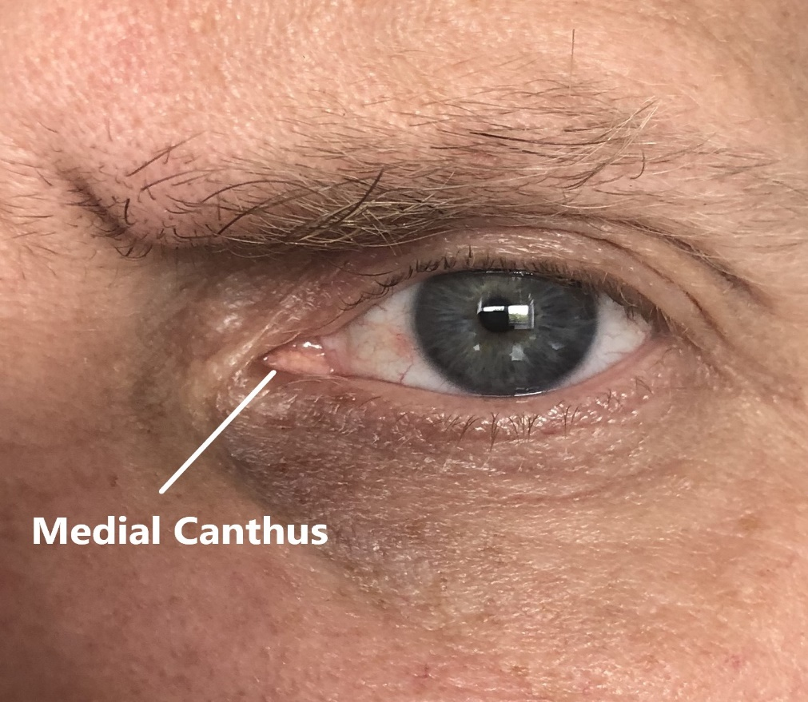
The Medial Canthus (tear duct) provides the strongest correlation between outside skin temperature and core body temperature and is measured more precisely from a close distance.

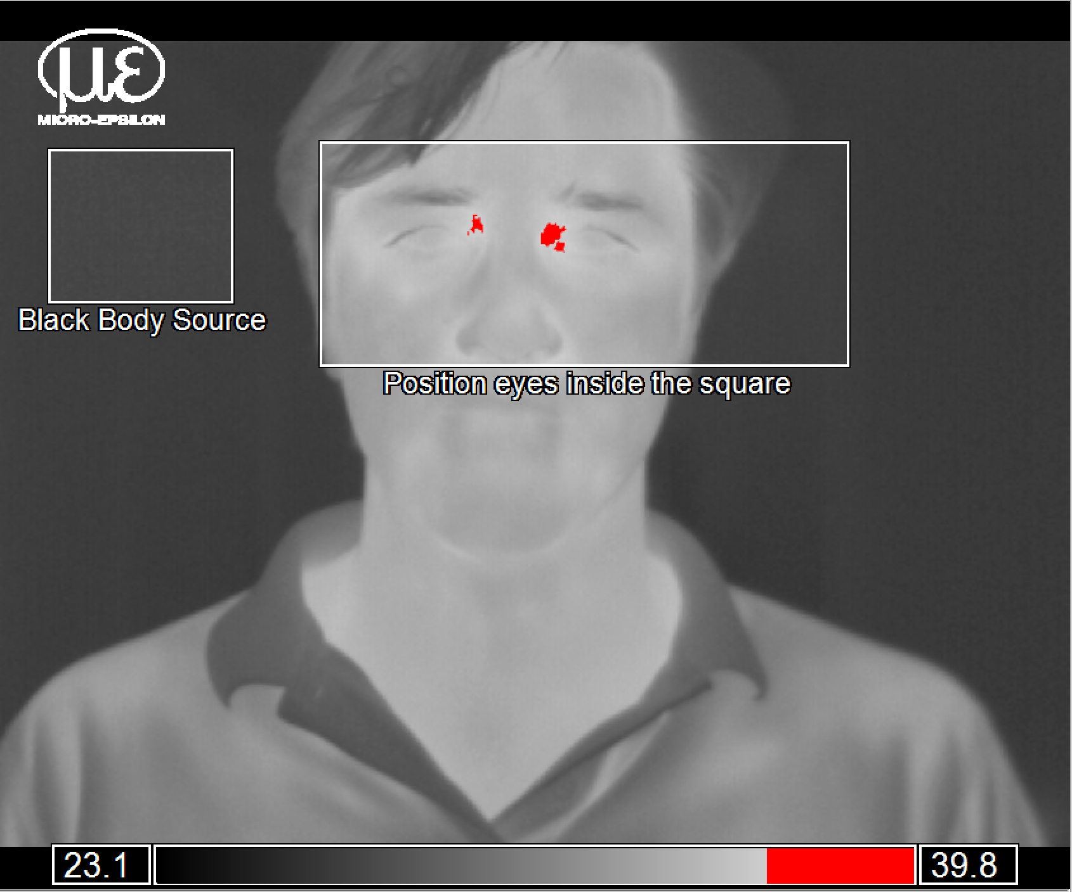
The accuracy of measurements can be increased to ± 0.5°C by using a black body reference source.

Note to Editors:
Manufacturing processes throughout all industries are evolving at a rapid pace, and the quality and tolerances expected from the end user are forever increasing. Thus, the need for smarter measurement solutions is continuously growing. Micro-Epsilon (www.micro-epsilon.co.uk) is renowned globally for being at the forefront of measurement technology.
For more than 50 years, we have continuously offered reliable, high performance, unique solutions particularly when high precision measurement or inspection is required. Our product range covers sensors for the measurement of distance and displacement, sensors for IR temperature measurement and colour detection, as well as turnkey systems for dimensional measurement and defect detection.
We understand that our customers are our business partners and aim to develop long term relationships with them.
We work closely with our customers to fully understand their requirements; our salespeople are engineers and understand more than just the sensor performance. We are problem solvers.
We operate a fair working policy, which results in excellent customer service and support even post sale.
Our high performance products and way of working provide our customers with a genuine competitive advantage.
To download high resolution images for this article, please go to www.silverbulletpr.co.uk/press . Alternatively, you can request an image by contacting:

Issued by: Dean Palmer
Director
SilverBullet PR Ltd
19, Glen Crescent, Stamford,
Lincolnshire PE9 1SW
Tel: 01780 754 254
Mobile: 07703 023771
Email: dean@silverbulletpr.co.uk

Reader Enquiries/
Advertising:
Glenn Wedgbrow,
Business Development Manager,
Micro-Epsilon UK Ltd
1, Shorelines Building,
Shore Road
Birkenhead
Cheshire CH41 1AU
Tel: +44 (0) 151 355 6070
Fax: +44(0) 151 355 6075
Email: glenn.wedgbrow@micro-epsilon.co.uk

