Ref. ME369 2nd September 2020

New white light interferometers offer a step change in measurement performance for absolute distance and thickness measurements
Precision sensor supplier Micro-Epsilon has developed a completely new range of high performance white light interferometers that provide new unmatched accuracy levels in absolute non-contact optical distance and thickness measurement. With measurement resolution from 30 picometres and linearity from ±10nm, these interferometers represent a step change in accuracy from its confocal measurement systems.

Having been in development for more than 10 years, the new interferoMETER range from Micro-Epsilon comprise of a controller, a sensor and a fibre optic cable. Unlike traditional laser interferometers that use a single wavelength and only perform relative measurements, the interferoMETER range from Micro-Epsilon operates with a broadband super-luminescent diode (SLED) and can make absolute measurements, ideal for step height and surface measurements. The use of a longer wavelength, 840nm, allows for a greater overall measurement range. In addition, being in the near-infrared part of the spectrum opens up the possibility to measure thicknesses of anti-reflective glass, plastics, reflective metals and coated objects. Another key benefit is the increased standoff and workable range for thickness measurement tasks which are independent of the target position within the working range of the sensor.

The sensors are designed for industrial measurement tasks and are equipped with robust metal housings and highly flexible cables. Connection into production lines or control cabinets is easy with numerous analogue and digital interfaces such as Ethernet and EtherCAT provided. System configuration is carried out via a user-friendly web interface that speeds up commissioning and parameter set up. Stable measurement results are achieved due to active temperature compensation and passive cooling. Measuring rates are up to 6 kHz, enabling high speed measurements in fast moving production environments.

Three variants to suit every application
Depending on the application, three different versions of the interferoMETER are available: the IMS5400-DS for high precision absolute distance measurements in industrial environments; the IMS5400-TH for high accuracy thickness measurements; and the IMS5600-DS with vacuum-compatible design for absolute distance measurements to picometre resolution in clean rooms and ultra-high vacuums.

The high accuracy IMS5400-TH is used to measure the thickness of thin, transparent materials. Measurements are carried out with a single sensor (one-sided) regardless of the distance to the measuring object. Nanometre-accurate measurements are possible even where there are distance fluctuations, vibrating or moving objects. Due to its near-infrared light source, thickness measurements of anti-reflective glass, as well as plastics, reflective metals and coated objects can also be performed. The system is particularly suitable for measurements in flat glass production lines or plastic film.

The IMS5600-DS is designed for absolute distance measurements in clean rooms and vacuums, including ultra-high vacuums (UHV). Special tuning of the controller and intelligent evaluation algorithms (which also evaluate the frequency) enable sub-nanometre resolution (< 30 picometres) measurements in, for example, micro-electronics, semiconductor wafer alignment and stage positioning applications.

The IMS5400-DS is used for industrial distance measurements. Compared to other absolute optical measuring systems, the system offers an unmatched combination of accuracy, measuring range and base/offset distance. The IMS5400-DS provides absolute measured values and can reliably detect steps and edges without any signal loss. Even when measuring on moving objects, the height differences of heels, steps and recesses are measured reliably. The compact, robust sensors enable integration into confined, narrow spaces. A small light spot size of 10 microns allows detection of the smallest objects and details such as structures on semiconductors or miniature electronic components.

For more information on the interferoMETER range, please call the Micro-Epsilon sales department on 0151 355 6070 or email info@micro-epsilon.co.uk

– ENDS – [577 words]

Photos and captions:
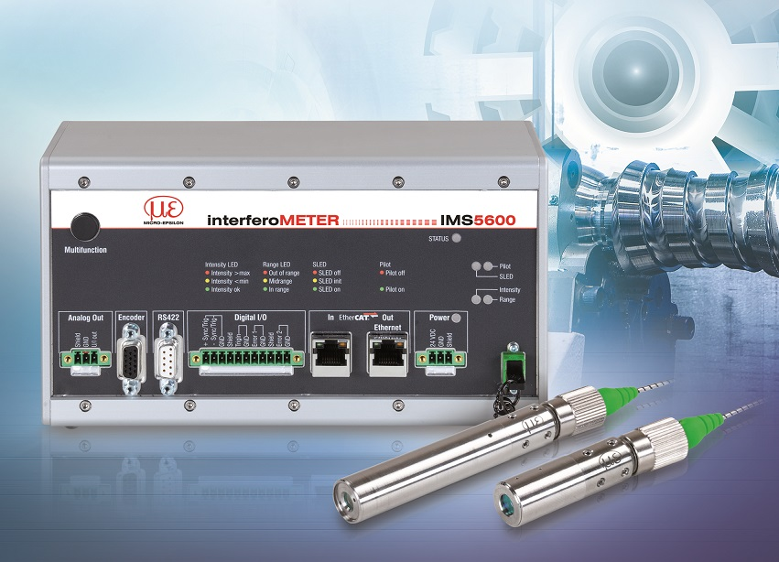
The new range of white light interferometers from Micro-Epsilon enable stable distance and thickness measurements to sub-nanometre resolution.
Note to Editors:
Manufacturing processes throughout all industries are evolving at a rapid pace, and the quality and tolerances expected from the end user are forever increasing. Thus, the need for smarter measurement solutions is continuously growing. Micro-Epsilon (www.micro-epsilon.co.uk) is renowned globally for being at the forefront of measurement technology.
For more than 50 years, we have continuously offered reliable, high performance, unique solutions particularly when high precision measurement or inspection is required. Our product range covers sensors for the measurement of distance and displacement, sensors for IR temperature measurement and colour detection, as well as turnkey systems for dimensional measurement and defect detection.
We understand that our customers are our business partners and aim to develop long term relationships with them.
We work closely with our customers to fully understand their requirements; our salespeople are engineers and understand more than just the sensor performance. We are problem solvers.
We operate a fair working policy, which results in excellent customer service and support even post sale.
Our high performance products and way of working provide our customers with a genuine competitive advantage.
To download high resolution images for this article, please go to www.silverbulletpr.co.uk/press . Alternatively, you can request an image by contacting:

Issued by: Dean Palmer
Director
SilverBullet PR Ltd
19, Glen Crescent, Stamford,
Lincolnshire PE9 1SW
Tel: 01780 754 254
Mobile: 07703 023771
Email: dean@silverbulletpr.co.uk

Reader Enquiries/
Advertising:
Glenn Wedgbrow,
Business Development Manager,
Micro-Epsilon UK Ltd
1, Shorelines Building,
Shore Road
Birkenhead
Cheshire CH41 1AU
Tel: +44 (0) 151 355 6070
Fax: +44(0) 151 355 6075
Email: glenn.wedgbrow@micro-epsilon.co.uk

