Ref. ME370 10th September 2020

New laser triangulation sensor offers unique combination of size, speed and accuracy for a wide range of control and automation tasks
Precision sensor manufacturer Micro-Epsilon continues the development of its comprehensive laser triangulation sensor range with the addition of the optoNCDT 1900. Ideally suited for both dynamic and high resolution measurement tasks, it features a completely new compact sensor housing with innovative mounting sleeves that ensures a repeatable sensor position and alignment to the target. This new performance class of laser sensor is perfect for high speed distance, displacement and position measurements in a wide range of automation tasks, including machine building, robotics, automotive production, 3D printing and coordinate measuring machines.

The new optoNCDT 1900 laser triangulation sensor offers a unique combination of speed, size and performance. The sensor itself has dimensions of 70 x 31 x 45mm and weighs just 185g. The measuring rate is continuously adjustable up to 10kHz and can be individually adapted to suit each measurement task. Newly developed, high performance optics create a small spot size onto the target, which enables tiny objects and surface details to be measured. A new larger aperture for the receiver ensures greater accuracy and repeatability when compared to other sensors of similar measurement range. The sensor itself is also extremely robust with the ability to withstand high shock and vibrations, like those seen in vehicle testing, as standard.

Two-stage averaging
For the first time, a two-stage measurement average is available for signal optimisation. This enables the sensor to provide a clean signal output at edges and steps. The high performance averaging ensures a stable, precise signal output and is particularly suitable for high speed measurements of fast moving parts.

The sensor uses the newly developed Advanced Surface Compensation (ASC) algorithm that allows it to operate almost regardless of the target material and colour. The exposure time or amount of light produced by the laser sensor is optimally matched to the reflection characteristics of the target surface, which enables reliable measurements even of difficult, changing surfaces. The sensor is extremely resistant to ambient light interference and so can be used in high illumination environments including those situations where lasers are combined with Vision Systems and their associated LED lighting. The new software algorithms compensate for ambient light up to 50,000 lux, which means operation in direct sunlight is also improved.

Mounting sleeves and highly flexible cables
Mounting the sensor is also fast and easy, with new fitting sleeves provided that automatically align the sensor in the correct position. This enables both easy sensor replacement and ensures continued high precision measurements to be taken with confidence that the new sensor is looking at the same point on the target. Highly flexible cables and a robust IP67 protected aluminium die cast housing make the sensor ideal for industrial use.

Using the now familiar Micro-Epsilon web interface, the optoNCDT 1900 is incredibly easy to set up and use without requiring any installed operating software. The settings for the measurement task can be quickly selected using application-specific, predefined presets. These are available to suit a wide variety of materials and surface types, including metals, plastics and organics. These presets enable rapid, straightforward set up and help to optimise the sensor for specific tasks.

New advanced features for peak separation and peak width determination enable reliable measurements on coated materials, measurement objects located behind glass and on film-sealed components. Data output is via analogue or digital RS422 interface. By using the Micro-Epsilon IF2030 interface module, EtherNet/IP and PROFINET are also available.

Glenn Wedgbrow, Business Development Manager at Micro-Epsilon UK comments: “The combination of enhanced performance, compactness and wide range of new features result in a laser sensor that sets new benchmarks for advanced automation tasks. Due to its compact design, integral controller, flexible mounting options and advanced surface compensation features, the optoNCDT 1900 is extremely versatile and will solve a wide variety of applications on industrial plant, machines, automated production lines and robots.”

The optoNCDT 1900 series is available in measuring ranges from 10mm up to 50mm (with higher ranges from 100mm up to 500mm planned for launch in 2021). Linearity is from
<± 2.0 microns.

For more information on the optoNCDT 1900, please call the Micro-Epsilon sales department on 0151 355 6070 or email info@micro-epsilon.co.uk

– ENDS – [690 words]

Photos and captions:
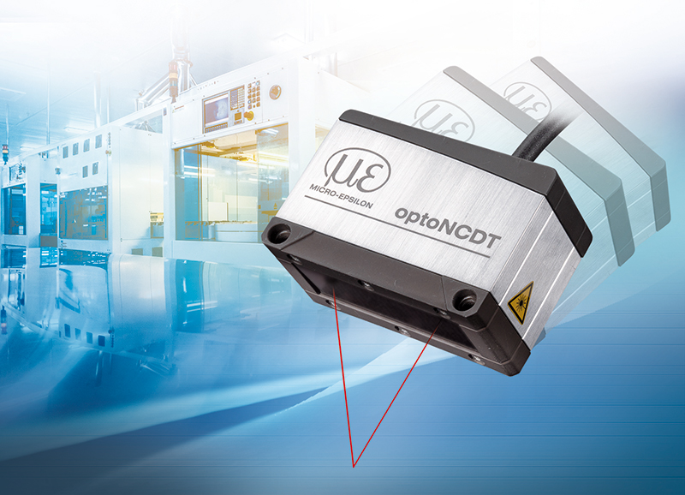
The new optoNCDT 1900 laser triangulation sensors from Micro-Epsilon offer even higher performance and are more compact, making them ideal for automation tasks.
Note to Editors:
Manufacturing processes throughout all industries are evolving at a rapid pace, and the quality and tolerances expected from the end user are forever increasing. Thus, the need for smarter measurement solutions is continuously growing. Micro-Epsilon (www.micro-epsilon.co.uk) is renowned globally for being at the forefront of measurement technology.
For more than 50 years, we have continuously offered reliable, high performance, unique solutions particularly when high precision measurement or inspection is required. Our product range covers sensors for the measurement of distance and displacement, sensors for IR temperature measurement and colour detection, as well as turnkey systems for dimensional measurement and defect detection.
We understand that our customers are our business partners and aim to develop long term relationships with them.
We work closely with our customers to fully understand their requirements; our salespeople are engineers and understand more than just the sensor performance. We are problem solvers.
We operate a fair working policy, which results in excellent customer service and support even post sale.
Our high performance products and way of working provide our customers with a genuine competitive advantage.
To download high resolution images for this article, please go to www.silverbulletpr.co.uk/press . Alternatively, you can request an image by contacting:

Issued by: Dean Palmer
Director
SilverBullet PR Ltd
19, Glen Crescent, Stamford,
Lincolnshire PE9 1SW
Tel: 01780 754 254
Mobile: 07703 023771
Email: dean@silverbulletpr.co.uk

Reader Enquiries/
Advertising:
Glenn Wedgbrow,
Business Development Manager,
Micro-Epsilon UK Ltd
1, Shorelines Building,
Shore Road
Birkenhead
Cheshire CH41 1AU
Tel: +44 (0) 151 355 6070
Fax: +44(0) 151 355 6075
Email: glenn.wedgbrow@micro-epsilon.co.uk

