Ref. ME372 13th October 2020

New capacitive measurement system offers unrivalled performance
and stability in counting and rotational speed tasks
Precision sensor manufacturer Micro-Epsilon has launched a new non-contact capacitive measurement system that complements its existing eddy current solution for turbo charger speed measurement. The new capaNCDT 6110 is suitable for industrial counting tasks and rotational speed (RPM) applications, including balancing machines, spin test benches, gearboxes, rotating shafts, engines, high speed generators, turbines and electric motors.

Regardless of the target material, be it electrical conductors (metals) or insulators (plastics, ceramics), they are counted from the first detection with no run-up necessary and without any impairment of the signal quality. Indeed, the capaNCDT CST6110 system provides reliable measurements even in applications where dirt, dust or oil mist are present. It even measures directly in oil, due to the signal change of the target being significantly higher than the change from the presence of oil.

The capaNCDT CST6110 capacitive measurement system comprises an IP67 rated controller and a compact sensor that can be integrated into confined spaces. The measurement system detects and counts all manner of targets including rotor blades, gear teeth, notches or similar objects with extremely high precision and stability across a speed range of 1 to 400,000RPM.

Micro-Epsilon has also developed a new miniature sensor to match the CST6110 controller. The CSE025/M5 sensor has an M5 thread for easy installation and its narrow size allows it to be mounted in confined spaces. However, the sensor is robust and will provide stable, reliable measurements even in the harshest of environments. As with the other capacitive controllers from Micro-Epsilon, the CST6110 can also be operated with any other capacitive sensor in its range.

The measurement system offers a high degree of interference immunity and reliability, particularly in environments where electromagnetic fields can occur. The rotational speed can be output in TTL digital form without any linearity error and also as an analogue 0-5V signal. For targets such as rotor blades, with multiple measuring points per rotation, a selector switch can set the number of blades (maximum 16) per rotation enabling the correct RPM value to be output

Glenn Wedgbrow, Business Development Manager at Micro-Epsilon UK comments: “The capaNCDT CST6110 is unrivalled in terms of performance, reliability and stability especially for non-metallic targets such as ceramics and plastics. It complements our existing Eddy Current solution, DZ140, used on turbochargers with titanium and aluminium blades. As industries move towards e-chargers and the use of plastic and ceramic blades, the CST6110 system is the perfect choice for rotating [RPM] and counting applications. Alternative measuring systems such as incremental or optical rotation speed measurement systems often require a ‘friendly’ target to be attached or manufactured on the shaft and they also tend to be limited to a measuring rate of 5kHz, neither of these adaptations are required with the new CST6110.”

For more information on the capaNCDT CST6110, please call the Micro-Epsilon sales department on 0151 355 6070 or email info@micro-epsilon.co.uk

– ENDS – [491 words]

Photos and captions:
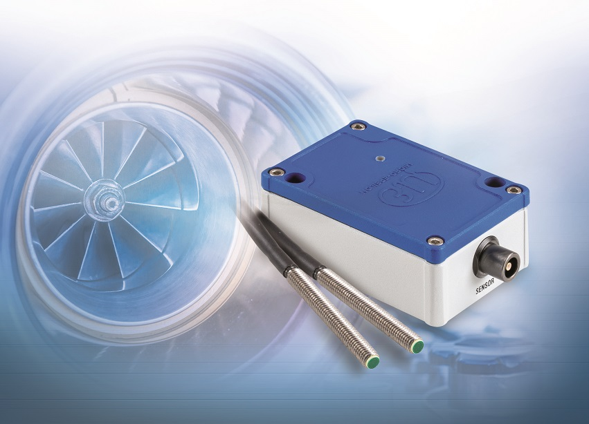
The capaNCDT CST6110 capacitive measurement system is suitable for rotational speed (RPM) applications such as generators, motors, shafts, gearboxes, and balancing machines.
Note to Editors:
Manufacturing processes throughout all industries are evolving at a rapid pace, and the quality and tolerances expected from the end user are forever increasing. Thus, the need for smarter measurement solutions is continuously growing. Micro-Epsilon (www.micro-epsilon.co.uk) is renowned globally for being at the forefront of measurement technology.
For more than 50 years, we have continuously offered reliable, high performance, unique solutions particularly when high precision measurement or inspection is required. Our product range covers sensors for the measurement of distance and displacement, sensors for IR temperature measurement and colour detection, as well as turnkey systems for dimensional measurement and defect detection.
We understand that our customers are our business partners and aim to develop long term relationships with them.
We work closely with our customers to fully understand their requirements; our salespeople are engineers and understand more than just the sensor performance. We are problem solvers.
We operate a fair working policy, which results in excellent customer service and support even post sale.
Our high performance products and way of working provide our customers with a genuine competitive advantage.
To download high resolution images for this article, please go to www.silverbulletpr.co.uk/press . Alternatively, you can request an image by contacting:

Issued by: Dean Palmer
Director
SilverBullet PR Ltd
19, Glen Crescent, Stamford,
Lincolnshire PE9 1SW
Tel: 01780 754 254
Mobile: 07703 023771
Email: dean@silverbulletpr.co.uk

Reader Enquiries/
Advertising:
Glenn Wedgbrow,
Business Development Manager,
Micro-Epsilon UK Ltd
1, Shorelines Building,
Shore Road
Birkenhead
Cheshire CH41 1AU
Tel: +44 (0) 151 355 6070
Fax: +44(0) 151 355 6075
Email: glenn.wedgbrow@micro-epsilon.co.uk

