Ref. ME376 24th November 2020

With 95mm of range and up to 2m separation, this new compact laser micrometer offers much greater measurement flexibility
Precision sensor supplier Micro-Epsilon has extended its optoCONTROL 2520 series of optical laser micrometers with the optoCONTROL 2520-95, which provides double the measuring range (95mm) of the existing optoCONTROL 2520-46. The increased range allows for measurements on larger diameter parts without the need to use or combine additional sensors.

The optoCONTROL 2520-95 is a compact laser micrometer characterised by its high accuracy, high repeatability and a large measuring range of 95mm. The micrometer is flexible too; measurements can be taken at any position within the light curtain whilst preset optimum distances are selectable in the controller. Due to its high linearity (<± 15µm), high repeatability (≤ 6µm) and measuring speed (2.0 kHz), the sensor is suitable for all applications where large measuring ranges are required.

The optoCONTROL 2520 series outputs up to 2,500 measurements values per second depending on the measuring range. Measurement modes such as Edge Tracking, Diameter, Gap and Centre Axis can be selected, whilst the Segment mode allows multiple targets to be measured that are within the optical beam. An option with an angled (90-degree) flat receiver is also available on both ranges for measurements in confined spaces.

Configuration of the sensor is performed via the web interface, enabling parameters to be set up including video signal, filter and the various measuring modes. The optoCONTROL 2520 micrometers are equipped with an integral controller and are rated as laser class 1M. Analogue, RS422, Ethernet and EtherCAT outputs are provided to simplify integration of the sensor into the customer’s own production control environment. Profinet and Ethernet/IP can also be used via the IF2030 interface converters.

Glenn Wedgbrow, Business Development Manager at Micro-Epsilon comments: “The optoCONTROL 2520-95 is extremely versatile and so will find applications across many different industry sectors in the UK, from food and pharmaceuticals, to automotive and machine building. The micrometers can be set up in production lines to inspect continuous material or single parts. For example, in strip material processing applications and cutting machines, several strips can be measured simultaneously by using multi-segment measurement. In addition, the sensor is ideal for hose and extruder products, including bars and plastic pipes.”

Wear-free and a long service life
All optoCONTROL laser micrometers from Micro-Epsilon work without rotating mirrors and so are completely wear-free. The parallel light curtain is created by using special optics in the light source. High quality components in the receiving optics, including filters and lenses, enable the high accuracy of the micrometers.

The optoCONTROL 2520 series of laser micrometers from Micro-Epsilon offer high accuracy and measuring rates. The improved linearity, different measuring ranges and variable mounting distances between transmitter and receiver, allow for a wide range of dimensional measurement applications in production control, quality control and inline inspection.

For more information on the optoCONTROL 2520-95, please call the Micro-Epsilon sales department on +44 (0)151 355 6070 or email info@micro-epsilon.co.uk

– ENDS – [474 words]

Photos and captions:

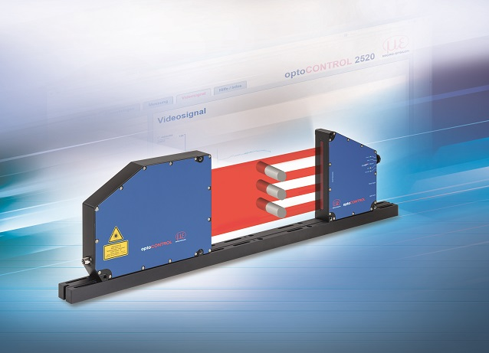
The new optoCONTROL 2520-95 offers double the measuring range (95mm) of the existing optoCONTROL 2520-46.

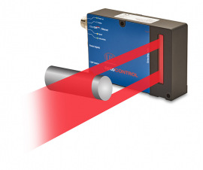
For confined installation situations, the optoCONTROL 2520-95 (270) has a flat receiver with 90-degree rotated optics.

Note to Editors:

About Micro-Epsilon
Manufacturing processes throughout all industries are evolving at a rapid pace, and the quality and tolerances expected from the end user are forever increasing. Thus, the need for smarter measurement solutions is continuously growing. Micro-Epsilon (www.micro-epsilon.co.uk) is renowned globally for being at the forefront of measurement technology.
For more than 50 years, we have continuously offered reliable, high performance, unique solutions particularly when high precision measurement or inspection is required. Our product range covers sensors for the measurement of distance and displacement, sensors for IR temperature measurement and colour detection, as well as turnkey systems for dimensional measurement and defect detection.
We understand that our customers are our business partners and aim to develop long term relationships with them. We work closely with our customers to fully understand their requirements; our salespeople are engineers and understand more than just the sensor performance. We are problem solvers.
We operate a fair working policy, which results in excellent customer service and support even post sale.
Our high performance products and way of working provide our customers with a genuine competitive advantage.

To download high resolution images for this article, please go to www.silverbulletpr.co.uk/press . Alternatively, you can request an image by contacting:

Issued by: Dean Palmer
Director
SilverBullet PR Ltd
19, Glen Crescent, Stamford,
Lincolnshire PE9 1SW
Tel: 01780 754 254
Mobile: 07703 023771
Email: dean@silverbulletpr.co.uk

Reader Enquiries/Advertising:
Glenn Wedgbrow,
Business Development Manager,
Micro-Epsilon UK Ltd
1, Shorelines Building,
Shore Road
Birkenhead
Cheshire CH41 1AU
Tel: +44 (0) 151 355 6070
Email: glenn.wedgbrow@micro-epsilon.co.uk

