Ref. ME377 3rd December 2020

Active capacitive measurement system with integrated preamplifier offers flexible cable lengths up to 15m for automation, machine building and robotics
Precision sensor supplier Micro-Epsilon has launched an active capacitive measurement system that incorporates a preamplifier within the sensor head to directly boost the signal. This provides end users with greater flexibility for cable routing and movement, especially in industrial automation, robotics, semiconductor production and machine building applications.

The capaNCDT 61x4 active capacitive system for displacement, distance and position measurements consists of a sensor with integrated preamplifier, a robust cable and a compact controller. Due to the integrated preamplifier, the cable length can be doubled compared to conventional capacitive sensors. The signal transmission remains stable with this sensor over a length of up to 15 metres.

Glenn Wedgbrow, Business Development Manager at Micro-Epsilon comments: “Previously, flexing and bending the cable of a capacitive sensor could cause noise on the signal due to the low level signals used. Now with the integrated preamplifier directly in the sensor head, changes in the capacitance of the cable due to movement or flexing have hardly any effect on the measurement signal. This offers clear advantages in terms of freedom of movement, extended lengths and enables cable routing with drag chains and on robot arms.”

Two sensors of flat design are available with extended measurement ranges of up to 4mm. The system is immediately ready for use without any on-site calibration required. The measuring system is available with cable lengths of 5m or 15m making it suitable for a wide range of industrial automation and machine building tasks.

The active flat sensor is designed with stainless steel housing and a ceramic sensor element. The cable is integrated on the sensor side, which significantly reduces the required installation space, whilst increasing the mechanical stability of the sensor. In order to achieve optimum signal quality, the system is factory-calibrated to the desired cable length.

Connectivity – analogue or RS485
Depending on the end users’ requirements, two controller versions are available for the active capacitive sensors. The capaNCDT 6114 capacitive measuring system provides an analogue output of 0… 10V, while the capaNCDT 6124 capacitive measurement system offers both an analogue output and a digital RS485 interface.

For more information on the capaNCDT DT61x4 range, please call the Micro-Epsilon sales department on +44 (0)151 355 6070 or email info@micro-epsilon.co.uk

– ENDS – [388 words]

Photos and captions:
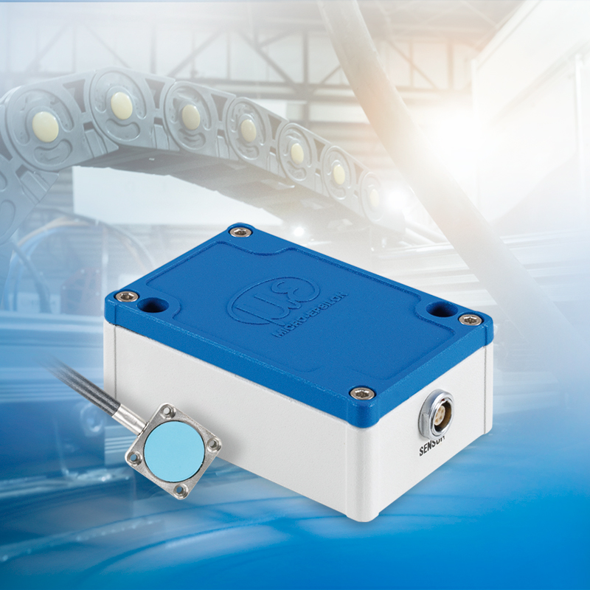
The capaNCDT DT61x4 offers longer signal transmission lengths in automation, robotics and drag chain applications.

Note to Editors:

About Micro-Epsilon
Manufacturing processes throughout all industries are evolving at a rapid pace, and the quality and tolerances expected from the end user are forever increasing. Thus, the need for smarter measurement solutions is continuously growing. Micro-Epsilon (www.micro-epsilon.co.uk) is renowned globally for being at the forefront of measurement technology.
For more than 50 years, we have continuously offered reliable, high performance, unique solutions particularly when high precision measurement or inspection is required. Our product range covers sensors for the measurement of distance and displacement, sensors for IR temperature measurement and colour detection, as well as turnkey systems for dimensional measurement and defect detection.
We understand that our customers are our business partners and aim to develop long term relationships with them. We work closely with our customers to fully understand their requirements; our salespeople are engineers and understand more than just the sensor performance. We are problem solvers.
We operate a fair working policy, which results in excellent customer service and support even post sale.
Our high performance products and way of working provide our customers with a genuine competitive advantage.

To download high resolution images for this article, please go to www.silverbulletpr.co.uk/press . Alternatively, you can request an image by contacting:

Issued by: Dean Palmer
Director
SilverBullet PR Ltd
19, Glen Crescent, Stamford,
Lincolnshire PE9 1SW
Tel: 01780 754 254
Mobile: 07703 023771
Email: dean@silverbulletpr.co.uk

Reader Enquiries/Advertising:
Glenn Wedgbrow,
Business Development Manager,
Micro-Epsilon UK Ltd
1, Shorelines Building,
Shore Road
Birkenhead
Cheshire CH41 1AU
Tel: +44 (0) 151 355 6070
Email: glenn.wedgbrow@micro-epsilon.co.uk

