Ref. ME378 26th January 2021

New laser sensor accurately measures distances to difficult surfaces or target objects up to 150 metres away
Precision sensor supplier Micro-Epsilon has introduced a non-contact laser distance sensor that measures distances up to 150m with an accuracy of < ± 1mm. The sensor measures accurately even on difficult surfaces such as dark, structured or weakly reflecting objects. Without any special adaptations to the target, the sensor has an impressive range up to 100m. Adding a reflector to the target extends the range to 150m.

Developed in-house by Micro-Epsilon, the new optoNCDT ILR2250-100 laser distance sensor is both smaller and more accurate than its predecessor, the optoNCDT ILR1181. The factory default AUTO measurement mode allows precise and reliable measurements to be made on targets over great distances. Additional modes are also available to tune the sensor to specific application requirements.

Protected by an IP65 die cast aluminium housing, the optoNCDT ILR2250-100 is suitable for a wide range of applications, from transport, logistics and conveyor systems, to automation, metal processing, production monitoring and unmanned drones or vehicles. It has already found uses in monitoring large coil diameters, silo filling levels and gantry cranes. The combined long range and high accuracy of the sensor has also found particular benefits in the measurement and control of diameters for hot ring rolling.

In terms of its technical performance, the sensor is unsurpassed in its field, providing excellent repeatability (<300µm), resolution (0.1mm) and linearity (< ± 1mm), resulting in extremely stable measurements and excellent signal stability. The sensor’s small footprint (102 x 53 x 50mm) and weight (254g) represent a 65% reduction in size and weight compared to its predecessor, allowing it to be easily installed in narrow or restricted spaces in production lines and machines.

Modes of operation
The optoNCDT ILR2250-100 provides four basic modes of operation:

- AUTO mode is the factory default setting where the speed (measuring rate) can be varied between 3 to 20Hz, depending on the target.
- FAST mode has a reduced accuracy of ± 1mm and requires a ‘good’ surface.
- ACCURATE mode is suitable for targets moving up to 1.5 m/s.
- PRECISE mode has an accuracy of 0.3mm.

Glenn Wedgbrow, Business Development Manager at Micro-Epsilon comments: “Rather than use the time-of-flight measuring principle like our previous sensor models, the optoNCDT ILR2250-100 operates on the phase comparison measuring principle. This method confirms the distance measurement more accurately and works well in smoke, steam and fog. In addition, due to its compact footprint and configurable software, the sensor can also be adapted to meet individual OEM requirements.”

The optoNCDT ILR2250-100 can provide continuous measurement output via a 16-bit, scalable, 4-20mA analogue output or via RS422 serial communication. Three digital switch outputs are available for simple process monitoring and a trigger input provides opportunities to control when the sensor takes a reading.

For more information on the optoNCDT ILR2250-100, please visit
https://www.micro-epsilon.co.uk/sensors/optoNCDT-ILR2250-100/ or call the Micro-Epsilon sales department on +44 (0)151 355 6070 or email info@micro-epsilon.co.uk

– ENDS – [472 words]

Photos and captions:

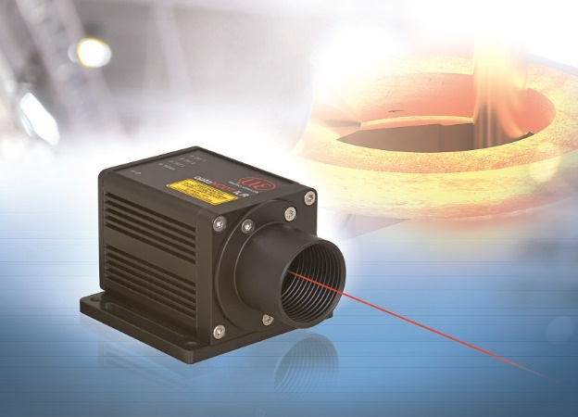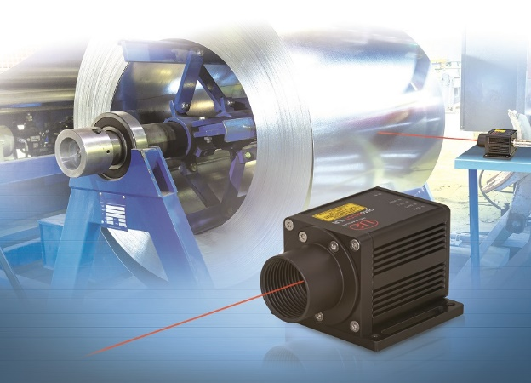
The new optoNCDT ILR2250-100 laser distance sensor can measure distances up to 150m.

Note to Editors:

About Micro-Epsilon
Manufacturing processes throughout all industries are evolving at a rapid pace, and the quality and tolerances expected from the end user are forever increasing. Thus, the need for smarter measurement solutions is continuously growing. Micro-Epsilon (www.micro-epsilon.co.uk) is renowned globally for being at the forefront of measurement technology.
For more than 50 years, we have continuously offered reliable, high performance, unique solutions particularly when high precision measurement or inspection is required. Our product range covers sensors for the measurement of distance and displacement, sensors for IR temperature measurement and colour detection, as well as turnkey systems for dimensional measurement and defect detection.
We understand that our customers are our business partners and aim to develop long term relationships with them. We work closely with our customers to fully understand their requirements; our salespeople are engineers and understand more than just the sensor performance. We are problem solvers.
We operate a fair working policy, which results in excellent customer service and support even post sale.
Our high performance products and way of working provide our customers with a genuine competitive advantage.

To download high resolution images for this article, please go to www.silverbulletpr.co.uk/press . Alternatively, you can request an image by contacting:

Issued by: Dean Palmer
Director
SilverBullet PR Ltd
19, Glen Crescent, Stamford,
Lincolnshire PE9 1SW
Tel: 01780 754 254
Mobile: 07703 023771
Email: dean@silverbulletpr.co.uk

Reader Enquiries/Advertising:
Glenn Wedgbrow,
Business Development Manager,
Micro-Epsilon UK Ltd
1, Shorelines Building,
Shore Road
Birkenhead
Cheshire CH41 1AU
Tel: +44 (0) 151 355 6070
Email: glenn.wedgbrow@micro-epsilon.co.uk

