Ref. ME381 4th March 2021

New portable gauges enable high precision, non-destructive coating thickness measurements on CFRP and metal substrates
A range of compact handheld gauges for measuring the coating or paint thickness on CFRP (carbon fibre reinforced plastic) and metal substrates is now available in the UK from Micro-Epsilon. Based on microwave technology, the gauges measure the total layer thickness of insulating materials with micrometer precision.

Knowing the thickness of paint applied to a CFRP or metal substrate is valuable for manufacturers and users alike. Too much paint can lead to increased weight and stiffness, as well as the excess cost of raw materials and rework. Too little paint could lead to premature ageing or poor aesthetic quality of the final product.

Two ranges of non-destructive coating thickness gauge are available from Micro-Epsilon.

The FSC (Fast Surface Check) series, which includes the FSC1/7 and FSC1000 versions, is the preferred choice of renowned aircraft manufacturers, airlines and paint shops. The FSC series is approved, recognised and listed as ‘thickness gauges for the aviation industry’ by the manufacturers.

The ISC1000 (Industrial Surface Check) series is designed for general industrial and process manufacturing applications. This coating thickness gauge is used for random thickness checks, process control and quality inspections on CFRP substrates, including CFRP laid materials, CFRP woven materials, CFRP with lightning protection, and metals.

With FSC and ISC gauges, neither the target surface (coating or paint) nor the substrate is affected by the measurement. In the case of multi-layer coatings, the total thickness of insulating layers is always measured up to the first conductive material layer. The measurement can be performed on any metallic substrate with the same signal quality regardless of electric and magnetic properties. The gauges are factory-calibrated and can then be individually adjusted to the customer’s substrate (CFRP, metals) using the included calibration foils. The adjustment only needs to be done once for measurement on any metal substrate.

Glenn Wedgbrow, Business Development Manager at Micro-Epsilon comments: “Unlike competing systems, the FSC and ISC gauges measure without residue or coupling medium. They are truly non-destructive with nothing to clean after the measurement. The systems can be used from 1µm substrate thickness and do not require a minimum layer thickness. This means that thin coating layers can be measured on even the thinnest metallic substrates.”

FSC and ISC gauges are supplied with a separate controller with a large LCD touch display for indicating measurement values. The controller offers numerous functions including measurement value memory with USB data export; statistical functions; individual adjustment possibilities; and dynamic tilt prevention which warns the user if there is movement during the measurement.

The measurement is triggered by pressing a button on the sensor or via the controller. As well as the sensor and controller, all FSC and ISC devices are supplied in a robust hard case with a complete set of accessories including battery pack, charger, cables and calibration foils.

For more information on the FSC/ISC coating thickness measurement devices, please visit
www.micro-epsilon.co.uk or call the Micro-Epsilon sales department on +44 (0)151 355 6070 or email info@micro-epsilon.co.uk

– ENDS – [508 words]

Photos and captions:

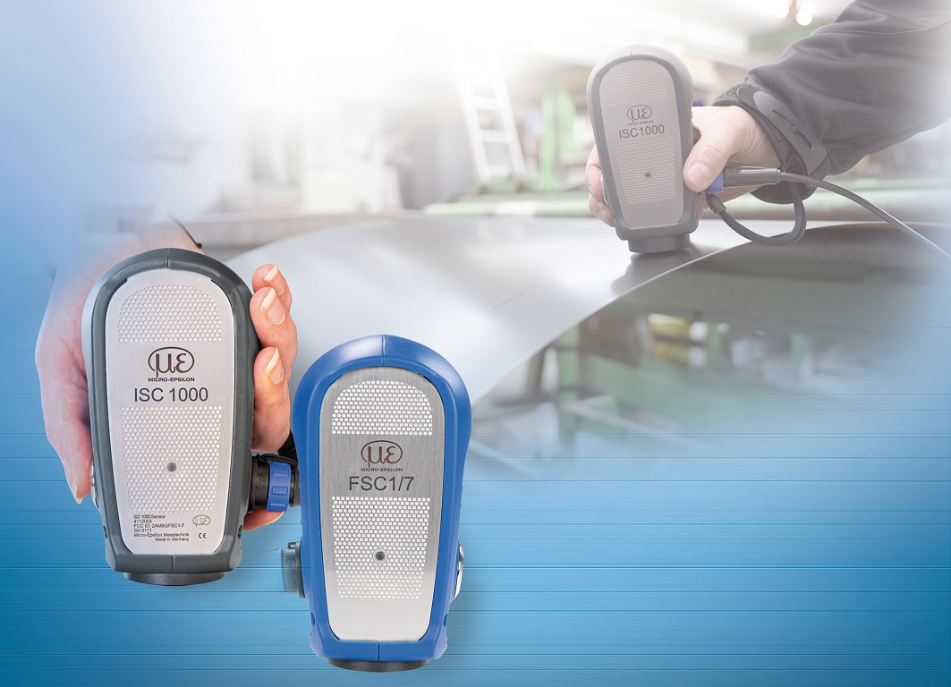
Based on microwave technology, the FSC and ISC gauges measure the total layer thickness of insulating materials with micrometer precision.

Note to Editors:

About Micro-Epsilon
Manufacturing processes throughout all industries are evolving at a rapid pace, and the quality and tolerances expected from the end user are forever increasing. Thus, the need for smarter measurement solutions is continuously growing. Micro-Epsilon (www.micro-epsilon.co.uk) is renowned globally for being at the forefront of measurement technology.
For more than 50 years, we have continuously offered reliable, high performance, unique solutions particularly when high precision measurement or inspection is required. Our product range covers sensors for the measurement of distance and displacement, sensors for IR temperature measurement and colour detection, as well as turnkey systems for dimensional measurement and defect detection.
We understand that our customers are our business partners and aim to develop long term relationships with them. We work closely with our customers to fully understand their requirements; our salespeople are engineers and understand more than just the sensor performance. We are problem solvers.
We operate a fair working policy, which results in excellent customer service and support even post sale.
Our high performance products and way of working provide our customers with a genuine competitive advantage.

To download high resolution images for this article, please go to www.silverbulletpr.co.uk/press . Alternatively, you can request an image by contacting:

Issued by: Dean Palmer
Director
SilverBullet PR Ltd
19, Glen Crescent, Stamford,
Lincolnshire PE9 1SW
Tel: 01780 754 254
Mobile: 07703 023771
Email: dean@silverbulletpr.co.uk

Reader Enquiries/Advertising:
Glenn Wedgbrow,
Business Development Manager,
Micro-Epsilon UK Ltd
1, Shorelines Building,
Shore Road
Birkenhead
Cheshire CH41 1AU
Tel: +44 (0) 151 355 6070
Email: glenn.wedgbrow@micro-epsilon.co.uk

