Ref. ME382 16th March 2021

New inductive sensors are more compact and offer high accuracy and temperature stability for continuous monitoring of tool clamping position
Precision sensor manufacturer Micro-Epsilon has introduced a range of inductive displacement sensors that monitor the clamping position in machine tools. The sensors are extremely compact and robust (IP67), while providing high temperature stability and high repeatability, even in harsh machine tool environments.

When developing new machine tools, key requirements include faster machining speeds, higher precision and higher productivity. However, if the cutting tool is incorrectly positioned in these high performance machines, this can lead to machining errors, damage to the machine or personal injury.

The new induSENSOR LVP-25-Z20 and induSENSOR LDR-14-Z20 from Micro-Epsilon are available with measuring ranges of 25mm and 14mm, respectively. The cylindrical sensors are integrated into the release device to detect the clamping stroke of the drawbar (i.e. shaft, spindle), which passes through the centre of the sensor. The measuring object is a target ring which is attached to the drawbar. This ‘through-bore’ sensor design requires the minimum amount of installation space compared to more traditional clamping position sensors.

Due to their extremely compact design – the LDR-14-Z20 has a diameter of just 13mm and a length of 26mm – the sensors can be integrated to a wide variety of different tools. The sensors provide an analogue output based on the target ring position that corresponds to the stroke movement of the drawbar when clamping the tool. The sensor provides continuous monitoring of the drawbar position and therefore removes the need to mechanically set the switching point and eliminates complex, time-consuming adjustments when changing the tool.

The miniature sensor controller can either be accommodated at the point of measurement or mounted in a control cabinet. Due to their high resolution (6-7µm), thermal stability and operating temperature range, up to 125°C as standard (higher on request), the sensors contribute significantly to meeting the ever-increasing requirements for high precision and availability of machine tools.

Glenn Wedgbrow, Business Development Manager at Micro-Epsilon comments: “The induSENSOR LVP and LDR sensors measure on a continuous, non-contact basis and are therefore wear-free. The sensors also offer large measuring ranges [25mm and 14mm] relative to their short design, which simplifies their integration into release devices on clamping systems where space can be limited. Also, compared to alternative methods of measuring the clamping stroke – which often comprise of multiple proximity sensors and complex mechanical control disks of various shapes and sizes – our solution is a much more elegant one that consists of an individual measurement sensor, which simplifies integration and significantly reduces the rotating mass on the drawbar. The sensors also offer higher temperature stability and higher resolution, linearity and repeatability than competing clamping stroke measurement systems.”

For more information on the induSENSOR LVP/LDR range, please visit
www.micro-epsilon.co.uk or call the Micro-Epsilon sales department on +44 (0)151 355 6070 or email info@micro-epsilon.co.uk

– ENDS – [455 words]

Photos and captions:

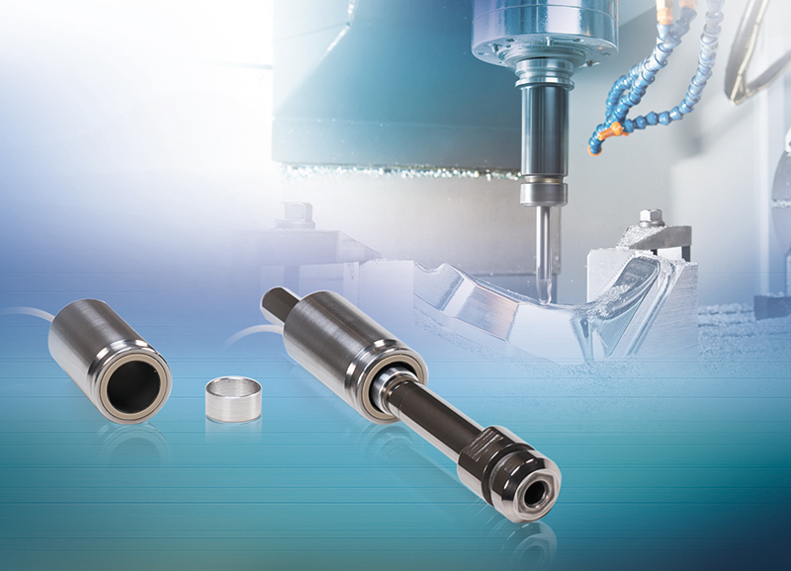
The new induSENSOR LVP/LDR range of inductive displacement sensors monitor the clamping position in machine tools.

Note to Editors:

About Micro-Epsilon
Manufacturing processes throughout all industries are evolving at a rapid pace, and the quality and tolerances expected from the end user are forever increasing. Thus, the need for smarter measurement solutions is continuously growing. Micro-Epsilon (www.micro-epsilon.co.uk) is renowned globally for being at the forefront of measurement technology.
For more than 50 years, we have continuously offered reliable, high performance, unique solutions particularly when high precision measurement or inspection is required. Our product range covers sensors for the measurement of distance and displacement, sensors for IR temperature measurement and colour detection, as well as turnkey systems for dimensional measurement and defect detection.
We understand that our customers are our business partners and aim to develop long term relationships with them. We work closely with our customers to fully understand their requirements; our salespeople are engineers and understand more than just the sensor performance. We are problem solvers.
We operate a fair working policy, which results in excellent customer service and support even post sale.
Our high performance products and way of working provide our customers with a genuine competitive advantage.

To download high resolution images for this article, please go to www.silverbulletpr.co.uk/press . Alternatively, you can request an image by contacting:

Issued by: Dean Palmer
Director
SilverBullet PR Ltd
19, Glen Crescent, Stamford,
Lincolnshire PE9 1SW
Tel: 01780 754 254
Mobile: 07703 023771
Email: dean@silverbulletpr.co.uk

Reader Enquiries/Advertising:
Glenn Wedgbrow,
Business Development Manager,
Micro-Epsilon UK Ltd
1, Shorelines Building,
Shore Road
Birkenhead
Cheshire CH41 1AU
Tel: +44 (0) 151 355 6070
Email: glenn.wedgbrow@micro-epsilon.co.uk

