Ref. ME383 26th March 2021

Draw wire sensor from Micro-Epsilon ensures water turbine maintains optimum efficiency
A draw wire sensor from Micro-Epsilon is performing a vital role in a water turbine control system. The sensor measures the precise position of the control vane in the turbine. Using the measurement data from the sensor in combination with the water level in the millrace, the control actuator is adjusted to maintain system pressure while maximising flow rate, which in turn produces the maximum electricity for the given amount of available water.
Ballywee Corn Mill in County Antrim, Northern Ireland is a listed building due to its Industrial Heritage and features a recently restored and working 24-foot diameter waterwheel. Now a family home, the Mill retains the grind stones and all the internal machinery required for the milling process.

To fully exploit the water from the millrace, a water turbine has been installed. Modern water turbines represent a highly efficient means of producing renewable ‘green’ energy. The turbine control vane must be continually adjusted to maximise the available flow of water from the race. With its combination of high accuracy, resolution and long travel, a draw wire sensor from Micro Epsilon is utilised to provide feedback for the turbine control actuator, ensuring the turbine is always operating at maximum efficiency.

Whilst the water turbine is completely separate from the waterwheel, they share the supply of water from the millrace. The water turbine includes an enclosed impeller which, via the belts, drives the generator mounted on top to produce electricity.

The Mill’s owner, Des Wallace, who is also a Technical Specialist at Thales, installed the water turbine at the Mill. He wanted to add his own controls to the water turbine in order to optimise performance and efficiency. He explains: “Water from the millrace enters a 300mm diameter pipe and travels down to the turbine. Over the distance of the pipe it falls ten metres, which is what produces the pressure to spin the turbine. Within the turbine is a control vane that must be adjusted to optimise efficiency. If the control vane is opened too much the pipe will not back fill. With the control vane closed too much, the pipe will produce pressure and back fill but with a reduced flow rate. So, depending on the available amount of water in the river and millrace, the control vane has to be adjusted to maintain pressure while maximising flow rate to produce the maximum electricity for the given amount of available water.”

He continues: “The control vane is opened and closed by a linear actuator. The draw wire sensor measures the precise position of the control vane. An ultrasonic sensor measures the height of water in the millrace – which is proportional to flow rate. The control servo measures the height of the water in the millrace and opens or closes the control vane via the actuator to maximise flow rate, while ensuring the pipe remains full, producing maximum pressure.”

‘Sensorble’ solution
The draw wire sensor is a wireSENSOR WDS-1000-P60 from Micro-Epsilon. High quality precision internal components and a rugged design ensure high operational reliability and a long service life. This version of the sensor has a measuring range of 1,000mm, a potentiometer output (analogue voltage output) and a linearity of ± 0.1% F.S.O. Mounting grooves are provided on the four sides of the sensor’s aluminium housing, which enable simple, flexible mechanical mounting.

Draw wire sensors from Micro-Epsilon are available in a range of compact housings with both analogue and digital output types and can measure distances up to 50,000mm.
As Des Wallace adds: “I approached Micro-Epsilon for a draw wire sensor as I had previous history with them from my work at Thales, where I made contact with Micro-Epsilon several years ago for a specific transducer requirement. For this project, I required a draw wire sensor with a long travel range that could also achieve good linearity and resolution. The sensor also needed to be rugged and able to operate consistently in a harsh environment.”

For more information on the wireSENSOR WDS series of draw wire sensors, please visit
www.micro-epsilon.co.uk or call the Micro-Epsilon sales department on +44 (0)151 355 6070 or email info@micro-epsilon.co.uk

– ENDS – [685 words]

Photos and captions:
Ballywee Corn Mill in County Antrim, Northern Ireland.

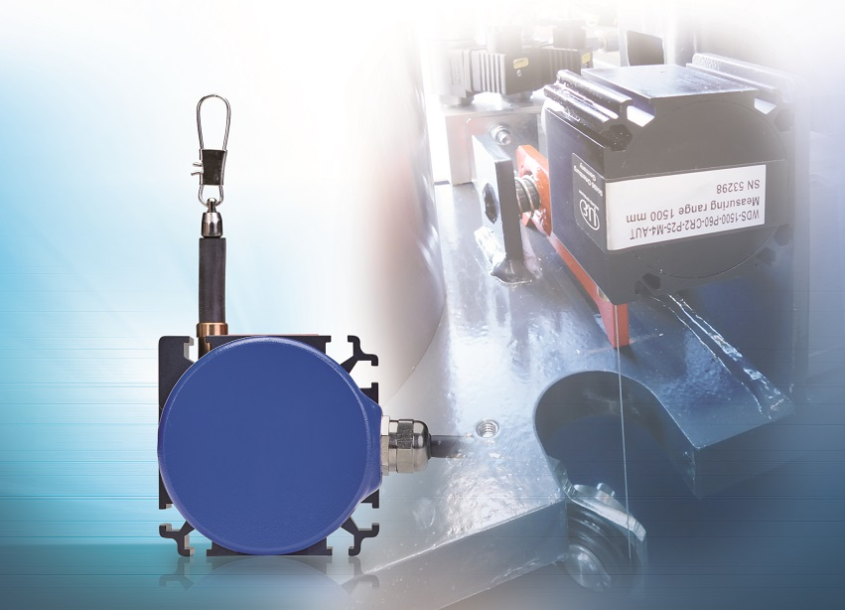
The wireSENSOR WDS-P60 draw wire sensor from Micro-Epsilon.

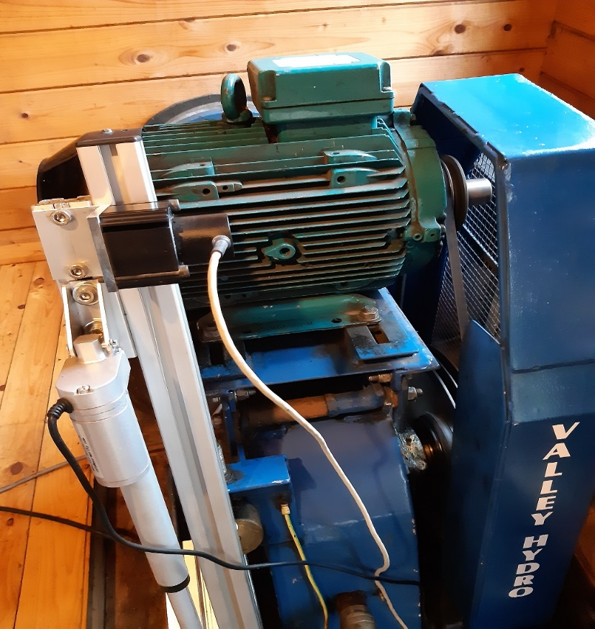
The water turbine (coloured blue) and its control system with linear actuator and draw wire sensor.

Note to Editors:

About Micro-Epsilon
Manufacturing processes throughout all industries are evolving at a rapid pace, and the quality and tolerances expected from the end user are forever increasing. Thus, the need for smarter measurement solutions is continuously growing. Micro-Epsilon (www.micro-epsilon.co.uk) is renowned globally for being at the forefront of measurement technology.
For more than 50 years, we have continuously offered reliable, high performance, unique solutions particularly when high precision measurement or inspection is required. Our product range covers sensors for the measurement of distance and displacement, sensors for IR temperature measurement and colour detection, as well as turnkey systems for dimensional measurement and defect detection.
We understand that our customers are our business partners and aim to develop long term relationships with them. We work closely with our customers to fully understand their requirements; our salespeople are engineers and understand more than just the sensor performance. We are problem solvers.
We operate a fair working policy, which results in excellent customer service and support even post sale.
Our high performance products and way of working provide our customers with a genuine competitive advantage.

To download high resolution images for this article, please go to www.silverbulletpr.co.uk/press . Alternatively, you can request an image by contacting:

Issued by: Dean Palmer
Director
SilverBullet PR Ltd
19, Glen Crescent, Stamford,
Lincolnshire PE9 1SW
Tel: 01780 754 254
Mobile: 07703 023771
Email: dean@silverbulletpr.co.uk

Reader Enquiries/Advertising:
Glenn Wedgbrow,
Business Development Manager,
Micro-Epsilon UK Ltd
1, Shorelines Building,
Shore Road
Birkenhead
Cheshire CH41 1AU
Tel: +44 (0) 151 355 6070
Email: glenn.wedgbrow@micro-epsilon.co.uk

