Ref. ME385 19th May 2021

Non-contact infrared temperature sensor offers ultra-high measuring speeds on metal and non-metal objects with a temperature of 0 to 500°C
Precision sensor manufacturer Micro-Epsilon has extended its thermoMETER CT series of non-contact infrared temperature sensors (pyrometers) with a new ultra-high speed version that offers a 300 µs response time (90 µs exposure time) on metal and non-metal objects with a temperature of 0 to 500°C.

High speed processes and low temperatures
In high speed processes with very short cycle times, requirements for pyrometers used for temperature measurements are extremely challenging. Previously, the combination of high speed, low temperature and short wavelength was never realised and there was always a compromise on at least one of the three. The new thermoMETER CTM-4SF10-C3 infrared temperature sensor (CTM-4) from Micro-Epsilon uses a new detector that measures within the spectral range of 2.2 to 6.0 µm and is therefore ideal for low temperature (0-500°C) measurements on metals, metal oxides, ceramics and plastics, as well as materials with an unknown or changing emissivity.

The CTM-4 is Micro-Epsilon’s fastest infrared pyrometer to date. While the previous models in the CT series operate in the millisecond range, the CTM-4 outputs a measured value every 300 µs and takes just 90 µs to acquire a stable measurement value. A spectral wavelength range of 2.2 to 6.0 µm supports the measurement of various objects including metals and non-metals (e.g. ceramics and plastics). For fast parameter set up, the CTM-4 provides an integrated USB interface.

With a sensor head diameter of just 14mm and a length of 28mm, the CTM-4 can be easily installed in restricted spaces on a machine or production line. The pyrometer can be used in ambient temperatures up to 70°C without cooling. The remote electronics unit (controller) is connected to the sensor head via a cable, which can be up to 15m in length. Important parameters can be entered directly via three keys and an illuminated display on the controller. An integrated USB interface enables the CTM-4 to be connected directly to a PC, where all settings can be fine-tuned using the CompactPlus Connect software. Data capture and recording are also possible using the software. Other serial interfaces or an Ethernet interface are also available as options. Two scalable analogue outputs and three programmable I/Os are available as standard for connecting the CTM-4 to the user’s own process environment.

Glenn Wedgbrow, Business Development Manager at Micro-Epsilon UK comments: “If speed matters in the customer’s production process, the thermoMETER CTM-4 is our fastest infrared temperature sensor yet. We see numerous temperature measurement applications for the pyrometer, including high speed, high volume production such as PET preform temperature monitoring, assembly and packaging processes that involve hot glue dispensing, high speed traffic and rail safety applications where hot box detection is required, as well as the more obvious processing of metals and metal oxides, ceramics, plastics and other materials with unknown or changing emissivity.”

For more information on the thermoMETER CTM-4SF10-C3, please visit
www.micro-epsilon.co.uk or call the Micro-Epsilon sales department on +44 (0)151 355 6070 or email info@micro-epsilon.co.uk
Link to page: https://www.micro-epsilon.co.uk/temperature-sensors/thermoMETER_CT_basic/

– ENDS – [493 words]

Photos and captions:

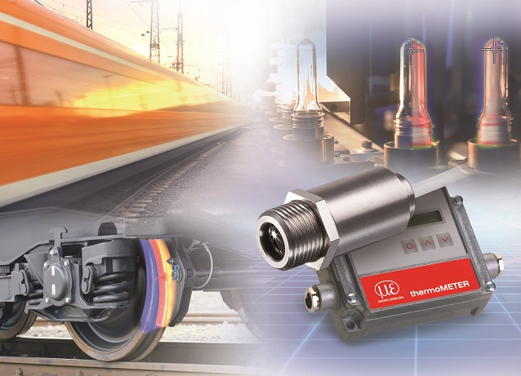
The new thermoMETER CTM-4SF10-C3 from Micro-Epsilon offers an ultra-high measuring speed. The sensor outputs a measured value every 300 µs.

Note to Editors:

About Micro-Epsilon
Manufacturing processes throughout all industries are evolving at a rapid pace, and the quality and tolerances expected from the end user are forever increasing. Thus, the need for smarter measurement solutions is continuously growing. Micro-Epsilon (www.micro-epsilon.co.uk) is renowned globally for being at the forefront of measurement technology.
For more than 50 years, we have continuously offered reliable, high performance, unique solutions particularly when high precision measurement or inspection is required. Our product range covers sensors for the measurement of distance and displacement, sensors for IR temperature measurement and colour detection, as well as turnkey systems for dimensional measurement and defect detection.
We understand that our customers are our business partners and aim to develop long term relationships with them. We work closely with our customers to fully understand their requirements; our salespeople are engineers and understand more than just the sensor performance. We are problem solvers.
We operate a fair working policy, which results in excellent customer service and support even post sale.
Our high performance products and way of working provide our customers with a genuine competitive advantage.

To download high resolution images for this article, please go to www.silverbulletpr.co.uk/press . Alternatively, you can request an image by contacting:

Issued by: Dean Palmer
Director
SilverBullet PR Ltd
19, Glen Crescent, Stamford,
Lincolnshire PE9 1SW
Tel: 01780 754 254
Mobile: 07703 023771
Email: dean@silverbulletpr.co.uk

Reader Enquiries/Advertising:
Glenn Wedgbrow,
Business Development Manager,
Micro-Epsilon UK Ltd
1, Shorelines Building,
Shore Road
Birkenhead
Cheshire CH41 1AU
Tel: +44 (0) 151 355 6070
Email: glenn.wedgbrow@micro-epsilon.co.uk

