Ref. ME386 16th June 2021

New short-wave thermal imaging camera is ideal for laser welding applications
Precision sensor manufacturer Micro-Epsilon has extended its thermoIMAGER TIM series of short-wave thermal imaging cameras with a new version that is suitable for almost all near infrared (NIR) and CO₂-based laser processing applications, including laser welding, cutting and 3D metal additive processing.

Operating on a narrow-band spectral wavelength of 780-820 nm, the thermoIMAGER TIM M-08 thermal imaging camera is specifically designed for non-contact temperature measurements on metal surfaces during laser processing. The camera uses a special filter that makes it ideal for use with NIR lasers such as neodymium-YAG lasers that operate outside of this range. This means the laser light does not pass through the filter, making the TIM-M08 particularly suitable for monitoring temperatures during laser welding and laser additive machining processes.

In addition to the well-known advantages of thermoIMAGER infrared cameras such as their compact size, robustness (protected to IP67), USB interface and TIMCONNECT licence-free software, the TIM M-08 is able to measure temperatures in a range from 575°C to 1,900°C without the need to swap or change settings. The lower starting temperature and special filter combined means that the TIM M-08 is perfect for capturing the heat dissipation through the metal as well as the weld temperature itself.

Glenn Wedgbrow, Business Development Manager at Micro-Epsilon UK comments: “The control of part temperature when laser welding within the additive manufacturing process is important for the strength and resilience of the build. The challenge for thermal imaging cameras has always been that the lasers operate in the same wavelengths as the camera needs for measuring the required temperature which can damage the camera detectors. The TIM M-08 avoids this problem by using a different spectral wavelength and does not require additional filters to operate.”

Short wavelength cameras for metal processing applications
Infrared thermal imaging cameras are normally grouped and differentiated according to their purpose or the material to be measured. For example, for the metal processing industry, Micro-Epsilon now offers three special short-wave thermal imagers: the TIM M-1, TIM M-05 and TIM M-08. These cameras cover many different metal temperature measurement tasks, from furnace melting through to secondary metal processing applications.

The thermoIMAGER TIM M-1 is a compact, robust (IP67) short wavelength infrared thermal imaging camera, which is specifically designed to measure the surface temperature of hot and glowing metal surfaces (as well as ceramics and graphite) in the range from 450°C to 1,800°C.

The thermoIMAGER TIM M-05 is a compact, robust (IP67) short wavelength infrared thermal imaging camera specifically designed to measure the temperature of molten metal or glowing metal surfaces in the range from 900°C to 2,450°C.

Licence-free analysis software
All thermoIMAGER cameras are set up using the TIMConnect software, which is available as a free download from the Micro-Epsilon website. TIMConnect includes a variety of process control and analysis features such as hot spot tracking, advanced peak hold for signal stability, as well as linescan modes for capturing up to 1,000 frames per second. Communication with the camera is made by USB connection. This licence-free software includes a full SDK and command library to allow custom software visualisations to be created.

A range of accessories are also available for the thermoIMAGER TIM range, including air purge collars, high temperature cables, protective windows and cooling housings, which enable the cameras to be operated in environments up to 315°C and can therefore be installed in a wide range of industrial metal processing environments.

For more information on the thermoIMAGER TIM short-wave cameras, please visit
www.micro-epsilon.co.uk or call the Micro-Epsilon sales department on +44 (0)151 355 6070 or email info@micro-epsilon.co.uk
– ENDS – [591 words]

Photos and captions:
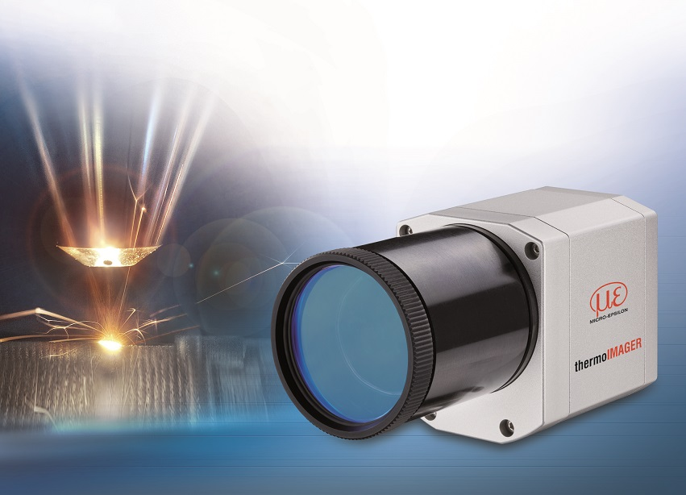
The new thermoIMAGER TIM M-08 from Micro-Epsilon is a shortwave thermal imager that is particularly well suited to laser welding applications.

Note to Editors:

About Micro-Epsilon
Manufacturing processes throughout all industries are evolving at a rapid pace, and the quality and tolerances expected from the end user are forever increasing. Thus, the need for smarter measurement solutions is continuously growing. Micro-Epsilon (www.micro-epsilon.co.uk) is renowned globally for being at the forefront of measurement technology.
For more than 50 years, we have continuously offered reliable, high performance, unique solutions particularly when high precision measurement or inspection is required. Our product range covers sensors for the measurement of distance and displacement, sensors for IR temperature measurement and colour detection, as well as turnkey systems for dimensional measurement and defect detection.
We understand that our customers are our business partners and aim to develop long term relationships with them. We work closely with our customers to fully understand their requirements; our salespeople are engineers and understand more than just the sensor performance. We are problem solvers.
We operate a fair working policy, which results in excellent customer service and support even post sale.
Our high performance products and way of working provide our customers with a genuine competitive advantage.

To download high resolution images for this article, please go to www.silverbulletpr.co.uk/press . Alternatively, you can request an image by contacting:

Issued by: Dean Palmer
Director
SilverBullet PR Ltd
19, Glen Crescent, Stamford,
Lincolnshire PE9 1SW
Tel: 01780 754 254
Mobile: 07703 023771
Email: dean@silverbulletpr.co.uk

Reader Enquiries/Advertising:
Glenn Wedgbrow,
Business Development Manager,
Micro-Epsilon UK Ltd
1, Shorelines Building,
Shore Road
Birkenhead
Cheshire CH41 1AU
Tel: +44 (0) 151 355 6070
Email: glenn.wedgbrow@micro-epsilon.co.uk

