Ref. ME389 3rd August 2021

New laser distance sensor with IO-Link simplifies integration and commissioning in industrial automation environments
Precision sensor supplier Micro-Epsilon has extended its optoNCDT ILR2250-100 range of non-contact laser distance sensors to include a version with IO-Link, a widely used industrial communications networking standard (IEC61131-9) for connecting digital sensors and actuators to industrial fieldbus or Ethernet networks.

The new optoNCDT ILR2250-100-IO laser distance sensor enables simple integration and commissioning in industrial automation environments, as well as faster sensor replacement with automated re-parameterisation during operation.

Developed in-house by Micro-Epsilon, the optoNCDT ILR2250-100-IO measures distances up to 150m with an accuracy of < ± 1mm. The sensor measures accurately even on difficult surfaces such as dark, structured or weakly reflecting objects. Without any special adaptations to the target, the sensor has an impressive range of up to 100m. Adding a reflector to the target extends the range to 150m. The sensor even operates well in smoke, steam and fog. In addition, due to its compact footprint and configurable software, the sensor can also be adapted to meet individual OEM requirements.

Protected by an IP65 die-cast aluminium housing, the optoNCDT ILR2250-100-IO is suitable for a variety of applications, from transport, logistics and conveyor systems, to automation, metal processing and production monitoring. The sensor can also be used to monitor large coil diameters, silo filling levels and gantry cranes.

In terms of its technical performance, the sensor provides excellent repeatability (<300µm), resolution (0.1mm) and linearity (< ± 1mm), resulting in extremely stable measurements and excellent signal stability. The sensor’s small footprint and weight allow it to be easily installed in narrow or restricted spaces in production lines and machines. The scope of supply also includes a 0.3m adapter cable that converts the M16 connector to a 5-pin M12 connector for linking to an IO-Link master. The 24V DC supply comes from the IO-Link network and so no additional power is required for the sensor.

For more information on the optoNCDT ILR2250-100-IO, please visit
www.micro-epsilon.co.uk or call the Micro-Epsilon sales department on +44 (0)151 355 6070 or email info@micro-epsilon.co.uk

– ENDS – [328 words]

Photos and captions:
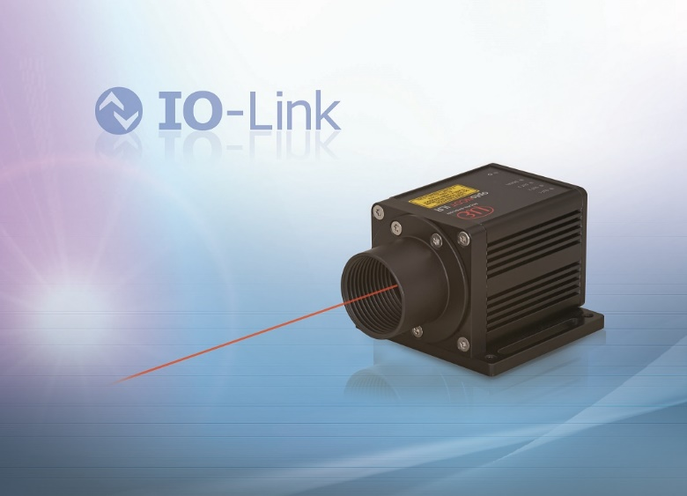
The new optoNCDT ILR2250-100-IO laser distance sensor simplifies integration and commissioning in industrial automation environments.

Note to Editors:

About Micro-Epsilon
Manufacturing processes throughout all industries are evolving at a rapid pace, and the quality and tolerances expected from the end user are forever increasing. Thus, the need for smarter measurement solutions is continuously growing. Micro-Epsilon (www.micro-epsilon.co.uk) is renowned globally for being at the forefront of measurement technology.
For more than 50 years, we have continuously offered reliable, high performance, unique solutions particularly when high precision measurement or inspection is required. Our product range covers sensors for the measurement of distance and displacement, sensors for IR temperature measurement and colour detection, as well as turnkey systems for dimensional measurement and defect detection.
We understand that our customers are our business partners and aim to develop long term relationships with them. We work closely with our customers to fully understand their requirements; our salespeople are engineers and understand more than just the sensor performance. We are problem solvers.
We operate a fair working policy, which results in excellent customer service and support even post sale.
Our high performance products and way of working provide our customers with a genuine competitive advantage.

To download high resolution images for this article, please go to www.silverbulletpr.co.uk/press . Alternatively, you can request an image by contacting:

Issued by: Dean Palmer
Director
SilverBullet PR Ltd
19, Glen Crescent, Stamford,
Lincolnshire PE9 1SW
Tel: 01780 754 254
Mobile: 07703 023771
Email: dean@silverbulletpr.co.uk

Reader Enquiries/Advertising:
Glenn Wedgbrow,
Business Development Manager,
Micro-Epsilon UK Ltd
1, Shorelines Building,
Shore Road
Birkenhead
Cheshire CH41 1AU
Tel: +44 (0) 151 355 6070
Email: glenn.wedgbrow@micro-epsilon.co.uk

