Ref. ME390 18th November 2021

High Pressure Water Descaling pilot facility in steel manufacturing makes use of Micro-Epsilon thermal imaging cameras
Tata Steel is using a thermoIMAGER TIM M-1 thermal imaging camera from Micro-Epsilon with a short 1µm wavelength, as well as a thermoIMAGER TIM 400T 1500 long wavelength thermal imaging camera, to measure surface temperature before and after descaling to assess descalability and heat loss based on nozzle pressure/flow and descaling speed.

High Pressure Water (HPW) descaling is the process of removing oxide scale by spraying the hot steel surface under a range of moderate-to-high pressure water using stationary (usually flat jet nozzles) or rotary (rotor descaler) systems. The aim is to ideally remove loose to sticky, primary to tertiary scale under optimum impingement and surface chilling, as well as power-water flow rate consumption, for improving the surface quality of rolled products and minimising work roll wear. Complex solid-fluid thermal-mechanical mechanisms are acting through the scale, scale interface and sub-surface of the steel substrate depending on the descaling process parameters of impact pressure, descaling energy and temperature.

The HPW descaling process is a harsh process where, in particular, measurement of temperature and surface state are difficult to achieve (in view of steam/water, oxide scale debris, confined descaling boxes). Measuring surface losses using IR technology can provide benefits to thermo-mechanical processing for difficult to roll steel grades that are prone, for example, to ductility cracking and/or surface defects, and leads to efficient descaling under robust and energy efficient regime maps.

To study and optimise the descaling process, Tata Steel together with the Steel Metal Institute in South Wales (SAMI) https://www.samiswansea.co.uk/ have revamped a HPW descaling rig to optimise the process. The unit can be used in two modes, static or dynamic, with hot or cold material, from steel to simulation material. Reheated samples are typically blocks of 70x70x100 mm thick placed on a carriage which transports the sample at a fixed speed (up to 4m/s). Following descaling, the carriage stops and the sample is transferred to an Argon-filled container to limit further oxidation.

All signals (height, pressure, flow, temperature, etc) are logged via a Windaq data acquisition system. A sophisticated post-analysis procedure has been put in place to characterise descaling efficiency.

Tata Steel is using a thermoIMAGER TIM M-1 thermal imaging camera from Micro-Epsilon with a short 1µm wavelength, as well as the thermoIMAGER TIM 400 T1500 long wavelength thermal imaging camera, to measure surface temperature before and after descaling. The cameras are mounted above the descaling trolley. By utilising both short and long wavelength detectors and the effect of emissivity on the scale at different wavelengths, Tata Steel can assess descalability and heat loss based on nozzle pressure/flow and descaling speed to develop regime maps for the production process.

The thermoIMAGER TIM M-1 camera was supplied with two exchangeable optics, f=25 and 75mm respectively, which allows flexibility in the field of view and camera location. The 1 µm short wavelength detector is most suited to harsh, steamy environments with reduced emissivity error at high temperatures. Included with the cameras is the powerful TIM Connect software, which allows the cameras to be used in a linescan mode or continuous acquisition from a fixed distance and location. The linescan function is particularly helpful when there is restricted viewing space and allows a complete image to be created of the slab as it passes.

As Didier Farrugia, Scientific Fellow, Rolling Finishing & Measurement Department at Tata Steel RD UK commented: “The thermal measurements made, together with surface state during and post-descaling, coupled with the use of a CCD optical camera post-descaling, has enabled the development of key HPW descaling knowledge for direct implementation and optimisation of plant practices.”

Any optimisation of yield, whether in terms of scale or metal loss during reheating, as well as enhancing surface state and defect minimisation, represents a critical cost-performance benefit for the steel industry, in the region of £1million for ~1% yield gain.

Didier Farrugia concludes: “The cameras have proven to be reliable and easy to use, including the possibility to synchronise the two cameras at two specific locations for full temperature traceability. The cameras are also being used in other specific parts of the steel manufacturing process.”

For more information on the thermoIMAGER TIM series of thermal imaging cameras, please visit www.micro-epsilon.co.uk or call the Micro-Epsilon sales department on +44 (0)151 355 6070 or email info@micro-epsilon.co.uk

– ENDS – [710 words]

Photos and captions:
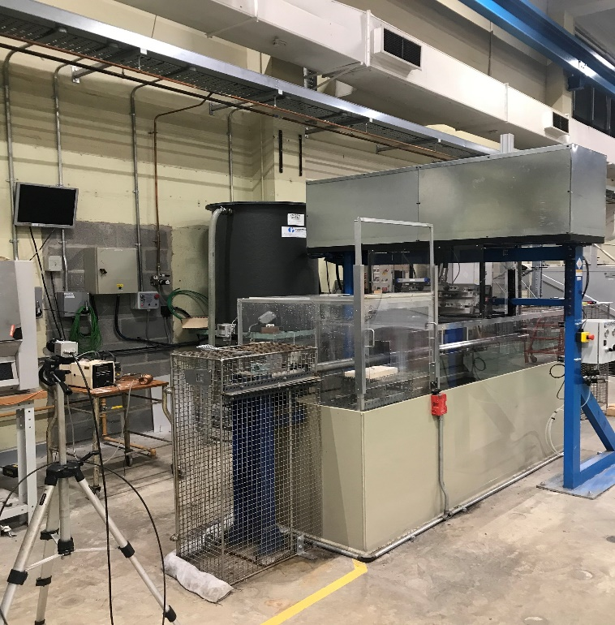
SAMI laboratory HPW descaling rig

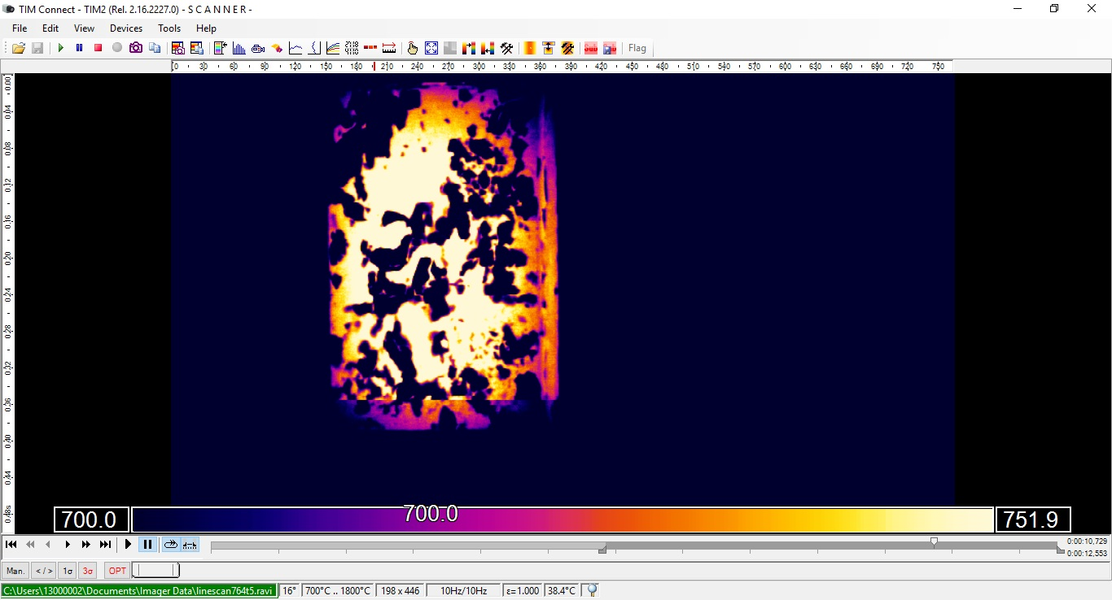
Micro-Epsilon linescan thermal images just after descaling jet/impact (TIM M-1).

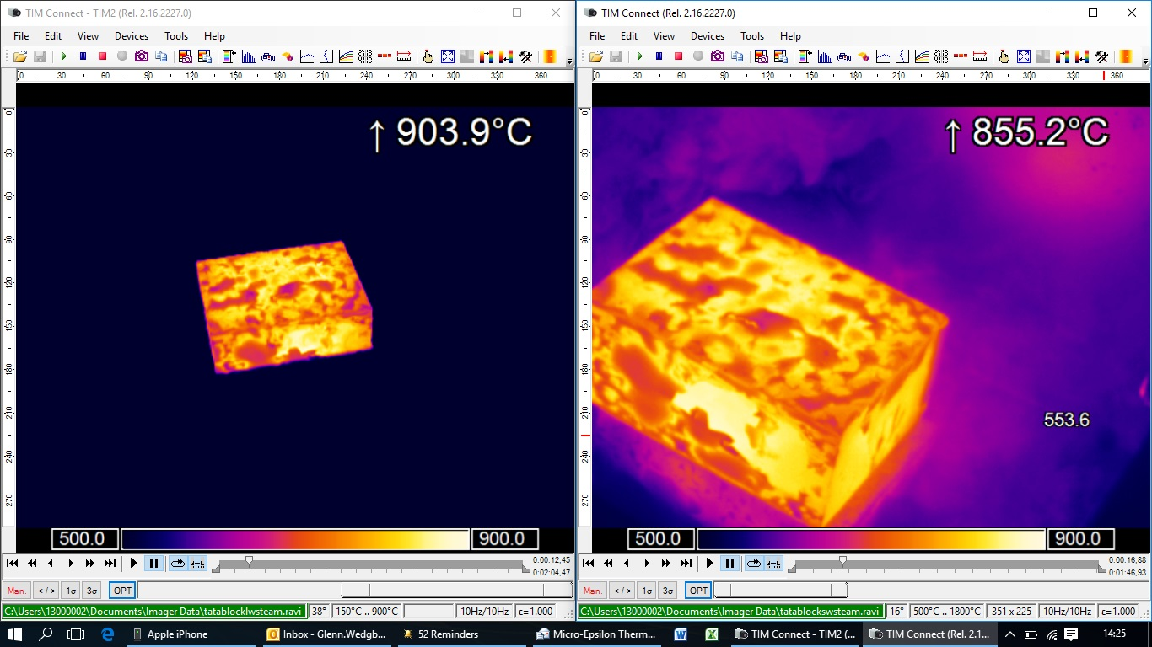
Micro-Epsilon standard thermal recording with TIM M-1 (right) pre-descaling showing reheat primary scale.

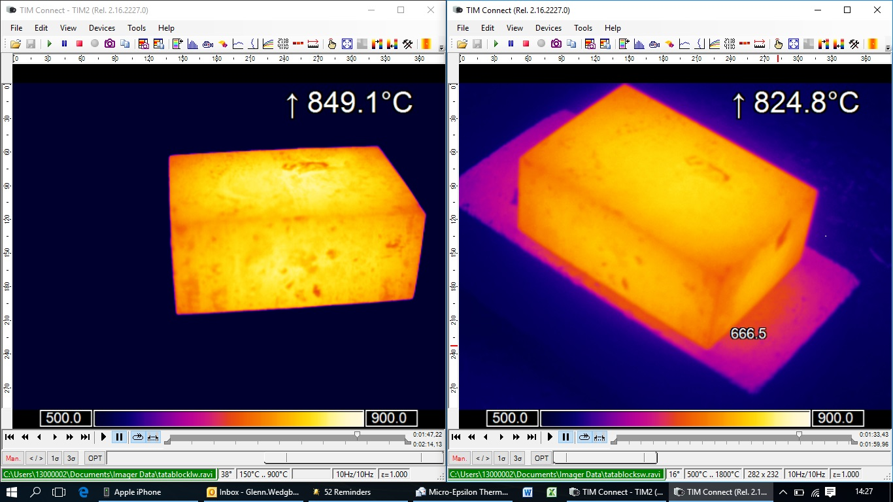
Micro-Epsilon standard thermal recording with TIM 400T (left) and TIM M-1 (right) post-descaling.

Note to Editors:

About Micro-Epsilon
Manufacturing processes throughout all industries are evolving at a rapid pace, and the quality and tolerances expected from the end user are forever increasing. Thus, the need for smarter measurement solutions is continuously growing. Micro-Epsilon (www.micro-epsilon.co.uk) is renowned globally for being at the forefront of measurement technology.
For more than 50 years, we have continuously offered reliable, high performance, unique solutions particularly when high precision measurement or inspection is required. Our product range covers sensors for the measurement of distance and displacement, sensors for IR temperature measurement and colour detection, as well as turnkey systems for dimensional measurement and defect detection.
We understand that our customers are our business partners and aim to develop long term relationships with them. We work closely with our customers to fully understand their requirements; our salespeople are engineers and understand more than just the sensor performance. We are problem solvers.
We operate a fair working policy, which results in excellent customer service and support even post sale.
Our high performance products and way of working provide our customers with a genuine competitive advantage.

To download high resolution images for this article, please go to www.silverbulletpr.co.uk/press . Alternatively, you can request an image by contacting:

Issued by: Dean Palmer
Director
SilverBullet PR Ltd
19, Glen Crescent, Stamford,
Lincolnshire PE9 1SW
Tel: 01780 754 254
Mobile: 07703 023771
Email: dean@silverbulletpr.co.uk

Reader Enquiries/Advertising:
Glenn Wedgbrow,
Business Development Manager,
Micro-Epsilon UK Ltd
1, Shorelines Building,
Shore Road
Birkenhead
Cheshire CH41 1AU
Tel: +44 (0) 151 355 6070
Email: glenn.wedgbrow@micro-epsilon.co.uk

