Ref. ME392 28th September 2021

New laser line triangulation sensor is designed for distance measurements on shiny metallic, rough and structured surfaces
Precision sensor manufacturer Micro-Epsilon continues to develop and expand its already comprehensive range of laser triangulation sensors with the introduction of the optoNCDT 1900 LL laser line sensor, as well as the addition of new larger measuring ranges for the optoNCDT 1900.

Ideally suited for both dynamic and high resolution measurement tasks, the optoNCDT 1900 LL is designed for distance measurements on shiny, metallic, rough and structured surfaces. A special cylindrical lens expands the conventional point of light into an oval-shaped light spot (small laser line). Optical averaging via the oval light spot compensates for any unevenness of the target surface. The oval-shaped light spot and intelligent software algorithms filter out disturbances caused by surface roughness, indentations or small holes on the surface. It also helps compensate for the laser penetrating into the surface. The laser line reveals its major strength in measurement tasks that involve a pure distance change in the z-axis. With movements in the x- or y-axis on the target, the measurement values are more stable than those from comparable point laser sensors.

More optoNCDT 1900 measuring ranges
The optoNCDT 1900 LL is available in measuring ranges of 2mm, 10mm and 25mm. Micro-Epsilon has also expanded its optoNCDT 1900 series of point laser sensors with new additional measuring ranges. The sensor is now available in seven versions with measuring ranges of 2mm, 10mm, 25mm, 50mm, 100mm, 200mm or 500mm.

With its unique combination of speed, size and performance, the optoNCDT 1900 is suitable for a wide range of measurement tasks in automation, machine building, robotics, automotive production, 3D printing and coordinate measuring machines. The sensor itself has dimensions of 70 x 31 x 45mm and weighs just 185g. The measuring rate is continuously adjustable up to 10kHz and can be individually adapted to suit each measurement task. Highly flexible cables and a robust IP67 protected aluminium die cast housing make the sensor ideal for industrial use. A compact sensor housing with innovative mounting sleeves ensures a repeatable sensor position and alignment to the target.

Standard features make the difference
The optoNCDT 1900 series uses the newly developed Advanced Surface Compensation (ASC) algorithm that allows it to operate almost regardless of the target material and colour. The exposure time or amount of light produced by the laser sensor is optimally matched to the reflection characteristics of the target surface, which enables reliable measurements of difficult, changing surfaces. The sensor is extremely resistant to ambient light interference and so can be used in high illumination environments including those situations where lasers are combined with Vision Systems and their associated LED lighting. The new software algorithms compensate for ambient light up to 50,000 lux, which means operation in direct sunlight is also improved.

Using the Micro-Epsilon web interface, the optoNCDT 1900 is easy to set up and use without requiring any installed operating software. The settings for the measurement task can be quickly selected using application-specific, predefined presets, which enable rapid, straightforward set up and help to optimise the sensor for specific tasks.

Data output is via analogue or digital RS422 interface. By using the Micro-Epsilon IF2030 interface module, EtherNet/IP and PROFINET are also available.

Glenn Wedgbrow, Business Development Manager at Micro-Epsilon UK comments: “The expansion of the optoNCDT 1900 series and the new 1900LL range of laser line triangulation sensors allows Micro-Epsilon to help customers solve almost every type of industrial distance, displacement and position measurement task. The combination of enhanced performance, compactness and wide range of new features result in a range of laser sensors that set new benchmarks for advanced automation tasks.”

For more information on the optoNCDT 1900 series of laser triangulation sensors, visit www.micro-epsilon.co.uk or call the Micro-Epsilon sales department on +44 (0)151 355 6070 or email info@micro-epsilon.co.uk
– ENDS – [623 words]

Photos and captions:
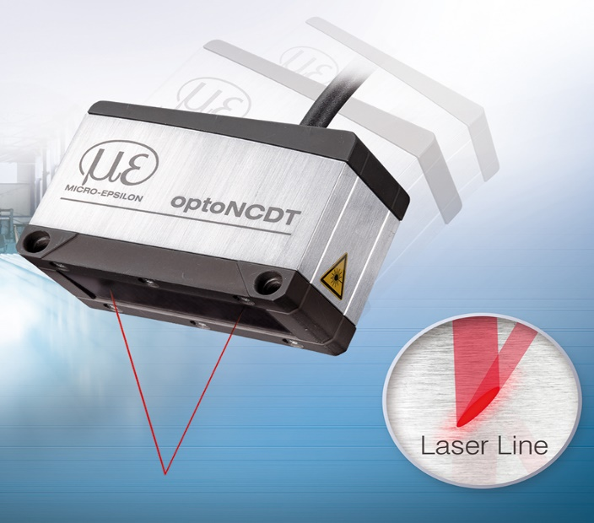
The new optoNCDT 1900 LL laser line sensor from Micro-Epsilon.

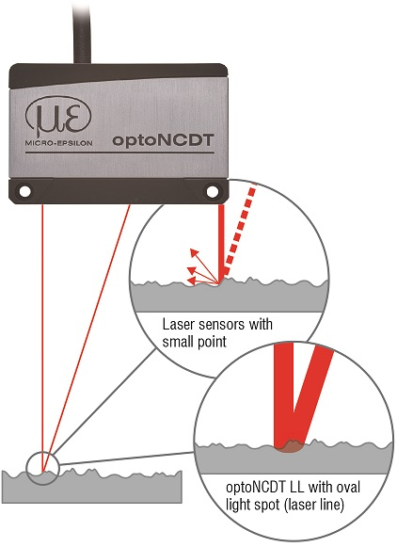
Optical averaging via the oval light spot compensates for any unevenness of the target surface.

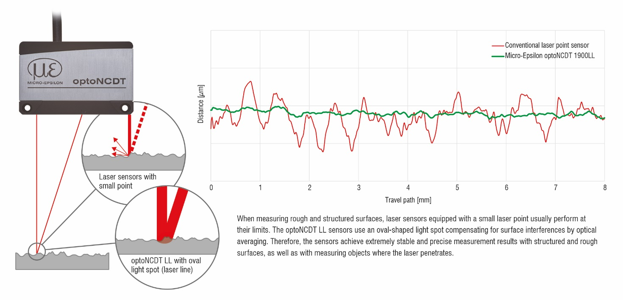

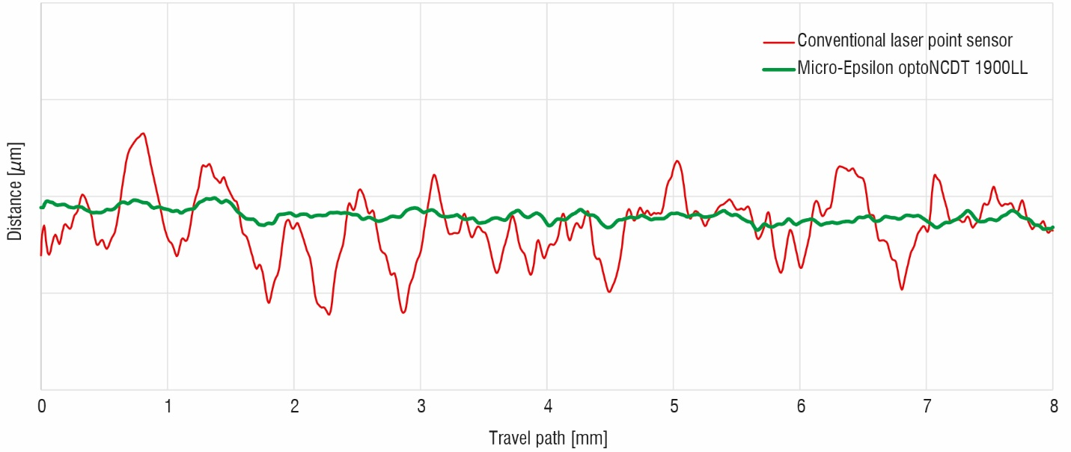

Note to Editors:

About Micro-Epsilon
Manufacturing processes throughout all industries are evolving at a rapid pace, and the quality and tolerances expected from the end user are forever increasing. Thus, the need for smarter measurement solutions is continuously growing. Micro-Epsilon (www.micro-epsilon.co.uk) is renowned globally for being at the forefront of measurement technology.
For more than 50 years, we have continuously offered reliable, high performance, unique solutions particularly when high precision measurement or inspection is required. Our product range covers sensors for the measurement of distance and displacement, sensors for IR temperature measurement and colour detection, as well as turnkey systems for dimensional measurement and defect detection.
We understand that our customers are our business partners and aim to develop long term relationships with them. We work closely with our customers to fully understand their requirements; our salespeople are engineers and understand more than just the sensor performance. We are problem solvers.
We operate a fair working policy, which results in excellent customer service and support even post sale.
Our high performance products and way of working provide our customers with a genuine competitive advantage.

To download high resolution images for this article, please go to www.silverbulletpr.co.uk/press . Alternatively, you can request an image by contacting:

Issued by: Dean Palmer
Director
SilverBullet PR Ltd
19, Glen Crescent, Stamford,
Lincolnshire PE9 1SW
Tel: 01780 754 254
Mobile: 07703 023771
Email: dean@silverbulletpr.co.uk

Reader Enquiries/Advertising:
Glenn Wedgbrow,
Business Development Manager,
Micro-Epsilon UK Ltd
1, Shorelines Building,
Shore Road
Birkenhead
Cheshire CH41 1AU
Tel: +44 (0) 151 355 6070
Email: glenn.wedgbrow@micro-epsilon.co.uk

