Ref. ME393 13th October 2021

2D/3D laser profile sensors now offer larger measuring fields
up to 290mm by 300mm
Precision sensor manufacturer Micro-Epsilon has extended its scanCONTROL 30xx range of laser profile sensors (laser scanners) with two larger measuring fields now available. In addition to the existing 25 mm and 50 mm models, there are now 100 mm and 200 mm versions available offering measuring fields of up to 170 mm x 131 mm and 300 mm x
290 mm respectively. The larger measuring fields open up greater opportunities for 2D/3D profile measurements in a wide variety of industrial applications including automation, robotics, machine building, quality control, production and process monitoring.

In addition, Micro-Epsilon has also introduced a new streamlined feature version of the scanCONTROL 3000 with the scanCONTROL 30x2 series. Based on the same next-generation platform and available also with the new larger measuring fields, the sensor has a compact housing with integrated controller, allowing fast integration into confined spaces. The scanCONTROL 30x2 sensor matrix offers a resolution of 1,024 points across the profile line and a maximum profile frequency of 5kHz providing calibrated profile data with up to 5.12 million points per second.

The scanCONTROL 30x2 model is targeted at OEM customers and system integrators, whilst the high end scanCONTROL 3000 continues to offer the highest accuracy and versatility.

The scanCONTROL 3000 and 30x2 models are available in COMPACT or SMART versions, with either red or blue laser technology. The COMPACT scanners provide calibrated profile data that can be further processed on a PC with software evaluation provided by the user. SMART scanners operate autonomously and provide selected measurement values where they can measure and evaluate profile width, height, depth, edges, beads, angles, steps, gaps and roundness.

Laser scanners for every measurement task
The wide selection of sensor models and measuring ranges now available in the scanCONTROL range of laser scanners enable engineers to solve every profile measurement task. Smart laser scanners with integrated data processing allow users to solve common measurement applications without the need for external data processing. For more complex applications, sensors with programmable software are available. With Micro-Epsilon’s Configuration Tools software, more than 40 measurement programs with a total of more than 90 evaluations are available. The programs are transferred to the SMART sensor, which performs the measurement, evaluation and output in standalone mode.

High volume OEM applications
The scanCONTROL range includes the scanCONTROL 25x0 series designed for high volume OEM industrial measurement applications. With its compact design, versatility and high signal stability, the sensors offer an excellent price-performance ratio and good all-round capabilities. Profile speed is up to 2000 Hz with three measuring ranges and is available with Blue or red laser technology, as well as a range of accessories that include protective housings, different cable lengths and interface adapters.

Finest details
The scanCONTROL 29x0 series is the only model available with a 10 mm wide profile line that offers point resolution down to 7µm. The controller is integrated in the sensor housing, simplifying cabling arrangements and mechanical integration. Due to its compact design and high profile resolution (up to 1,280 points in the x-axis) this series is well suited to static, dynamic and robotics applications that require the highest precision. Measurement speed is up to 2kHz and a Blue laser option is available.

Fast, high precision 2D/3D measurements
The scanCONTROL 30x0 series is among the highest performing profile sensors in terms of their size, accuracy and measuring rate. They provide calibrated 2D profile data with up to 7.37 million points per second. A profile frequency of up to 10kHz enables precise profile measurements in dynamic high speed processes. The high resolution sensor matrix offers a resolution of 2,048 points with an ultimate point distance of just 12µm, enabling extremely fine details to be detected reliably. The sensors are available with either blue or red laser diodes.

For more information on the scanCONTROL series of laser profile sensors, visit www.micro-epsilon.co.uk or call the Micro-Epsilon sales department on +44 (0)151 355 6070 or email info@micro-epsilon.co.uk

– ENDS – [652 words]

Photos and captions:
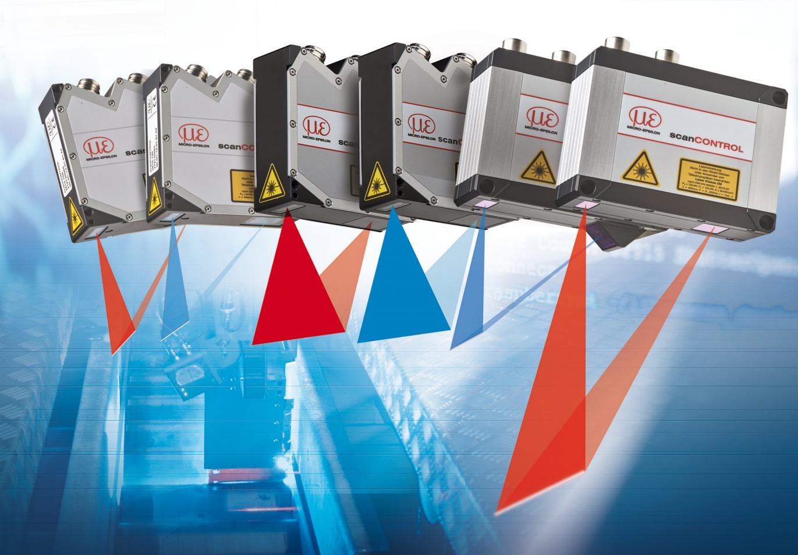
The scanCONTROL range of laser scanners now offer larger measuring fields up to 290mm by 300mm.

Note to Editors:

About Micro-Epsilon
Manufacturing processes throughout all industries are evolving at a rapid pace, and the quality and tolerances expected from the end user are forever increasing. Thus, the need for smarter measurement solutions is continuously growing. Micro-Epsilon (www.micro-epsilon.co.uk) is renowned globally for being at the forefront of measurement technology.
For more than 50 years, we have continuously offered reliable, high performance, unique solutions particularly when high precision measurement or inspection is required. Our product range covers sensors for the measurement of distance and displacement, sensors for IR temperature measurement and colour detection, as well as turnkey systems for dimensional measurement and defect detection.
We understand that our customers are our business partners and aim to develop long term relationships with them. We work closely with our customers to fully understand their requirements; our salespeople are engineers and understand more than just the sensor performance. We are problem solvers.
We operate a fair working policy, which results in excellent customer service and support even post sale.
Our high performance products and way of working provide our customers with a genuine competitive advantage.

To download high resolution images for this article, please go to www.silverbulletpr.co.uk/press . Alternatively, you can request an image by contacting:

Issued by: Dean Palmer
Director
SilverBullet PR Ltd
19, Glen Crescent, Stamford,
Lincolnshire PE9 1SW
Tel: 01780 754 254
Mobile: 07703 023771
Email: dean@silverbulletpr.co.uk

Reader Enquiries/Advertising:
Glenn Wedgbrow,
Business Development Manager,
Micro-Epsilon UK Ltd
1, Shorelines Building,
Shore Road
Birkenhead
Cheshire CH41 1AU
Tel: +44 (0) 151 355 6070
Email: glenn.wedgbrow@micro-epsilon.co.uk

