Ref. ME394 9th November 2021

New O-frame inline thickness measurement system for plastic strip, film and sheet materials with web widths up to 1,250mm
Precision sensor supplier Micro-Epsilon has extended its thicknessGAUGE range of inline thickness measurement systems with an O-frame version for precise thickness measurements of plastic strip, coatings, film and sheet materials, up to 3mm thick and for web widths up to a maximum of 1,250mm. The complete ‘out-of-the-box’ solution for thickness gauging and quality control comprises a compact, sturdy base frame, an integrated control cabinet and an aluminium measuring roller.

The thicknessGAUGE O.EC system from Micro-Epsilon offers precise measurement from ± 0.3 µm and fills the gap that currently exists in the market between basic thickness sensors and higher cost, dedicated inline thickness measurement systems. The thicknessGAUGE O.EC is suitable for integration in complete production lines, for example, in the production of plastics and battery film.

The fully assembled thicknessGAUGE O.EC system uses a combiSENSOR KSS6430 for thickness measurement, which enables sub-micron accuracy and high signal stability. The combiSENSOR combines a capacitive sensor with an inductive sensor based on eddy current technology. Both sensors measure from the same side in the direction of the aluminium roller. The capacitive sensor uses the dielectric constant of the non-conductive material to determine the distance to the topside of the target object, while the integrated eddy current sensor records the distance to the aluminium roller. The difference between the two signals provides the thickness of the material. Before measurement, calibration must be performed on a reference target of known thickness.

Depending on the application requirements the system can be operated in traversing mode, scanning back and forth continuously, or in fixed track mode where a specific point, often the centreline, is taken for gauge control. The system can also be set to edge mode for control of the material edge thickness. The entire system is powered via a 24V power source, which makes the installation and integration work as simple as possible.

Powerful analysis and control software
All thicknessGAUGE systems are supplied with a multi-touch panel industrial PC that is pre-installed with the thicknessCONTROL software package from Micro-Epsilon. This is the same software used in the high end measurement systems and provides convenient touch gesture control similar to that of modern smart phones. The measured process values can be displayed in multiple ways, including simple large values of thickness, cross profiles and length trends or combinations of each. The different measurement modes such as fixed track thickness measurement at any position, traversing measurement of the thickness cross profile, and 3 or 5 track measurement of longitudinal thickness trends can be selected. Full SPC data of the measurements is available and an automated verification of the system’s capability can be completed by the customer themselves.

Other features for documentation and process control include an article database, production archive, statistical evaluations, as well as limit value monitoring with ‘return back to production’ using (optional) digital fieldbus interfaces.

Glenn Wedgbrow, Business Development Manager at Micro-Epsilon comments: “Our thicknessGAUGE range now includes both C-frame and O-frame configurations, with a variety of sensor technologies available to suit the exact requirements of the application. The O-frame design enables customers to measure increased web widths, up to three times wider than our C-frame version. All thicknessGAUGE systems are suitable for OEM series integration [plant manufacturers] but can also be retrofitted by the end customer to existing plants.”
For more information on the thicknessGAUGE O.EC measurement system, please call the Micro-Epsilon sales department on +44 (0)151 355 6070 or email info@micro-epsilon.co.uk

– ENDS – [570 words]

Photos and captions:

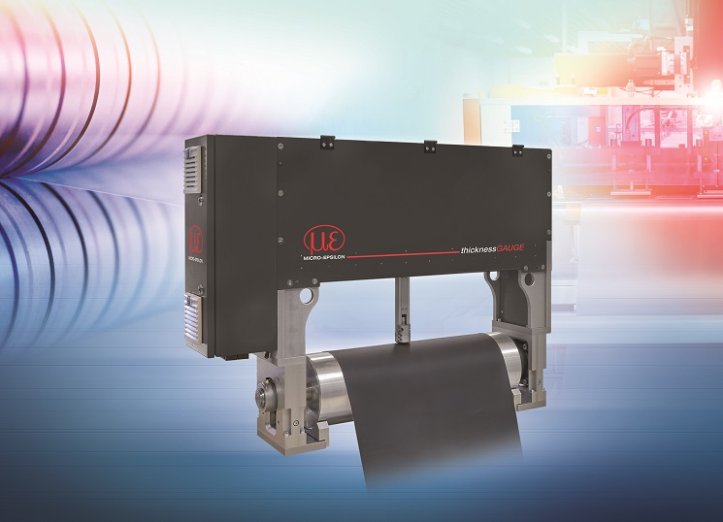
thicknessGAUGE O.EC is a complete, compact, inline thickness measurement system for plastic film, strip, coatings and sheet materials up to 3mm thick and for web widths up to 1,250mm.

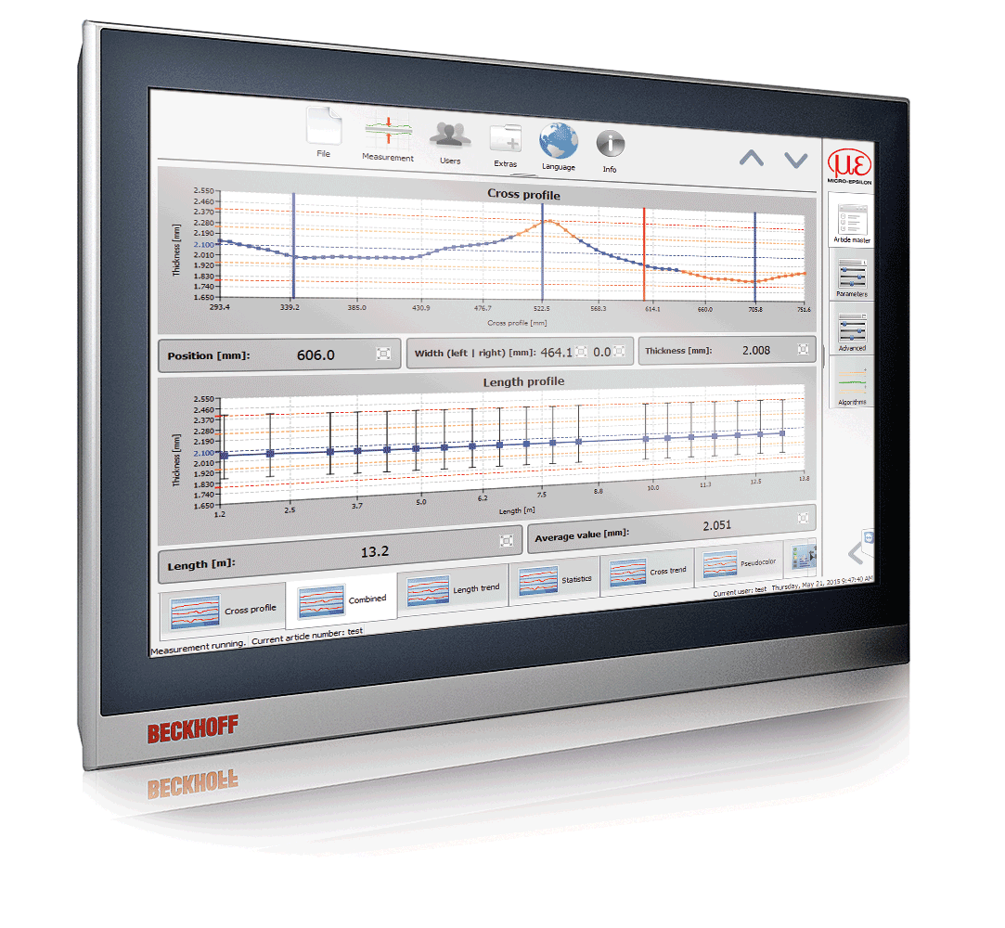
All thicknessGAUGE systems are supplied with a multi-touch panel industrial PC that is pre-installed with the thicknessCONTROL software package from Micro-Epsilon

Note to Editors:

About Micro-Epsilon
Manufacturing processes throughout all industries are evolving at a rapid pace, and the quality and tolerances expected from the end user are forever increasing. Thus, the need for smarter measurement solutions is continuously growing. Micro-Epsilon (www.micro-epsilon.co.uk) is renowned globally for being at the forefront of measurement technology.
For more than 50 years, we have continuously offered reliable, high performance, unique solutions particularly when high precision measurement or inspection is required. Our product range covers sensors for the measurement of distance and displacement, sensors for IR temperature measurement and colour detection, as well as turnkey systems for dimensional measurement and defect detection.
We understand that our customers are our business partners and aim to develop long term relationships with them. We work closely with our customers to fully understand their requirements; our salespeople are engineers and understand more than just the sensor performance. We are problem solvers.
We operate a fair working policy, which results in excellent customer service and support even post sale.
Our high performance products and way of working provide our customers with a genuine competitive advantage.

To download high resolution images for this article, please go to www.silverbulletpr.co.uk/press . Alternatively, you can request an image by contacting:

Issued by: Dean Palmer
Director
SilverBullet PR Ltd
19, Glen Crescent, Stamford,
Lincolnshire PE9 1SW
Tel: 01780 754 254
Mobile: 07703 023771
Email: dean@silverbulletpr.co.uk

Reader Enquiries/Advertising:
Glenn Wedgbrow,
Business Development Manager,
Micro-Epsilon UK Ltd
1, Shorelines Building,
Shore Road
Birkenhead
Cheshire CH41 1AU
Tel: +44 (0) 151 355 6070
Email: glenn.wedgbrow@micro-epsilon.co.uk

