Ref. ME396 2nd December 2021

Micro-Epsilon extends its range of 3D snapshot sensors with an even more affordable high performance version
Precision sensor manufacturer Micro-Epsilon has extended its surfaceCONTROL range of high precision 3D snapshot measurement sensors for automated, inline measurement of geometry, shape and surface quality of objects. The surfaceCONTROL 3D 3200 is a more affordable version of the surfaceCONTROL 3D 3500, but still offers many similar technical performance benefits, including extremely high resolution and repeatability, as well as a large measuring area.

The surfaceCONTROL 3D 3200 is a 3D snapshot sensor with a compact design and extremely high resolution in the Z-axis (from 1.5 µm). With a repeatability up to 0.6µm, the sensor sets a new benchmark in high precision 3D measurement technology. A high data processing speed of up to 2.2 million 3D points per second enables the sensor to increase productivity in the respective application.

With such an attractive price-performance ratio, the surfaceCONTROL 3200 is suitable for an even wider range of applications, including: surface defect detection; flatness inspection of circuit boards; planarity inspection of unpopulated PCB substrates; completeness check of electronic components on fitted PCBs; 3D measurement of high precision mechanical parts; width, tilt angle and position measurement of rivets; detection and evaluation of breaks on clutch discs; 3D text recognition of embossments that cannot be solved using 2D image processing due to lack of contrast; inspection of height and thickness of adhesive beading on smartphone shells; and determination of shape deviation defects on injection moulded parts.

The surfaceCONTROL 3D 3200 is available in two models, each offering a different measuring area and depth of field. Both models are fully integrated industrial sensors that are protected to IP67 with passive cooling (active cooling is available for higher operating temperatures).

The complete surfaceCONTROL series of 3D snapshot sensors from Micro-Epsilon now includes three product ranges: surfaceCONTROL 3D 3500, surfaceCONTROL 3D 3200 and the re-developed surfaceCONTROL 3D 2500.

surfaceCONTROL 3D 2500 is designed for the inspection of diffuse surfaces on larger targets and has measuring fields up to 575 x 435 x 300mm³, with lateral resolution from 0.25mm. The new control unit provides compatibility with the latest GigE Vision and GenICam standards and is also fully compatible with Micro-Epsilon’s 3D Inspect software tool. The system measures against non-reflective surfaces such as matt, plastic, unpainted and bare metal, making it suitable for automotive press shop and body-in-white inspection. However, other industries where high quality surface finish and consistency are important such as aerospace manufacturing will also benefit from the system. Application examples include the inspection of injection moulded components such as car fenders, fuel filler caps and sliding roofs, as well as composite parts such as tailgates and spoilers, inspection of dashboards and homogeneity of furniture fronts.

All surfaceCONTROL 3D systems support the very latest GigE Vision and GenICam standards for easy integration into third-party image processing software. A comprehensive software development kit (SDK) is also provided that allows customers to develop their own analysis software. Also included in the scope of supply is Micro-Epsilon’s 3D View software, which offers a convenient user interface for surfaceCONTROL sensors. The software allows fast commissioning, evaluation of the sensor, set up and optimisation of parameters, and ensures the correct positioning of the measuring object.

For more information on the surfaceCONTROL series, please visit
www.micro-epsilon.co.uk or call the Micro-Epsilon sales department on +44 (0)151 355 6070 or email info@micro-epsilon.co.uk

– ENDS – [546 words]

Photos and captions:

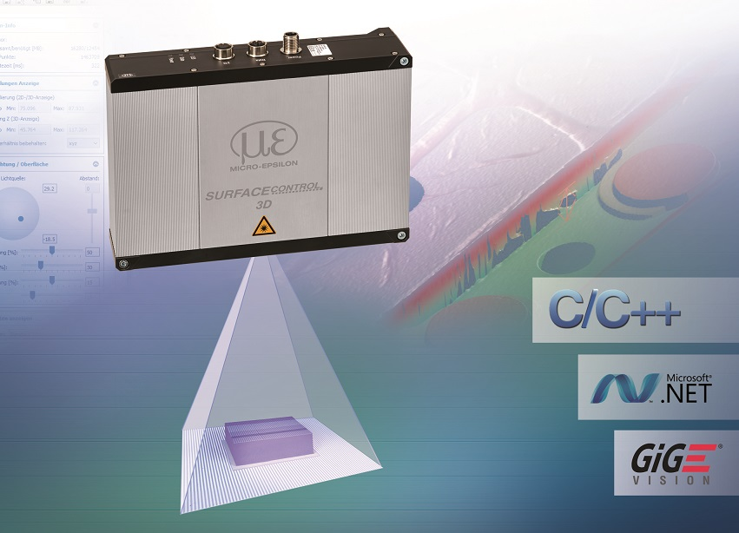
The surfaceCONTROL 3D 3200 from Micro-Epsilon measures up to 2.2 million 3D points per second.

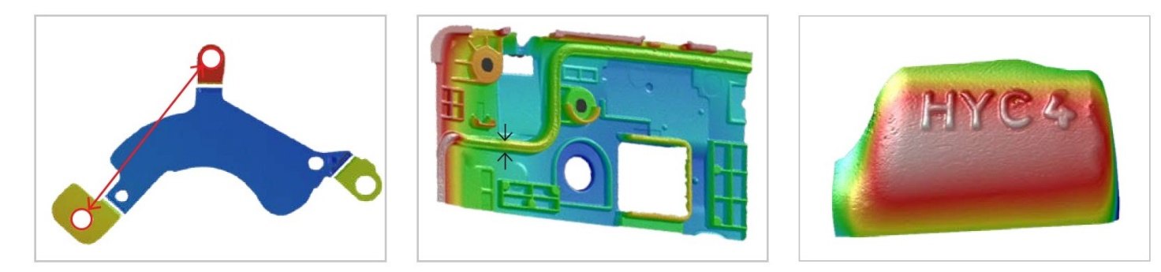
Application examples for the surfaceCONTROL 3D 3200 include 3D measurements of high precision mechanical parts, inspection of adhesive beads on smartphone shells, and 3D text recognition of embossments.

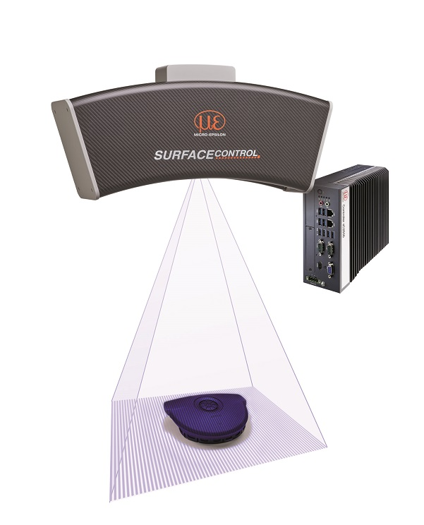
The re-developed surfaceCONTROL 3D 2500 is designed for the inspection of diffuse surfaces on larger targets.

Note to Editors:

About Micro-Epsilon
Manufacturing processes throughout all industries are evolving at a rapid pace, and the quality and tolerances expected from the end user are forever increasing. Thus, the need for smarter measurement solutions is continuously growing. Micro-Epsilon (www.micro-epsilon.co.uk) is renowned globally for being at the forefront of measurement technology.
For more than 50 years, we have continuously offered reliable, high performance, unique solutions particularly when high precision measurement or inspection is required. Our product range covers sensors for the measurement of distance and displacement, sensors for IR temperature measurement and colour detection, as well as turnkey systems for dimensional measurement and defect detection.
We understand that our customers are our business partners and aim to develop long term relationships with them. We work closely with our customers to fully understand their requirements; our salespeople are engineers and understand more than just the sensor performance. We are problem solvers.
We operate a fair working policy, which results in excellent customer service and support even post sale.
Our high performance products and way of working provide our customers with a genuine competitive advantage.

To download high resolution images for this article, please go to www.silverbulletpr.co.uk/press . Alternatively, you can request an image by contacting:

Issued by: Dean Palmer
Director
SilverBullet PR Ltd
19, Glen Crescent, Stamford,
Lincolnshire PE9 1SW
Tel: 01780 754 254
Mobile: 07703 023771
Email: dean@silverbulletpr.co.uk

Reader Enquiries/Advertising:
Glenn Wedgbrow,
Business Development Manager,
Micro-Epsilon UK Ltd
1, Shorelines Building,
Shore Road
Birkenhead
Cheshire CH41 1AU
Tel: +44 (0) 151 355 6070
Email: glenn.wedgbrow@micro-epsilon.co.uk

