Ref. ME397 24th November 2021

New high resolution thermal imaging camera with Ethernet interface includes autonomous operation without external PC
Precision sensor manufacturer Micro-Epsilon has introduced a thermal imaging camera with Ethernet interface and automatic hotspot finder function, enabling the camera to be operated autonomously without a PC for automatic monitoring of hot and cold spots in a wide range of applications.

The thermoIMAGER TIM41 is a compact, robust (IP67) thermal imaging camera that is particularly suitable for industrial OEM applications. The camera has an excellent optical resolution (384 x 240 pixels) and provides temperature measurements in the range -20°C to +900°C. With communication and data made available via the Ethernet interface and support for Power-over-Ethernet (PoE), direct cable lengths of up to 100m can be realised. IR video is transferred with a frame rate of up to 25Hz and can be viewed in the freely available TIMConnect software. Measured temperature values can also be output via the camera’s process interface (4-20mA). The camera can also be powered with 5-30 VDC if PoE is not available.

The camera can be operated without a PC using the ‘auto-hotspot-finder’ function, which enables automated detection of hot and cold spots within the camera’s field of view, even on moving objects. Simultaneous monitoring of up to three measuring fields is possible on a continuous basis in autonomous mode. Measurement values can be output to a PLC, for example, which in the event of limit values being exceeded, trigger subsequent actions such as alarms, opening of doors, cooling or switching. This means users can shutdown machines or processes preventively if overheating is detected. Fire monitoring in critical plant, machinery and electronics/electrical equipment are primary areas of use.

Setup is intuitive via the well-established TIMConnect configuration software, available as a free download from the Micro-Epsilon website. When connected with the software an almost unlimited number of inspection areas can be configured, along with IR video recording, snapshots and plots of temperature readings against time.

The TIM41 is available with a choice of 4 lens configurations depending on the distance and field of view required and incorporates a motorised focus for easy adjustments on targets via the software. A range of accessories are also available including air purge collars, protective windows and cooling housings, which enable the TIM41 device to be installed in a wide range of industrial environments.

For more information on the thermoIMAGER TIM41, please visit
www.micro-epsilon.co.uk or call the Micro-Epsilon sales department on +44 (0)151 355 6070 or email info@micro-epsilon.co.uk

– ENDS – [396 words]

Photos and captions:
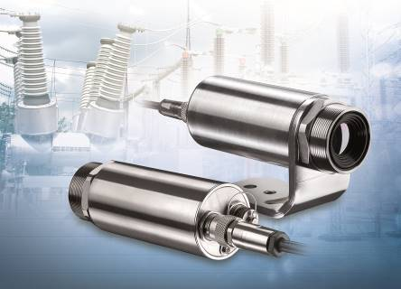
The thermoIMAGER TIM41 with Ethernet interface enables autonomous operation without a PC.

Note to Editors:

About Micro-Epsilon
Manufacturing processes throughout all industries are evolving at a rapid pace, and the quality and tolerances expected from the end user are forever increasing. Thus, the need for smarter measurement solutions is continuously growing. Micro-Epsilon (www.micro-epsilon.co.uk) is renowned globally for being at the forefront of measurement technology.
For more than 50 years, we have continuously offered reliable, high performance, unique solutions particularly when high precision measurement or inspection is required. Our product range covers sensors for the measurement of distance and displacement, sensors for IR temperature measurement and colour detection, as well as turnkey systems for dimensional measurement and defect detection.
We understand that our customers are our business partners and aim to develop long term relationships with them. We work closely with our customers to fully understand their requirements; our salespeople are engineers and understand more than just the sensor performance. We are problem solvers.
We operate a fair working policy, which results in excellent customer service and support even post sale.
Our high performance products and way of working provide our customers with a genuine competitive advantage.

To download high resolution images for this article, please go to www.silverbulletpr.co.uk/press . Alternatively, you can request an image by contacting:

Issued by: Dean Palmer
Director
SilverBullet PR Ltd
19, Glen Crescent, Stamford,
Lincolnshire PE9 1SW
Tel: 01780 754 254
Mobile: 07703 023771
Email: dean@silverbulletpr.co.uk

Reader Enquiries/Advertising:
Glenn Wedgbrow,
Business Development Manager,
Micro-Epsilon UK Ltd
1, Shorelines Building,
Shore Road
Birkenhead
Cheshire CH41 1AU
Tel: +44 (0) 151 355 6070
Email: glenn.wedgbrow@micro-epsilon.co.uk

