Ref. ME399 13th December 2021

New laser distance sensor with integrated heating and cooling element is
suitable for permanent outdoor use
Precision sensor supplier Micro-Epsilon has extended its popular optoNCDT ILR2250-100 range of non-contact laser distance sensors with an integrated heating and cooling version that is suitable for use in ambient temperatures from -40°C up to +65°C, enabling the sensor to be used in permanent outdoor distance measurement applications.

The optoNCDT ILR2250-100-H laser distance sensor is the ideal choice for outdoor measurements over long distances. The sensor not only measures distances up to 150m with an accuracy of < ± 1mm, but also measures accurately on difficult surfaces such as dark, structured or weakly reflecting objects. Without any special adaptations to the target, the sensor has an impressive range up to 100m. Adding a reflector to the target extends the range to 150m.

The optoNCDT ILR2250-100 range of laser distance sensors now comprises three models: the ILR2250-100, ILR2250-100-IO and the ILR2250-100-H.

The ILR2250-100 and ILR2250-100-IO have no integrated heating and cooling element and are suitable for use in ambient temperatures from -10°C to +50°C.

The ILR2250-100-IO is a version with IO-Link, a widely used industrial communications networking standard (IEC61131-9) for connecting digital sensors and actuators to industrial fieldbus or Ethernet networks. This enables simple integration and commissioning in industrial automation environments, as well as faster sensor replacement with automated re-parameterisation during operation.

All ILR2250-100 sensors are protected by an IP65 die cast aluminium housing and are suitable for a wide range of applications, both indoor and outdoor, from transport, logistics and conveyor systems, to automation, metal processing, production monitoring and unmanned drones or vehicles. The factory default AUTO measurement mode allows precise and reliable measurements to be made on targets over great distances. Additional modes are also available to tune the sensor to specific application requirements. The sensors have already found uses in monitoring large coil diameters, silo filling levels and gantry cranes. The combined long range and high accuracy of the sensors has also found particular benefits in the measurement and control of diameters for hot ring rolling.

In terms of technical performance, the ILR2250-100 is unsurpassed in its field, providing excellent repeatability (<300µm), resolution (0.1mm) and linearity (< ± 1mm), resulting in extremely stable measurements and excellent signal stability. The sensor’s small footprint (102 x 53 x 50mm) and weight (254g) represent a 65% reduction in size and weight compared to its predecessor, allowing it to be easily installed in narrow or restricted spaces in production lines and machines.

The optoNCDT ILR2250-100 can provide continuous measurement output via a 16-bit, scalable, 4-20mA analogue output or via RS422 serial communication. Three digital switch outputs are available for simple process monitoring and a trigger input provides opportunities to control when the sensor takes a reading.

For more information on the optoNCDT ILR2250-100-H, please visit
https://www.micro-epsilon.co.uk/sensors/optoNCDT-ILR2250-100/ or call the Micro-Epsilon sales department on +44 (0)151 355 6070 or email info@micro-epsilon.co.uk

– ENDS – [468 words]

Photos and captions:

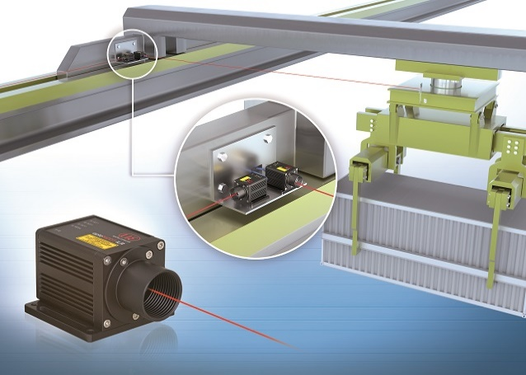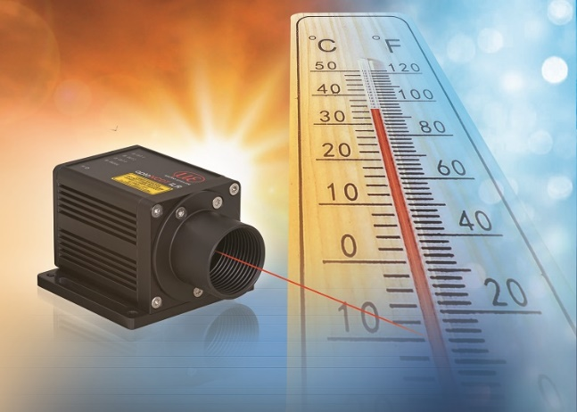
The new optoNCDT ILR2250-100-H laser distance sensor with integrated heating and cooling is suitable for permanent outdoor use.

Note to Editors:

About Micro-Epsilon
Manufacturing processes throughout all industries are evolving at a rapid pace, and the quality and tolerances expected from the end user are forever increasing. Thus, the need for smarter measurement solutions is continuously growing. Micro-Epsilon (www.micro-epsilon.co.uk) is renowned globally for being at the forefront of measurement technology.
For more than 50 years, we have continuously offered reliable, high performance, unique solutions particularly when high precision measurement or inspection is required. Our product range covers sensors for the measurement of distance and displacement, sensors for IR temperature measurement and colour detection, as well as turnkey systems for dimensional measurement and defect detection.
We understand that our customers are our business partners and aim to develop long term relationships with them. We work closely with our customers to fully understand their requirements; our salespeople are engineers and understand more than just the sensor performance. We are problem solvers.
We operate a fair working policy, which results in excellent customer service and support even post sale.
Our high performance products and way of working provide our customers with a genuine competitive advantage.

To download high resolution images for this article, please go to www.silverbulletpr.co.uk/press . Alternatively, you can request an image by contacting:

Issued by: Dean Palmer
Director
SilverBullet PR Ltd
19, Glen Crescent, Stamford,
Lincolnshire PE9 1SW
Tel: 01780 754 254
Mobile: 07703 023771
Email: dean@silverbulletpr.co.uk

Reader Enquiries/Advertising:
Glenn Wedgbrow,
Business Development Manager,
Micro-Epsilon UK Ltd
1, Shorelines Building,
Shore Road
Birkenhead
Cheshire CH41 1AU
Tel: +44 (0) 151 355 6070
Email: glenn.wedgbrow@micro-epsilon.co.uk

