Ref. ME400 18th January 2022

New multi-point colour detection system measures up to 28 LED test specimens simultaneously with high repeatability
Precision sensor supplier Micro-Epsilon has updated its popular colorCONTROL MFA series of LED Analyzers with the colorCONTROL MFA-7. The high precision, multi-point colour detection system is available in either 7, 14, 21 or 28 channel configurations to monitor up to 28 LED test objects simultaneously.

The continued drive for energy efficiency and sustainability has seen Light Emitting Diodes (LEDs) appear in everything from household lighting and electrical appliances, to computers, toys and all over the latest vehicles. However, the individual colour quality of an LED and its colour temperature are often determined by its ‘bin’. When combining multiple LEDs together, the difference in colour temperature can be quite apparent if LEDs are used from different ‘bins’ and so there is a need to inspect and check that the illumination and colour temperatures are equal.

The colorCONTROL MFA-7 series replaces the discontinued colorCONTROL MFA-5 series. Compared to the MFA-5, the MFA-7 offers 30 times higher data processing/sampling speeds (up to 100Hz), 10 times higher repeatability (xy < ±0.000025) and 10 times wider dynamic range (1 to 50,000 lux). The MFA series is available with 7, 14, 21 or 28 measurement channels, each with a uniform installation size.

The MFA-7 determines colour, intensity and function. Colour inspection takes place in the XYZ, xyY, Luv, uvL or RGB colour spaces. In addition, the colorCONTROL MFA-7 outputs the dominant wavelength (λdom) and the colour temperature (CCT).

Information is directly transmitted from the measured object to the MFA controller via individual MFS receiver sensors with fibre optic cables. These are interchangeable and can be universally coupled. The freely available sensorTOOL software from Micro-Epsilon is used for parameter set up of the LED Analyzer, as well as to read out and record the measured values for all measuring points synchronously. The integrated RS422 interface allows easy connectivity with other process control units. USB and RS232 interfaces are also provided.

Glenn Wedgbrow, Business Development Manager at Micro-Epsilon UK comments: “Potential applications for the MFA-7 series include any industrial sector where LED manufacturing or testing takes place, including LED testing of electronic assemblies. The system is suitable for the testing of self-luminous objects, LED bin tests, seven-segment display tests and front panel tests. The system can measure the colour and intensity of vehicle headlights, as well as the homogeneity of surface area lights and displays. The high sensitivity of the MFA-7 also makes it particularly well suited to precision light transmission testing of pushbuttons, switches and alarm buttons.”

For more information on the colorCONTROL MFA-7, please visit
https://www.micro-epsilon.co.uk or call the Micro-Epsilon sales department on +44 (0)151 355 6070 or email info@micro-epsilon.co.uk

– ENDS – [434 words]

Photos and captions:

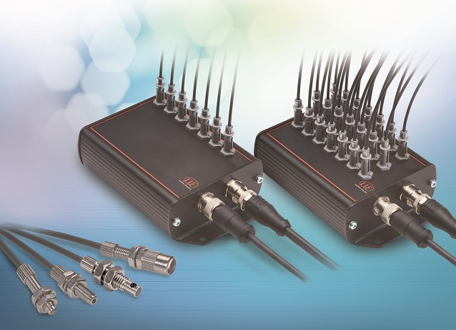
The new colorCONTROL MFA-7 can test multiple LEDs simultaneously.

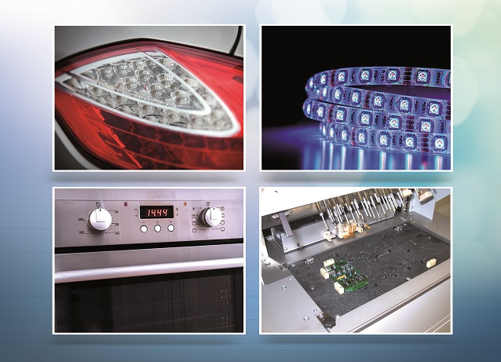
Applications include colour and intensity testing of vehicle headlights; brightness testing of LED line lights; LED backlights on kitchen appliances; and LED testing of electronic assemblies.

Note to Editors:

About Micro-Epsilon
Manufacturing processes throughout all industries are evolving at a rapid pace, and the quality and tolerances expected from the end user are forever increasing. Thus, the need for smarter measurement solutions is continuously growing. Micro-Epsilon (www.micro-epsilon.co.uk) is renowned globally for being at the forefront of measurement technology.
For more than 50 years, we have continuously offered reliable, high performance, unique solutions particularly when high precision measurement or inspection is required. Our product range covers sensors for the measurement of distance and displacement, sensors for IR temperature measurement and colour detection, as well as turnkey systems for dimensional measurement and defect detection.
We understand that our customers are our business partners and aim to develop long term relationships with them. We work closely with our customers to fully understand their requirements; our salespeople are engineers and understand more than just the sensor performance. We are problem solvers.
We operate a fair working policy, which results in excellent customer service and support even post sale.
Our high performance products and way of working provide our customers with a genuine competitive advantage.

To download high resolution images for this article, please go to www.silverbulletpr.co.uk/press . Alternatively, you can request an image by contacting:

Issued by: Dean Palmer
Director
SilverBullet PR Ltd
19, Glen Crescent, Stamford,
Lincolnshire PE9 1SW
Tel: 01780 754 254
Mobile: 07703 023771
Email: dean@silverbulletpr.co.uk

Reader Enquiries/Advertising:
Glenn Wedgbrow,
Business Development Manager,
Micro-Epsilon UK Ltd
1, Shorelines Building,
Shore Road
Birkenhead
Cheshire CH41 1AU
Tel: +44 (0) 151 355 6070
Email: glenn.wedgbrow@micro-epsilon.co.uk

