Ref. ME401 27th January 2022

A comparison of blue and red light sensor technology: which one is

best for your application?
Glenn Wedgbrow, Business Development Manager at Micro-Epsilon UK, highlights the benefits and limitations of red and blue laser light sensor technologies, as well as those applications where blue lasers are a better choice over traditional red lasers.

Requirements for precision techniques in manufacturing operations have bolstered the use of laser triangulation sensors on production lines, where they are used for industrial displacement measurement. From its development more than two decades ago, the default measurement technology has used a red laser light source. Red light lasers are as familiar in grocery store checkout stations as they are on the production line. But effective as red lasers are, they can come up short in some applications. To overcome these challenges, Micro-Epsilon developed and patented sensors based on blue laser technology.

Basics of linear displacement measurement
In practical terms, linear displacement measurement refers to the movement of an object in one direction along a single axis. In an industrial setting, this could be a discrete piece of material travelling along a belt or roller. As the material passes the measuring device, an output signal from the linear displacement sensor takes measurements in units of millimetres or inches, or even in micrometers.

Laser triangulation sensors pinpoint a narrow beam of laser light onto an object or sample, and light reflected from the object’s surface is focused by a high-quality optical lens onto a charge-coupled device (CCD) or complementary metal-oxide semiconductor (CMOS) image sensor. As the object moves, the reflected light also changes position on the image sensor, which is computed to detect the position of the object or sample. The triangulation principle involves the measurement of distance on a wide range of material surfaces. To measure displacement, distance and position, laser point triangulation sensors are used. To measure profile and gap, laser line triangulation sensors or ‘laser scanners’ are used.

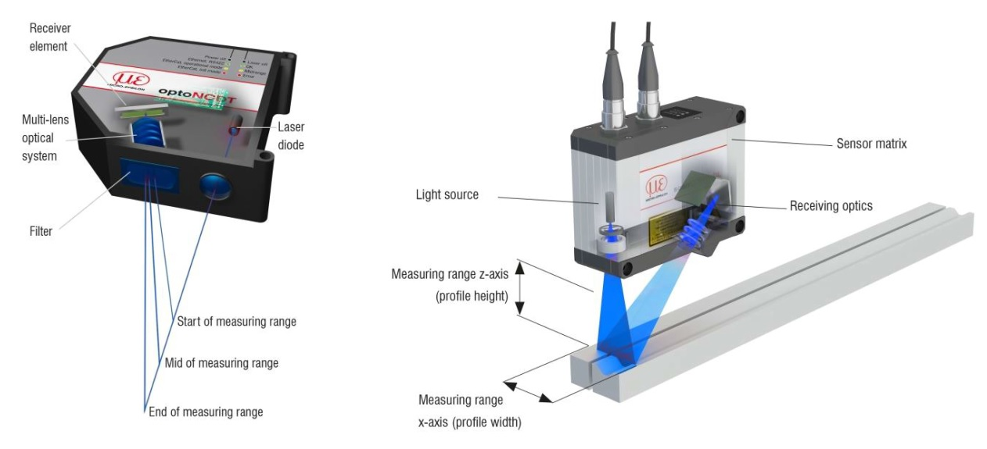
Principles of laser point triangulation (left) and laser line triangulation sensors (right)

Red vs. blue: when to use which
Laser triangulation technology works best in automated position sensing, as well as for passive and dynamic dimensional measurements. Most often, the laser used in this application is red in colour, and this type of laser suits the vast majority of industrial applications. In addition, because of the red laser’s ubiquity and lengthy development history, a wide variety of cost effective red laser measurement and sensing systems are available.

Red lasers perform best when reflected from matt or low reflectivity surfaces, or what are called “non-specular” surfaces. Specular surfaces are typically glossy, polished or highly reflective. Such materials introduce distortion to the red reflected light, adding ‘noise’ to the image detector readings and decreasing measurement accuracy.

Red laser light is also preferable for fast moving objects, due to its long wavelength and intensity. Red lasers typically operate at 670 nm, close to the infrared spectrum and are perfect for use with CCD sensors. The high intensity of the red laser can also be a disadvantage, as it is more likely to penetrate and be diffused on the target material, especially on organic and transparent materials, further decreasing measurement accuracy.

The same is also true for metal forging. It was formerly a challenge to use red laser measuring techniques in the steel industry, where red-hot glowing metals, typically above 700°C, emit sufficient infrared light to skew the image sensor readings.

To solve these challenges, blue light laser triangulation technology was developed. Blue lasers operate at approximately 405 nm of the visible light spectrum, a shorter wavelength with lower intensity than red, and close to the ultraviolet spectrum. This creates a more focused laser point with less surface diffusion, resulting in less noise in the sensor, thereby increasing measurement accuracy, sometimes by a scale of two or three times when compared to red lasers.

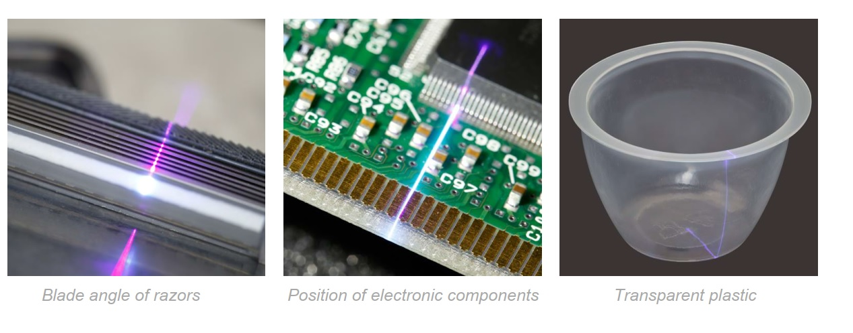

Blue laser technology is more than just a light colour change. It also requires a different lens that is optimised for short wavelength radiation, different optical filters for the reflected light, a different light sensor and innovative analysis algorithms.

Blue light laser triangulation technology has proved so valuable that the applications for it have expanded over time. It is especially prevalent in automotive testing, for example in engine manifolds or brake discs. It has also been used in paper production because a red light laser shines through damp paper pulp and does not return usable measurements.

Blue light is preferable to red light laser triangulation for measuring transparent or translucent materials, reflective or specular surfaces, and organic materials, including wood and food.

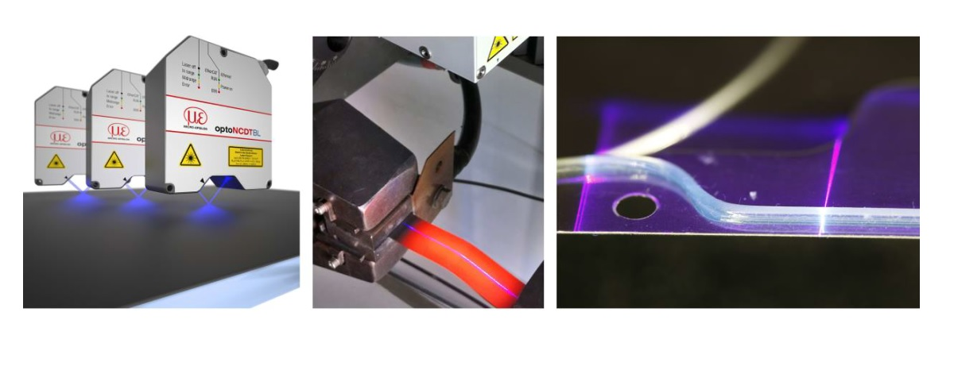
Distance measurement on anti-reflective coated glass, profile measurement on red glowing metal and profile measurement of glue beads using blue laser sensors from Micro-Epsilon.

Patented technology
Blue laser measurements on red-hot objects, as well as transparent objects such as glass or plastic, is a proprietary and patented technology from Micro-Epsilon. Micro-Epsilon plays a leading role in measurement technology. For more than 50 years, the company has offered reliable, high performance, unique solutions whenever high precision measurement or inspection is required. Its product range covers sensors to measure distance and displacement, sensors for infrared temperature measurement and colour detection, as well as systems for dimensional measurement and defect detection.

For more information, please call the Micro-Epsilon sales department on +44 (0)151 355 6070 or email info@micro-epsilon.co.uk

– ENDS – [876 words]

Note to Editors:

About Micro-Epsilon
Manufacturing processes throughout all industries are evolving at a rapid pace, and the quality and tolerances expected from the end user are forever increasing. Thus, the need for smarter measurement solutions is continuously growing. Micro-Epsilon (www.micro-epsilon.co.uk) is renowned globally for being at the forefront of measurement technology.
For more than 50 years, we have continuously offered reliable, high performance, unique solutions particularly when high precision measurement or inspection is required. Our product range covers sensors for the measurement of distance and displacement, sensors for IR temperature measurement and colour detection, as well as turnkey systems for dimensional measurement and defect detection.
We understand that our customers are our business partners and aim to develop long term relationships with them. We work closely with our customers to fully understand their requirements; our salespeople are engineers and understand more than just the sensor performance. We are problem solvers.
We operate a fair working policy, which results in excellent customer service and support even post sale.
Our high performance products and way of working provide our customers with a genuine competitive advantage.

To download high resolution images for this article, please go to www.silverbulletpr.co.uk/press . Alternatively, you can request an image by contacting:

Issued by: Dean Palmer
Director
SilverBullet PR Ltd
19, Glen Crescent, Stamford,
Lincolnshire PE9 1SW
Tel: 01780 754 254
Mobile: 07703 023771
Email: dean@silverbulletpr.co.uk

Reader Enquiries/Advertising:
Glenn Wedgbrow,
Business Development Manager,
Micro-Epsilon UK Ltd
1, Shorelines Building,
Shore Road
Birkenhead
Cheshire CH41 1AU
Tel: +44 (0) 151 355 6070
Email: glenn.wedgbrow@micro-epsilon.co.uk

