Ref. ME402 21st February 2022

mainSENSOR: a new twist on sensor technology
Magneto-inductive displacement sensors combine the best attributes of inductive and magnetic sensors but without their drawbacks, says Glenn Wedgbrow, Business Development Manager at Micro-Epsilon UK.

Sensors that detect motion, position, rotation and the presence of objects are essential in hundreds of applications, from aircraft and elevators, to garage doors and vehicles, as well as equipment used in production lines. However, as they are small, unassuming and their actions are taken for granted, they tend to blend into the background, unseen but essential. Two sensor types, inductive and magnetic, represent a significant proportion of these devices, but a hybrid type known as a magneto-inductive sensor is rapidly gaining popularity. It combines the advantages of inductive and magnetic sensors while providing benefits that neither alone can achieve. To see why this is so, it is necessary to understand how all three sensor types work.
An inductive sensor essentially functions either as a switch or a linear sensor. A voltage is applied to a coil that creates an electromagnetic field in front of the sensor, and if a conductive metal “target” enters this field, eddy currents induced by this field are created, reducing the field’s strength as it approaches. When they decline to a pre-defined threshold, the sensor outputs a linear signal or triggers the switch. Inductive sensors are simple, reliable and rugged but they can detect only metal objects, and although relatively insensitive to low-frequency magnetic fields, even a very small amount of metal between the target and sensing element can reduce their effectiveness.

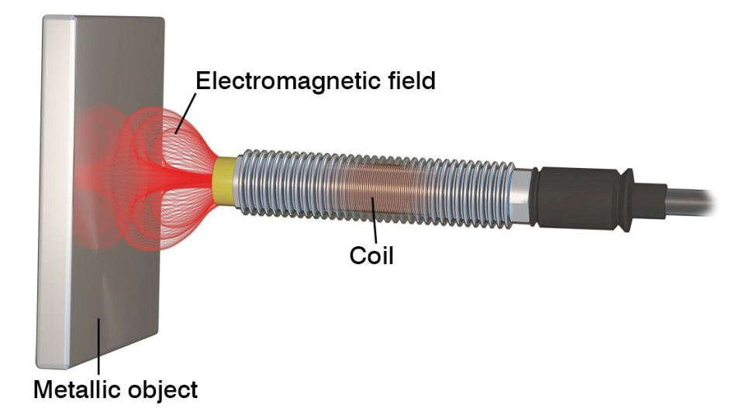
A voltage applied to a coil in an inductive sensor creates an electromagnetic field.

There are several technologies employed to create magnetic sensors, many of which rely on the Hall effect, where the output voltage of a transducer changes in response to variations in a magnetic field. When current flows into a material, electrons move through it in a nearly straight line, but if a force acts on them, they will deviate from this path. The amount of deviation is directly proportional to the amount of current and the strength of the magnetic field.

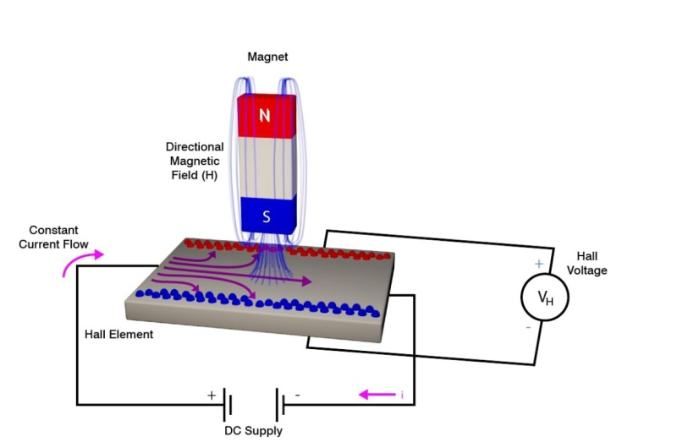
A transducer in a magnetic sensor responds to variations in a magnetic field.

The mainSENSOR
The magneto-inductive mainSENSOR developed by Micro-Epsilon combines aspects of inductive and magnetic sensors but uses proprietary techniques that build on their inherent strengths, minimises their disadvantages and provides advantages over both. A comparison of all three techniques is shown in the table below. Like an inductive sensor, when an alternating current is supplied to a sensor coil, a magnetic field induces eddy currents in the conductive target placed in front of it.

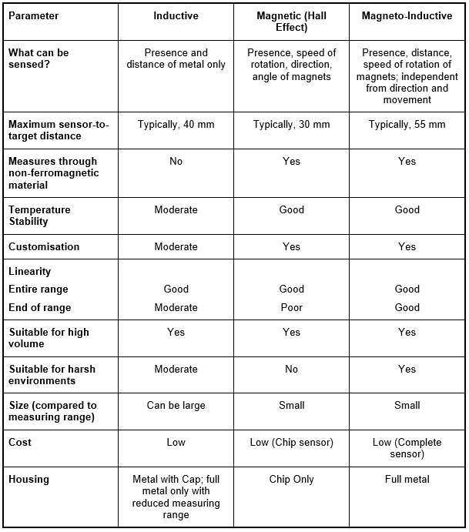

However, by placing a special film in the eddy current field, the field is attenuated in direct proportion to its field strength, producing a linear relationship between the distance from the sensor to the magnet (and the resulting output signal). As printed coils are used in the sensor element, no semiconductor devices are required, simplifying the design.

Measurement range is typically from 20 mm to 55 mm and custom solutions can increase this to around 55 mm. Even over this large measurement range, a very small change of the magnet position can still be detected. The measurement range can be customised by simply changing the magnet size and strength.

A mainSENSOR can measure through any non-ferromagnetic material, including aluminium or stainless steel, so it can be used in pressure-tight containers and closed systems. It has high temperature stability, and when combined with a microprocessor can produce a digital output compatible with pulse width modulation (PWM), CAN bus and other digital communication standards.

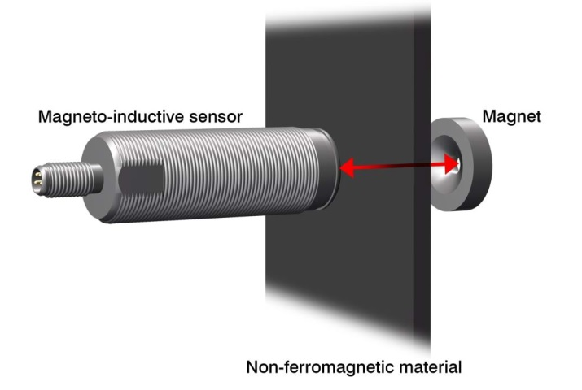
Magneto-inductive sensors measure the position of a magnet. The innovative measuring principle enables through non-ferromagnetic materials.

Unlike magnetic sensors based on the Hall effect, the mainSENSOR’s measurement capability is linear throughout its measurement range rather than only a portion of it. This high linearity is achieved through a process called "self-linearisation", allowing it to provide a linear response even at the limits of the measurement range. A compact PC board contains the sensor element and signal preparation, signal evaluation and signal output. As it is a separate assembly, the sensor can be located in protected areas while the magnet can be placed in harsh environments.

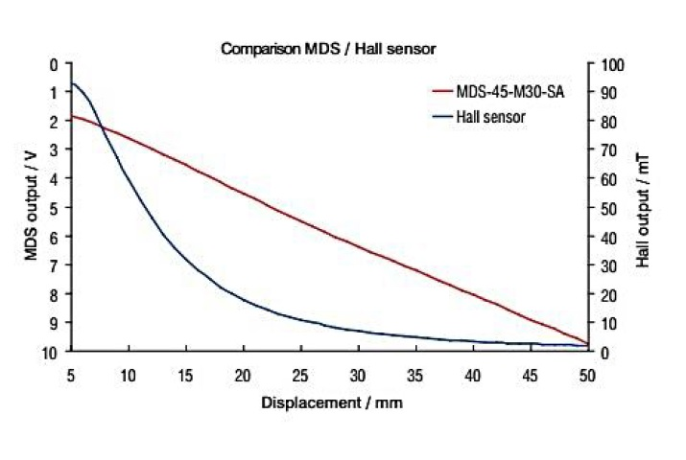
One of the most important advantages of the mainSENSOR is its high linearity and sensitivity even with large measurement ranges.

Flexibility in mounting the magneto-inductive sensor
Micro-Epsilon’s magneto-inductive sensors can be applied in many different applications. In the case of non-ferromagnetic objects, the sensor can either be countersunk, flush mounted or protruding, without any effects on the measurements. The magnet is mounted to the measurement object using a stainless steel screw, which is supplied with the sensor.
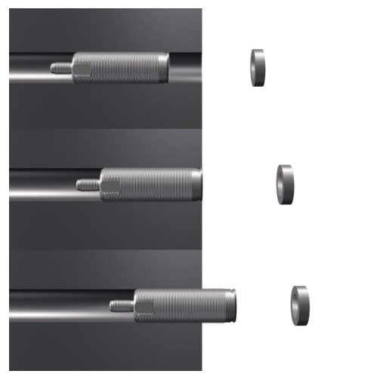
Flexible mounting options make magneto-inductive sensors ideally suitable for integration into machines.

Axial and side shifted measurement
The mainSENSOR detects the position of a magnet, which is fixed to the measurement object. The magnet can be applied to the sensor either axially or side on. Especially in the case of limited installation spaces, side shifted measurement offers a space-saving alternative.

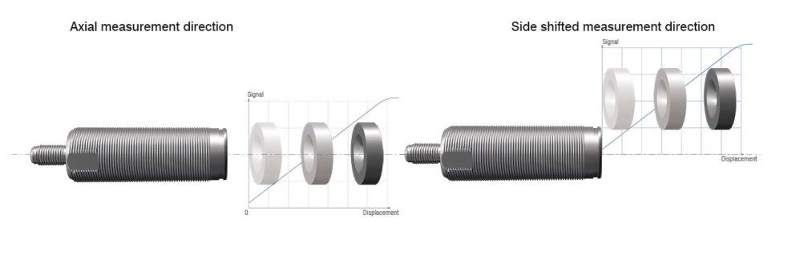
A unique feature is the possibility for axial and radial measurement alignment of the magnet. In limited installation space, this enables new aspects of using a displacement sensor.

Customisation
The mainSENSOR gives designers significant flexibility for incorporation into a system. For example, sensors can be arranged in rows to measure long distances in applications such as the damper in a washing machine, whereby the sensor is placed outside on the damper and detects vibration of the drum via an integrated magnet.

The PC board can be modified to meet specific requirements, including distance or speed measurement, accuracy and required frequency response. Communications interfaces can be selected to produce current, voltage, PWM and others, and signal conditioning can be provided to achieve the best price/performance ratio. One family within the mainSENSOR product line provides a rectangular output signal in which the distance signal is proportional to duration or frequency, depending on the magnet.

The housing, material and protection class can also be changed so that, for example, in space-constricted environments, a side-shifted measurement can be employed to save space. If the sensor is to be used in a harsh industrial environment, it can be housed in a sealed stainless steel enclosure that withstands high pressure, dirt, aggressive chemicals (acids) and solvents. Finally, for rotational speed measurements of ferromagnetic objects such as toothed racks, the sensor can be pre-tensioned with the magnet integrated within the housing.

Conclusion
Inductive and magnetic sensors have served numerous applications well for many years and will continue to do so. However, the mainSENSOR magneto-inductive sensor from Micro-Epsilon combines the inherent strengths of both types while increasing measurement accuracy over a wider range. It can also be customised and can measure through non-ferromagnetic materials, is very compact, and can be used in virtually any type of environment. These benefits essentially make it a new type of sensor for both traditional and new applications.

For more information, please call the Micro-Epsilon sales department on +44 (0)151 355 6070 or email info@micro-epsilon.co.uk

– ENDS – [1,169 words]

Note to Editors:

About Micro-Epsilon
Manufacturing processes throughout all industries are evolving at a rapid pace, and the quality and tolerances expected from the end user are forever increasing. Thus, the need for smarter measurement solutions is continuously growing. Micro-Epsilon (www.micro-epsilon.co.uk) is renowned globally for being at the forefront of measurement technology.
For more than 50 years, we have continuously offered reliable, high performance, unique solutions particularly when high precision measurement or inspection is required. Our product range covers sensors for the measurement of distance and displacement, sensors for IR temperature measurement and colour detection, as well as turnkey systems for dimensional measurement and defect detection.
We understand that our customers are our business partners and aim to develop long term relationships with them. We work closely with our customers to fully understand their requirements; our salespeople are engineers and understand more than just the sensor performance. We are problem solvers.
We operate a fair working policy, which results in excellent customer service and support even post sale.
Our high performance products and way of working provide our customers with a genuine competitive advantage.

To download high resolution images for this article, please go to www.silverbulletpr.co.uk/press . Alternatively, you can request an image by contacting:

Issued by: Dean Palmer
Director
SilverBullet PR Ltd
19, Glen Crescent, Stamford,
Lincolnshire PE9 1SW
Tel: 01780 754 254
Mobile: 07703 023771
Email: dean@silverbulletpr.co.uk

Reader Enquiries/Advertising:
Glenn Wedgbrow,
Business Development Manager,
Micro-Epsilon UK Ltd
1, Shorelines Building,
Shore Road
Birkenhead
Cheshire CH41 1AU
Tel: +44 (0) 151 355 6070
Email: glenn.wedgbrow@micro-epsilon.co.uk

