Ref. ME405 22nd March 2022

New inline 3D profile measurement systems inspect geometry of long strip products in hot and cold rolling mills
Precision sensor manufacturer Micro-Epsilon has introduced a range of inline 3D profile measurement systems for the geometrical inspection of long products in metal processing. Depending on the application and profile shape, the measurement systems can be equipped with either ThruBeam sensors, red laser profile scanners or blue laser profile scanners from Micro-Epsilon, to provide the optimal solution for the application.

Long strip products such as profiles, billets and tubes, which are produced by rolling, drawing or forging, often have complex cross-sectional geometries. The new dimensionCONTROL Metal Profile Gauge (MPG) measuring systems from Micro-Epsilon have a compact, horseshoe-shaped design that allows them to be easily integrated directly into metal processing lines, including harsh hot rolling environments. Fully automatic calibration compensates for any potential temperature-related long term drift of the mechanical structure, resulting in a reliable inline measurement system for process control of hot and cold rolled products.

Continuous, reliable measurements
Inside the dimensionCONTROL MPG frame are six laser profile triangulation sensors and a fully automated calibration system. The lasers project straight lines onto the surface to be measured. These lines from each sensor are combined to provide a complete profile around the circumference of the target. The basic calibration of the sensor serves as a reference to convert the deviation into real/actual measured values. Pneumatic protection of sensor optics and optional water cooling is available for harsh, hot environments.

Typical applications for dimensionCONTROL MPG systems include hot and cold rolled long strip products, blooming and finishing mills, where the systems can measure both ferrous (e.g. iron, steel) and non-ferrous (aluminium, zinc, alloys, etc.) metals. Positioned at various points along a rolling line, dimensionCONTROL MPG systems acquire and log measurement data to provide essential information to support 100% process control, quality assurance and good/bad inspection decisions, helping to reduce set up time (tool changeovers) during product changes.

dimensionCONTROL MPG systems generate real 3D data with which the key dimensions of the target are calculated. The systems are available with Micro-Epsilon’s comprehensive software package for monitoring and optimising production. A variety of communications interfaces are available for linking the measurement systems with production control systems. All dimensionCONTROL systems can be fitted with non-contact infrared temperature measurement sensors (pyrometers) to provide additional information on the material temperature and can be logged alongside other key measurement parameters.

Three versions for every scenario
The dimensionCONTROL MPG range includes three systems: the MPG 8208 ODC, MPG 8208 LLT, and the MPG 9208 LLT.

The MPG 8208 ODC system uses ThruBeam sensors and has a measuring range of up to 500mm. This air-cooled system is designed for discrete diameter measurements in one to three axes (with no axis correction for curved targets). Typical applications include wire, bar, rebar and tube products.

The MPG 8208 LLT and MPG 9208 LLT systems use red or blue (respectively) laser line profile scanners. The systems have a measuring range of 130mm and provide 360-degree profile measurements in an unlimited number of axes. Both systems can measure the profile of complex shaped products (with axis correction for curved products) such as double ‘T’ and ‘U’ profiles. Whilst the MPG 8208 LLT system is air-cooled, the MPG 9208 LLT version is water-cooled to ensure reliable measurements of red-hot glowing products where temperatures may exceed 1,000°C.

For more information on the dimensionCONTROL range of 3D profile measurement systems, please visit www.micro-epsilon.co.uk or call the Micro-Epsilon sales department on +44 (0)151 355 6070 or email info@micro-epsilon.co.uk

– ENDS – [570 words]

Photos and captions:
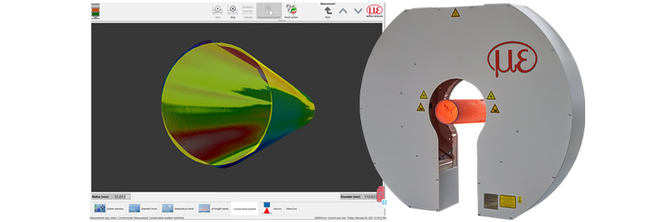

The new dimensionCONTROL systems provide real 3D measurements with axis correction of potentially curved targets.

Note to Editors:

About Micro-Epsilon
Manufacturing processes throughout all industries are evolving at a rapid pace, and the quality and tolerances expected from the end user are forever increasing. Thus, the need for smarter measurement solutions is continuously growing. Micro-Epsilon (www.micro-epsilon.co.uk) is renowned globally for being at the forefront of measurement technology.
For more than 50 years, we have continuously offered reliable, high performance, unique solutions particularly when high precision measurement or inspection is required. Our product range covers sensors for the measurement of distance and displacement, sensors for IR temperature measurement and colour detection, as well as turnkey systems for dimensional measurement and defect detection.
We understand that our customers are our business partners and aim to develop long term relationships with them. We work closely with our customers to fully understand their requirements; our salespeople are engineers and understand more than just the sensor performance. We are problem solvers.
We operate a fair working policy, which results in excellent customer service and support even post sale.
Our high performance products and way of working provide our customers with a genuine competitive advantage.

To download high resolution images for this article, please go to www.silverbulletpr.co.uk/press . Alternatively, you can request an image by contacting:

Issued by: Dean Palmer
Director
SilverBullet PR Ltd
19, Glen Crescent, Stamford,
Lincolnshire PE9 1SW
Tel: 01780 754 254
Mobile: 07703 023771
Email: dean@silverbulletpr.co.uk

Reader Enquiries/Advertising:
Glenn Wedgbrow,
Business Development Manager,
Micro-Epsilon UK Ltd
1, Shorelines Building,
Shore Road
Birkenhead
Cheshire CH41 1AU
Tel: +44 (0) 151 355 6070
Email: glenn.wedgbrow@micro-epsilon.co.uk

