Ref. ME410 18th May 2022

New laser triangulation sensor provides unique combination of high performance, compact design and integrated Industrial Ethernet interface
Precision sensor manufacturer Micro-Epsilon continues the development of its optoNCDT 1900 series of laser triangulation sensors with the addition of the optoNCDT 1900-EtherCAT. This compact sensor has an integrated EtherCAT interface for direct connection to industrial controllers, eliminating the need for an external interface module, while reducing installation effort and wiring.

With the optoNCDT 1900-EtherCAT, signal conversion takes place directly in the sensor, without loss of speed and with full performance. After rebooting in EtherCAT mode, all the sensor settings are automatically applied to the TwinCAT software, which means time consuming settings made directly in TwinCAT are no longer necessary. Less experienced TwinCAT users are able therefore to quickly integrate the sensor into the EtherCAT control unit.

For very fast measurements, that would normally be limited by the PLC’s cycle time, an oversampling function can be activated in the sensor, allowing measurement data to be transferred four times faster than the cycle time of the PLC (up to a maximum of 10 kHz). For a PLC with a 1 ms cycle time, this means a possible sensor measuring rate of 4 kHz. For this purpose, the data is temporarily stored by the sensor and only transmitted with the next query cycle.

Glenn Wedgbrow, Business Development Manager at Micro-Epsilon UK comments: “The optoNCDT 1900-EtherCAT is the only laser triangulation sensor worldwide that combines high precision and such a compact design with an integrated Industrial Ethernet interface. This results in a sensor that sets new benchmarks for advanced automation tasks. Due to its flexible mounting options and advanced surface compensation features, the optoNCDT 1900-EtherCAT is also extremely versatile and will help solve a wide variety of industrial challenges, particularly in high speed applications such as packaging machines, robots, high speed presses, hydraulic systems, injection moulding machines and CNC machine tools, as well in highly networked systems or plants, for example, in transport technology, logistics and automation.”

The optoNCDT 1900-EtherCAT is available in seven measuring ranges from 2 mm up to 500 mm. Linearity is from ± 1.0 µm. Depending on the application, power can be supplied externally or via PoE (Power-over-Ethernet). Other industrial fieldbus interfaces, including Profinet and EtherNet/IP, will be available for the optoNCDT 1900 in 2022.

Laser line version for metals and structured surfaces
A laser line version of the optoNCDT 1900-EtherCAT is also available. The optoNCDT 1900LL-EtherCAT projects a small laser line onto the measuring object. The sensor performs particularly well in distance measurements where the sensor or measuring object is moved in the Z-axis direction, such as robot positioning. The sensor is designed for shiny metallic and structured surfaces, as well as for measurements of materials where the laser beam penetrates. For these surfaces, the small laser line offers significant advantages, as it optically averages and compensates for irregularities such as structure and roughness. In addition to optical averaging, special software algorithms filter out interferences caused by surface roughness, defects, depressions or the smallest of holes. Especially on metals, they achieve more stable and reliable measurement results than point sensors.

The optoNCDT 1900LL-EtherCAT is available in four measuring ranges from 2mm up to 50mm. Linearity is from ± 1.0 µm.

All models are fast, precise and stable
The optoNCDT 1900 series of laser triangulation sensors is perfect for high speed distance, displacement and position measurements in a wide range of automation tasks, including machine building, robotics, automotive production, 3D printing and coordinate measuring machines. The high performance controller integrated in all optoNCDT 1900 sensors enables fast and highly precise processing of measurement values. The intelligent exposure control and powerful signal processing ensure a stable measurement signal and maximum process reliability. In addition, the sensor has the highest resistance to ambient light in its class and can be used in strongly illuminated environments up to 50,000 lux.

The sensor itself has dimensions of 70 x 31 x 45mm and weighs just 185g. High performance optics create a small spot size onto the target, which enables tiny objects and surface details to be measured. A large aperture for the receiver ensures greater accuracy and repeatability when compared to other sensors of similar measurement range. The sensor itself is also extremely robust with the ability to withstand high shock and vibrations (up to 30 g).

For more information on the optoNCDT 1900-EtherCAT series, please visit
www.micro-epsilon.co.uk or call the Micro-Epsilon sales department on +44 (0)151 355 6070 or email info@micro-epsilon.co.uk

– ENDS – [729 words]

Photos and captions:
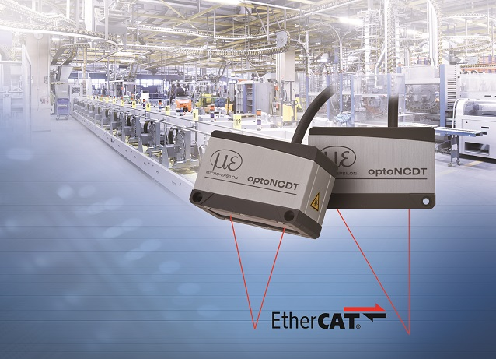
The new optoNCDT 1900-EtherCAT is ideal for a wide range of high speed industrial automation applications.

Note to Editors:

About Micro-Epsilon
Manufacturing processes throughout all industries are evolving at a rapid pace, and the quality and tolerances expected from the end user are forever increasing. Thus, the need for smarter measurement solutions is continuously growing. Micro-Epsilon (www.micro-epsilon.co.uk) is renowned globally for being at the forefront of measurement technology.
For more than 50 years, we have continuously offered reliable, high performance, unique solutions particularly when high precision measurement or inspection is required. Our product range covers sensors for the measurement of distance and displacement, sensors for IR temperature measurement and colour detection, as well as turnkey systems for dimensional measurement and defect detection.
We understand that our customers are our business partners and aim to develop long term relationships with them. We work closely with our customers to fully understand their requirements; our salespeople are engineers and understand more than just the sensor performance. We are problem solvers.
We operate a fair working policy, which results in excellent customer service and support even post sale.
Our high performance products and way of working provide our customers with a genuine competitive advantage.

To download high resolution images for this article, please go to www.silverbulletpr.co.uk/press . Alternatively, you can request an image by contacting:

Issued by: Dean Palmer
Director
SilverBullet PR Ltd
19, Glen Crescent, Stamford,
Lincolnshire PE9 1SW
Tel: 01780 754 254
Mobile: 07703 023771
Email: dean@silverbulletpr.co.uk

Reader Enquiries/Advertising:
Glenn Wedgbrow,
Business Development Manager,
Micro-Epsilon UK Ltd
1, Shorelines Building,
Shore Road
Birkenhead
Cheshire CH41 1AU
Tel: +44 (0) 151 355 6070
Email: glenn.wedgbrow@micro-epsilon.co.uk

