Ref. ME412 16th June 2022

New software from Micro-Epsilon enables 3D data capture and evaluation
Precision sensor manufacturer Micro-Epsilon has developed a new powerful software tool, 3DInspect, which enables 3D data capture and evaluation. The software is compatible with all 3D sensors in the Micro-Epsilon portfolio, including surfaceCONTROL for geometry, shape and surface inspection of matt objects; reflectCONTROL for measurement of shiny, reflective surfaces, and scanCONTROL sensors laser scanners for precise, inline 3D measurements.

3DInspect is designed for ease while offering a wide range of functions for analysing and measuring captured data. These include parameter setting of the sensors, alignment of point clouds and the selection of relevant objects, filters for smoothing and optimising point clouds, as well as calculation programs for height, radius and determining flatness and distances between points and angles. The software is able to find a target based on its contour and readjust it to allow further inspection to be made.

The 3DInspect software concept offers four steps to obtaining results:
- Data acquisition – ensuring that the sensor and the target are correctly aligned aided by the ‘Display Image’ data. The data is then captured and processed into the software.
- Data pre-processing – realigning of the captured data so that it is in line with the XYZ coordinate system.
- Evaluation – the data can now be evaluated and various processes can be set up to inspect.
- Transfer of data – the data can now be output from the software. This can be done in a number of different ways depending on the user’s configuration and set up. Available output formats are UDP, TCP and Modbus, where 3DInspect acts as the server. With additional modules, control and measured value output are also possible via Profinet and Ethernet/IP.

Glenn Wedgbrow, Business Development Manager at Micro-Epsilon UK comments: “For those system integrators with their own 3D processing software such as HALCON or similar, we offer our documented 3D Software Development Kit [SDK] with examples for various programming languages , so that they can create their own solutions to applications. For end users who do not have the capability to write their own software code, we offer the 3DInspect software solution.”

In addition to the standard version of 3DInspect, the ‘Automation’ function extension supports automated production processes. Video tutorials explain the software application and its features. As the software is constantly being developed, it is always up to date and every new release offers further useful functions. A comprehensive SDK is available for third party and custom image processing solutions. This is based on the GigE Vision and GenICam industry standards, including numerous function blocks.

For more information on 3DInspect or to download the software for free, please visit www.micro-epsilon.co.uk or call the Micro-Epsilon sales department on +44 (0)151 355 6070 or email info@micro-epsilon.co.uk

– ENDS – [450 words]

Photos and captions:
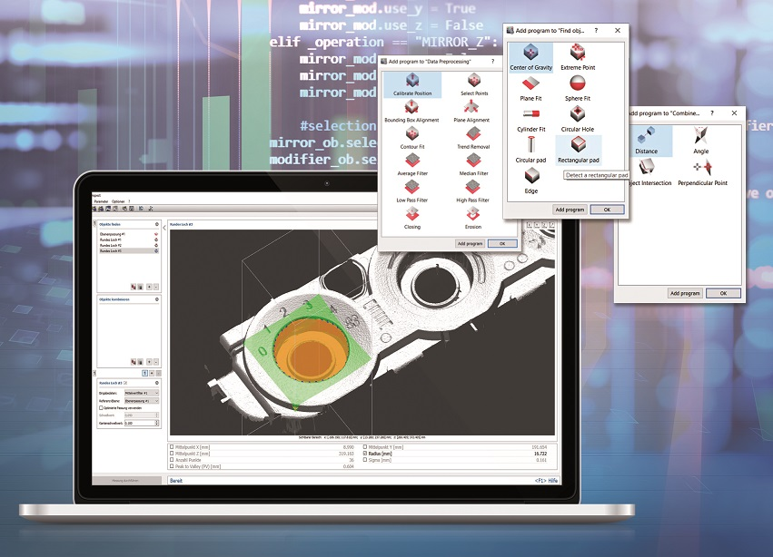
3DInspect enables 3D data capture and evaluation and is compatible with all 3D sensors in the
Micro-Epsilon portfolio.

Note to Editors:

About Micro-Epsilon
Manufacturing processes throughout all industries are evolving at a rapid pace, and the quality and tolerances expected from the end user are forever increasing. Thus, the need for smarter measurement solutions is continuously growing. Micro-Epsilon (www.micro-epsilon.co.uk) is renowned globally for being at the forefront of measurement technology.
For more than 50 years, we have continuously offered reliable, high performance, unique solutions particularly when high precision measurement or inspection is required. Our product range covers sensors for the measurement of distance and displacement, sensors for IR temperature measurement and colour detection, as well as turnkey systems for dimensional measurement and defect detection.
We understand that our customers are our business partners and aim to develop long term relationships with them. We work closely with our customers to fully understand their requirements; our salespeople are engineers and understand more than just the sensor performance. We are problem solvers.
We operate a fair working policy, which results in excellent customer service and support even post sale.
Our high performance products and way of working provide our customers with a genuine competitive advantage.

To download high resolution images for this article, please go to www.silverbulletpr.co.uk/press . Alternatively, you can request an image by contacting:

Issued by: Dean Palmer
Director
SilverBullet PR Ltd
19, Glen Crescent, Stamford,
Lincolnshire PE9 1SW
Tel: 01780 754 254
Mobile: 07703 023771
Email: dean@silverbulletpr.co.uk

Reader Enquiries/Advertising:
Glenn Wedgbrow,
Business Development Manager,
Micro-Epsilon UK Ltd
1, Shorelines Building,
Shore Road
Birkenhead
Cheshire CH41 1AU
Tel: +44 (0) 151 355 6070
Email: glenn.wedgbrow@micro-epsilon.co.uk

