Ref. ME413 4th July 2022

White light interferometers with new multi-peak function measure multiple
thin transparent layers in one measuring process
Precision sensor manufacturer Micro-Epsilon has further developed its interferoMETER range of white light interferometers to include Multi-Peak systems, which enable high precision measurement of multiple transparent layers in just one measuring process. This further expands the range of potential applications, particularly in the semiconductor industry, as well as in the production of coated glass, batteries and plastic film.

The new interferoMETER Multi-Peak (MP) systems allow the measurement of multiple layers, substrates and coatings that are transparent to the 840 nm wavelength range. This opens up applications in the semiconductor industry, where high precision solutions are required for positioning tasks, gap dimension inspection and measurements of extremely thin layers. In glass and plastic film production, MP systems can rapidly measure very thin or coated glass, as well as multiple bonded plastic films based on high process stability in the production line.

Two controller models are available for multi-peak distance measurement (IMS5x00-DS/MP) or multi-layer thickness measurement (IMS5400-TH/MP). The two system variants differ in that the layer thicknesses of the spacing systems are calculated from the respective distance values and measured directly in the thickness system.

Multi-peak distance
Systems for multi-peak distance measurement are particularly beneficial in alignment and positioning tasks in which a distance is to be measured and a thickness determined at the same time. In a large measuring range of 2.1 mm, up to 14 layers with minimum thicknesses of up to 10 µm can be detected. Thanks to the absolute measurement, the system does not have to be referenced even after a signal interruption, for example, at steps or edges.

Multi-layer thickness
Systems for multi-layer thickness measurement are always used when distance-independent thickness values for up to 5 layers are required. In the thickness measuring range of 2.1 mm, individual layers of up to 35 µm are measured in a process-stable manner. The large working range compensates for distance fluctuations of the measuring object, so that vibrations or other material movements have no influence on the measurement. A large base distance of up to 70 mm offers process reliability and protects the sensor from damage.

For easy set up and configuration, a modern, intuitive web interface is provided for all MP systems. In addition, various interfaces (EtherCAT, Ethernet, Profinet, EtherNet/IP, RS422, analogue) offer numerous integration options.

In addition to the MP systems, new sensor housings with a higher IP65 protection rating for industrial environments are also available, as well as the previous vacuum-compatible versions.

Unmatched accuracy
The interferoMETER range of high performance white light interferometers from Micro-Epsilon provide unmatched accuracy levels in absolute non-contact optical distance and thickness measurement. With measurement resolution from 30 picometres and linearity from ±10nm, these interferometers represent a step change in accuracy from its confocal measurement systems. The interferoMETER range comprises of a controller, a sensor and a fibre optic cable. Unlike traditional laser interferometers that use a single wavelength and only perform relative measurements, the interferoMETER range operates with a broadband super-luminescent diode (SLED) and can make absolute measurements, ideal for step height and surface measurements. The use of a longer wavelength, 840nm, allows for a greater overall measurement range. In addition, being in the near-infrared part of the spectrum opens up the possibility to measure thicknesses of anti-reflective glass, plastics, reflective metals and coated objects.

For more information on the interferoMETER series from Micro-Epsilon, please visit www.micro-epsilon.co.uk or call the Micro-Epsilon sales department on +44 (0)151 355 6070 or email mailto:info@micro-epsilon.co.uk

– ENDS – [569 words]

Photos and captions:

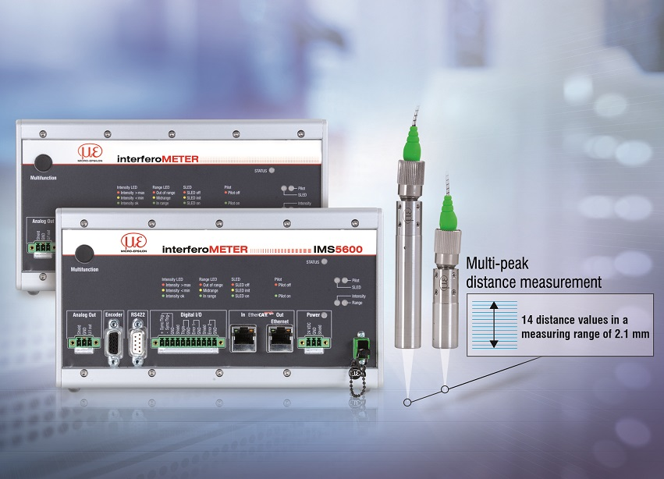
The white light interferometers with new multi-peak function measure multiple transparent layers.

Note to Editors:

About Micro-Epsilon
Manufacturing processes throughout all industries are evolving at a rapid pace, and the quality and tolerances expected from the end user are forever increasing. Thus, the need for smarter measurement solutions is continuously growing. Micro-Epsilon (www.micro-epsilon.co.uk) is renowned globally for being at the forefront of measurement technology.
For more than 50 years, we have continuously offered reliable, high performance, unique solutions particularly when high precision measurement or inspection is required. Our product range covers sensors for the measurement of distance and displacement, sensors for IR temperature measurement and colour detection, as well as turnkey systems for dimensional measurement and defect detection.
We understand that our customers are our business partners and aim to develop long term relationships with them. We work closely with our customers to fully understand their requirements; our salespeople are engineers and understand more than just the sensor performance. We are problem solvers.
We operate a fair working policy, which results in excellent customer service and support even post sale.
Our high performance products and way of working provide our customers with a genuine competitive advantage.

To download high resolution images for this article, please go to www.silverbulletpr.co.uk/press . Alternatively, you can request an image by contacting:

Issued by: Dean Palmer
Director
SilverBullet PR Ltd
19, Glen Crescent, Stamford,
Lincolnshire PE9 1SW
Tel: 01780 754 254
Mobile: 07703 023771
Email: dean@silverbulletpr.co.uk

Reader Enquiries/Advertising:
Glenn Wedgbrow,
Business Development Manager,
Micro-Epsilon UK Ltd
1, Shorelines Building,
Shore Road
Birkenhead
Cheshire CH41 1AU
Tel: +44 (0) 151 355 6070
Email: glenn.wedgbrow@micro-epsilon.co.uk

