Ref. ME414 19th July 2022

Luminary ROLI chooses laser triangulation sensor from Micro-Epsilon to measure displacement of keys and finger movements in musical touch technology
Luminary ROLI Limited, a pioneering designer and developer of musical touch technology, has chosen to use an optoNCDT 1320 laser triangulation sensor from Micro-Epsilon in its R&D process to precisely measure displacements of musical device keys and finger movements. By integrating the laser sensor with an Arduino board, Luminary ROLI now has greater flexibility to use the measurement data in different ways to control test jigs and to test its products in a wider range of scenarios.

Based in East London, Luminary ROLI is a multi-disciplinary team of creators who design and develop the latest in music learning. Its musical touch technology ranges from handheld drum pads to stage-performance synthesizers and software programs with free apps and advanced sound design programs.

As Xorge Castro, Senior NPI and Mechanical Engineer at the company comments: “Every year, our musical touch technology becomes more accessible. Smaller, more approachable, more affordable tools are bringing us closer to our long term goal of empowering everyone to make music. Making these new instruments accessible to everyone also means connecting with tools that music makers know and love. Our musical touch technology is more and more compatible and this gives music makers a way to explore and be expressive, without leaving their present setups behind.”

The challenge
As part of its R&D process, Luminary ROLI needs to characterise the products that it develops and to benchmark against its competitors. As Xorge explains: “The most important aspects of interaction in our products are force and displacement. These can be seen as how a key is pressed and released in a conventional music keyboard. However, in our products, we go beyond this to create expressive responses that will vary the sound depending on small changes in how the key or surface is pressed.”

Luminary ROLI purchased the optoNCDT 1320 laser sensor to help it measure precise displacements and finger movements. The test equipment must be versatile and adapt to different product sizes and use scenarios. Most of the test equipment is developed in-house using Arduino boards to control them.

As Xorge puts it: “These boards allow us to quickly modify parameters and create bespoke solutions for each test that we need. Our force gauges and other sensors can send data to Arduino boards through analogue or TX RX signal format. The challenge we had was how to communicate the optoNCDT 1320 sensor measurement readings to an Arduino using TX RX, as this would provide more functionality and better accuracy than analogue output.”

Approach taken
Xorge purchased a MAX490 board from Amazon for £18. The board translates the RS422 signal from the laser sensor into TX RX signal format that can be read in the Arduino. An Arduino Mega board was required, as several devices need to be connected through TX RX.

“In order to communicate through RS422, we had to change the laser settings on the web browser to use a Baud rate of 115,200 and connect through RS422. This provided raw data in binary, which at first, we could not make any sense of,” explains Xorge.

The next challenge was to translate this binary data into a number that could be used. Micro-Epsilon provided the formula for converting the binary value into a measurement reading based on the sensor’s measurement range. ROLI’s firmware engineer, Chris Slater, then developed the necessary code for use in the Arduino: https://create.arduino.cc/projecthub/user2160000/reading-rs-422-binary-data-from-opto-laser-23fb34

“We then integrated the Arduino Mega with a force gauge sensor and another Arduino board that controls an XYZ gantry. The test equipment allows us to move a force gauge on any XY and Z-axis position. With the help of the laser sensor, we can precisely measure a key displacement as we apply a force. In other applications, we can measure the force under the key and use the laser sensor to measure how the key is pressed with a finger or a tool,” adds Xorge.

All-round benefits
According to Xorge, the optoNCDT 1320 met all his performance needs in terms of measurement accuracy and measuring rate (up to 2kHz), while also impressing with its compact, lightweight design (dimensions of 46mm x 30mm x 20mm, weight 30g) that allows the sensor to be easily mounted in tight spaces on his test jigs.

The sensor’s unique ‘Auto Target Compensation’ (ATC) feature ensures stable distance signal control regardless of target colour or brightness. The optoNCDT 1320 is designed for rapid set up and installation, which is achieved with just a few clicks of the multi-function sensor button. The user can select the zero setting/mastering function or the trigger set up. An intuitive web interface enables the user to carry out extended sensor set up and configuration.

As Xorge concludes: “By integrating the optoNCDT 1320 laser sensor with an Arduino board, this has given us greater flexibility to use the measurement data in different ways that allows us to control our test jigs and to test our products in a wider range of scenarios. We’ve been impressed with Micro-Epsilon and the relationship we’ve built and are also pleased with the excellent technical support they’ve provided when we needed it.”

For more information on the optoNCDT 1320 sensor from Micro-Epsilon, please visit www.micro-epsilon.co.uk or call the Micro-Epsilon sales department on +44 (0)151 355 6070 or email mailto:info@micro-epsilon.co.uk

– ENDS – [871 words]

Photos and captions:

Luminary ROLI touch technology includes light-up keyboards and handheld drum pads.

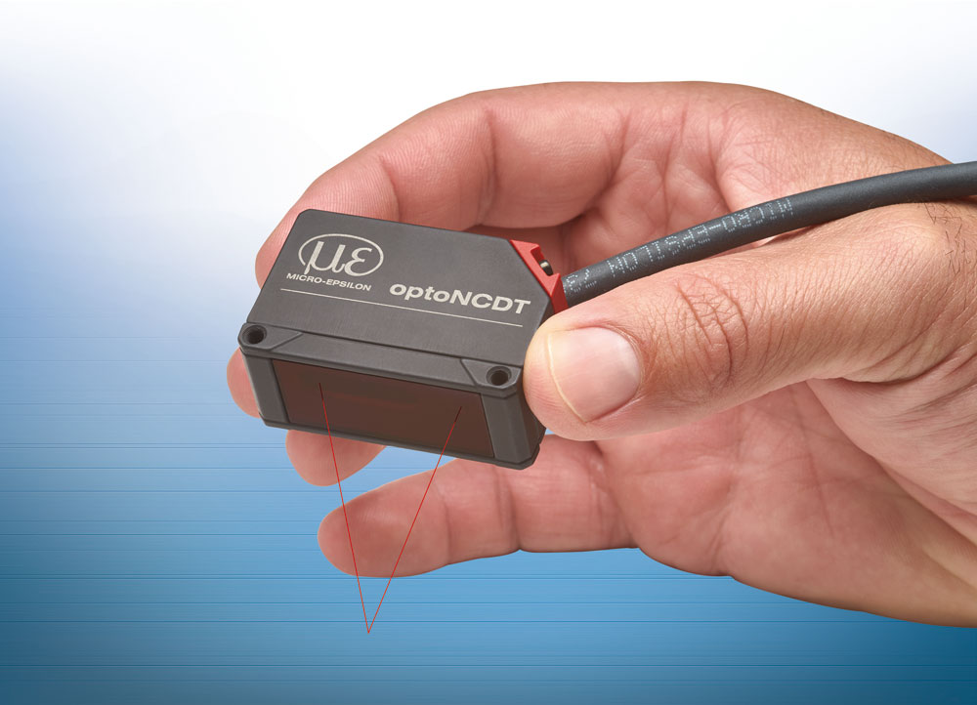
The optoNCDT 1320 laser triangulation sensor is compact, lightweight and easy to install.

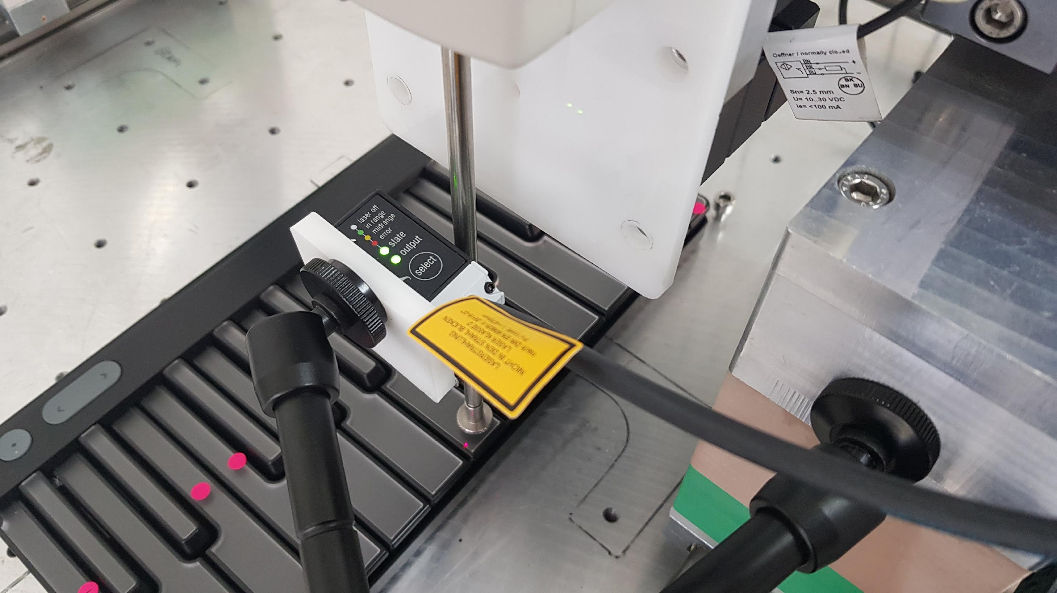
The test equipment at Luminary ROLI showing the optoNCDT 1320 laser sensor.

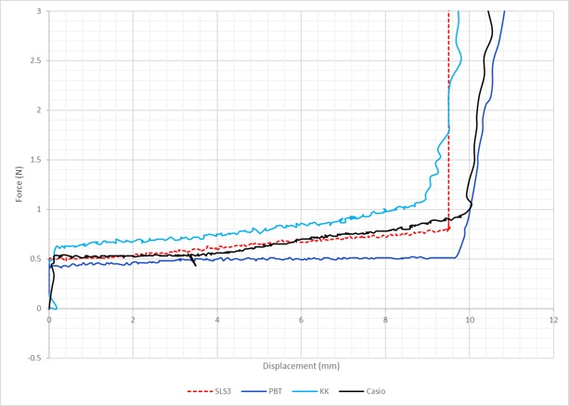
The system allows a force gauge to be moved on any XY and Z position. With the help of the laser sensor, a key displacement can be measured precisely as force is applied.

Note to Editors:

About Micro-Epsilon
Manufacturing processes throughout all industries are evolving at a rapid pace, and the quality and tolerances expected from the end user are forever increasing. Thus, the need for smarter measurement solutions is continuously growing. Micro-Epsilon (www.micro-epsilon.co.uk) is renowned globally for being at the forefront of measurement technology.
For more than 50 years, we have continuously offered reliable, high performance, unique solutions particularly when high precision measurement or inspection is required. Our product range covers sensors for the measurement of distance and displacement, sensors for IR temperature measurement and colour detection, as well as turnkey systems for dimensional measurement and defect detection.
We understand that our customers are our business partners and aim to develop long term relationships with them. We work closely with our customers to fully understand their requirements; our salespeople are engineers and understand more than just the sensor performance. We are problem solvers.
We operate a fair working policy, which results in excellent customer service and support even post sale.
Our high performance products and way of working provide our customers with a genuine competitive advantage.

To download high resolution images for this article, please go to www.silverbulletpr.co.uk/press . Alternatively, you can request an image by contacting:

Issued by: Dean Palmer
Director
SilverBullet PR Ltd
19, Glen Crescent, Stamford,
Lincolnshire PE9 1SW
Tel: 07703 023771
Email: dean@silverbulletpr.co.uk

Reader Enquiries/Advertising:
Glenn Wedgbrow,
Business Development Manager,
Micro-Epsilon UK Ltd
1, Shorelines Building,
Shore Road
Birkenhead
Cheshire CH41 1AU
Tel: +44 (0) 151 355 6070
Email: glenn.wedgbrow@micro-epsilon.co.uk

