Ref. ME415 27th July 2022

New light-intensive confocal controllers measure at high speed, even
on dark or rough surfaces
Precision sensor manufacturer Micro-Epsilon has expanded its confocalDT range of confocal controllers with two new industrial-grade controllers for distance and thickness measurements on a variety of materials, including dark or rough surfaces. The confocalDT 2465 single channel controller and the confocalDT 2466 dual channel controller offer extremely high light intensity at high measuring rates up to 30kHz.

In terms of the size and performance of its product portfolio, Micro-Epsilon is a leader in the field of confocal measurement technology. The confocal measurement principle is designed for high accuracy, non-contact displacement, distance and position measurement against any surface: solid, transparent, polished mirrored surfaces, low reflective matt surfaces and even liquids. If a surface is transparent, a one-sided thickness measurement can be achieved with inbuilt correction for the material refractive index.

The confocalDT 2465 and confocalDT 2466 controllers are suitable for use with all confocal chromatic sensors from Micro-Epsilon. The controllers are extremely light-intensive, which enables good signal stability and therefore stable measurements, even on dark or rough surfaces. Very fast measurements are possible on shiny targets.

The confocalDT 2465 is designed for one measuring channel. With the confocalDT 2466, two measuring channels can be processed via one controller, which offers a price advantage for multi-channel applications. Measurement acquisition is synchronous and can be carried out while exploiting the full measuring rate for both channels.

Quite often, confocal sensors are selected when laser triangulation or other optical sensors are not accurate or stable enough on the surface being measured. In addition, confocal sensors have an extremely small spot diameter, typically a few microns and measure in the vertical plane, so do not suffer from shadowing of the reflected light. This also enables measurement into small bores and holes.

Almost all industries benefit from this measurement principle as it can be used in both R&D and in-process measurements. In particular, the semiconductor, micro lens, automotive parts, medical, glass and MEMS industries use this sensor technology in many ways.

Multi-peak versions
As with previous models, Multi-Peak controllers are also available for the confocalDT 2465 and 2466. These enable layer thickness measurements of up to five transparent layers. Integration and commissioning (interfaces, ASCII commands, parameter set up, etc.) are identical to the existing confocalDT 242x controllers, as are the controller dimensions.

Due to a user-friendly web interface, no additional software is required to configure the controller and the sensors. Data output is via Ethernet, EtherCAT, RS422 or analogue. Optional interface modules are also available which enable data output via Profinet or EtherNet/IP.

For more information on the confocalDT 2465 and 2466 from Micro-Epsilon, please visit www.micro-epsilon.co.uk or call the Micro-Epsilon sales department on +44 (0)151 355 6070 or email mailto:info@micro-epsilon.co.uk

– ENDS – [445 words]

Photos and captions:

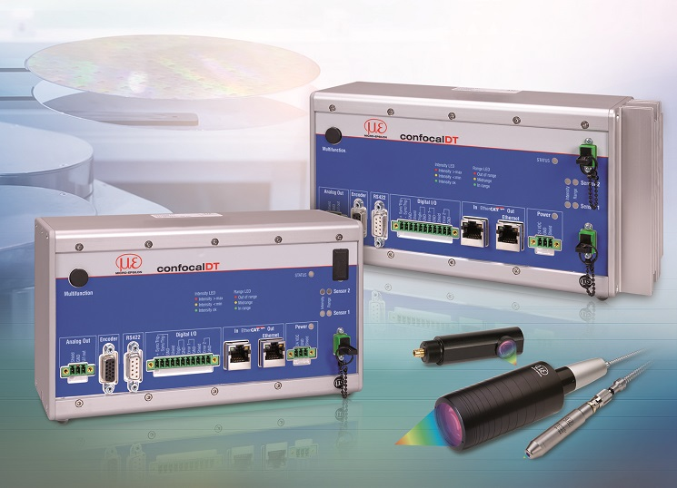
The confocalDT 2465 and 2466 Multipeak controllers offer extremely high light intensity at high measuring rates up to 30kHz.

Note to Editors:

About Micro-Epsilon
Manufacturing processes throughout all industries are evolving at a rapid pace, and the quality and tolerances expected from the end user are forever increasing. Thus, the need for smarter measurement solutions is continuously growing. Micro-Epsilon (www.micro-epsilon.co.uk) is renowned globally for being at the forefront of measurement technology.
For more than 50 years, we have continuously offered reliable, high performance, unique solutions particularly when high precision measurement or inspection is required. Our product range covers sensors for the measurement of distance and displacement, sensors for IR temperature measurement and colour detection, as well as turnkey systems for dimensional measurement and defect detection.
We understand that our customers are our business partners and aim to develop long term relationships with them. We work closely with our customers to fully understand their requirements; our salespeople are engineers and understand more than just the sensor performance. We are problem solvers.
We operate a fair working policy, which results in excellent customer service and support even post sale.
Our high performance products and way of working provide our customers with a genuine competitive advantage.

To download high resolution images for this article, please go to www.silverbulletpr.co.uk/press . Alternatively, you can request an image by contacting:

Issued by: Dean Palmer
Director
SilverBullet PR Ltd
19, Glen Crescent, Stamford,
Lincolnshire PE9 1SW
Tel: 07703 023771
Email: dean@silverbulletpr.co.uk

Reader Enquiries/Advertising:
Glenn Wedgbrow,
Business Development Manager,
Micro-Epsilon UK Ltd
1, Shorelines Building,
Shore Road
Birkenhead
Cheshire CH41 1AU
Tel: +44 (0) 151 355 6070
Email: glenn.wedgbrow@micro-epsilon.co.uk

