

#### Ref. ME418 15th September 2022

New 3mm diameter capacitive displacement sensor is one of the smallest  
 triaxial sensors in the world

Precision sensor manufacturer Micro-Epsilon has introduced two new sensors to its already extensive capaNCDT range of non-contact capacitive displacement sensors. The capaNCDT CSE01 and capaNCDT CSE025 are extremely compact sensors that provide a measuring range of 0.1mm and 0.25mm respectively. With a diameter of 3mm and a length of 15.6mm, the capaNCDT CSE01 is one of the smallest triaxial sensors in the world. The CSE025 has a diameter of 4mm and a length of 16.1mm, making both sensors ideal for distance, position and thickness measurement tasks in confined installation spaces.

As well as being small, the new sensors offer extreme measurement performance with resolutions of just 0.08nm and 0.188nm for the respective ranges. The two new sensors complement Micro-Epsilon’s comprehensive portfolio of 30 standard capacitive displacement sensors with measuring ranges from 0.05mm to 10mm. Capacitive sensors are available in a range of form factors from cylindrical, threaded and flat housings and all feature unsurpassed resolution and accuracy with high signal stability.

Applications range from vacuums and clean rooms, where sub-nanometer accuracy is possible, to industrial applications in harsh environments, where the sensors offer sub-micron accuracy. The sensors are sufficiently robust to withstand extreme temperature conditions (low to high, -50°C to +200°C) while providing the best possible temperature stability. The sensors are also extremely resistant to magnetic fields, which means safe and trouble-free operation are possible in the vicinity of magnets. Full compatibility of the sensors and controllers from Micro-Epsilon creates the greatest variety of combinations worldwide. Furthermore, due to the triaxial technology, replacing the sensors and controller is possible without requiring additional calibration.

The capaNCDT CSE01 and CSE025 have an integrated cable with a length of either 1.4m or 2.8m and are compatible with all Micro-Epsilon controllers in the DT61xx, DT62xx and DT65xx series.

For more information on the capaNCDT CSE01 and capaNCDT CSE025 from Micro-Epsilon, please visit [www.micro-epsilon.co.uk](http://www.micro-epsilon.co.uk) or call the Micro-Epsilon sales department on +44 (0)151 355 6070 or email <mailto:info@micro-epsilon.co.uk>

**– ENDS – [323 words]**

**Photos and captions:**

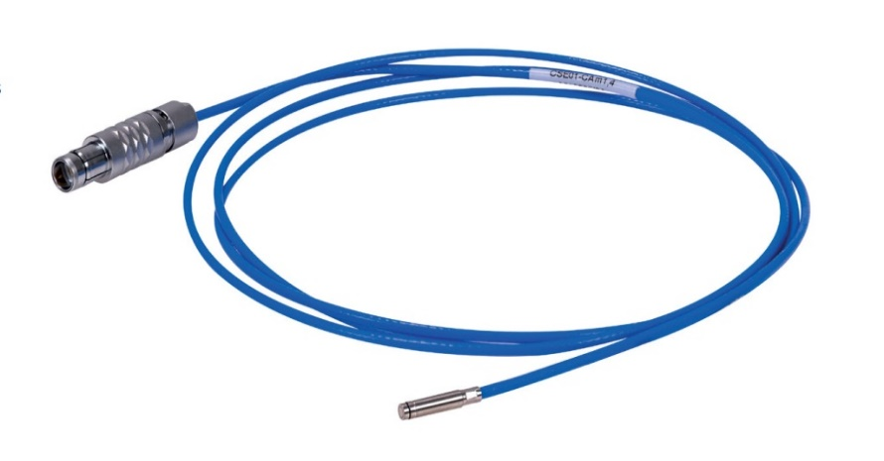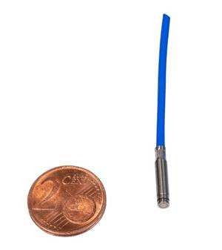

***The capaNCDT CSE01 is one of the smallest triaxial sensors in the world.***

**Note to Editors:**

**About Micro-Epsilon**

Manufacturing processes throughout all industries are evolving at a rapid pace, and the quality and tolerances expected from the end user are forever increasing. Thus, the need for smarter measurement solutions is continuously growing. Micro-Epsilon ([www.micro-epsilon.co.uk](http://www.micro-epsilon.co.uk)) is renowned globally for being at the forefront of measurement technology.

For more than 50 years, we have continuously offered reliable, high performance, unique solutions particularly when high precision measurement or inspection is required. Our product range covers sensors for the measurement of distance and displacement, sensors for IR temperature measurement and colour detection, as well as turnkey systems for dimensional measurement and defect detection.

We understand that our customers are our business partners and aim to develop long term relationships with them. We work closely with our customers to fully understand their requirements; our salespeople are engineers and understand more than just the sensor performance. We are problem solvers.

We operate a fair working policy, which results in excellent customer service and support even post sale.

Our high performance products and way of working provide our customers with a genuine competitive advantage.

**To download high resolution images for this article, please go to** [**www.silverbulletpr.co.uk/press**](http://www.silverbulletpr.co.uk/press) **. Alternatively, you can request an image by contacting:**

**Issued by:** Dean Palmer

Director

SilverBullet PR Ltd

19, Glen Crescent, Stamford,

Lincolnshire PE9 1SW

Tel: 07703 023771

Email: [dean@silverbulletpr.co.uk](mailto:d.palmer598@btinternet.com)

**Reader Enquiries/Advertising:**

Glenn Wedgbrow,

Business Development Manager,   
Micro-Epsilon UK Ltd

1, Shorelines Building,  
Shore Road  
Birkenhead  
Cheshire CH41 1AU  
Tel: +44 (0) 151 355 6070  
Email: [glenn.wedgbrow@micro-epsilon.co.uk](mailto:glenn.wedgbrow@micro-epsilon.co.uk)