Ref. ME419 23rd September 2022

New wavefront sensor and software solution for optics testing, laser beam characterisation and alignment of optical systems
Precision sensor manufacturer Micro-Epsilon has introduced a range of Shack-Hartmann wavefront sensors and analysis software to its product portfolio. Developed by Optocraft GmbH, a member of the Micro-Epsilon group of companies since 2018, the SHSLab is a powerful and comprehensive wavefront measurement solution for applications such as optics testing, optics alignment and laser beam characterisation. The solution pairs the SHSCam wavefront sensor head with the SHSWorks advanced wavefront analysis software to deliver high speed, single shot measurements with excellent accuracy, extreme measurement dynamics and a broad spectral range.

Wavefront sensors are used in production and R&D in optics manufacturing, laser industries, astronomy and space applications, as well as by contact- and intra ocular lens manufacturers, including mobile phone optics, microscope and photographic lenses. Typical applications include the alignment of optical systems, where wavefront guiding facilitates and speeds up the alignment process significantly. Wavefront sensors are also used to measure the imaging quality of objective lenses, as well as for measuring the shape of plano, spherical and slightly aspherical surfaces. In laser beam characterisation, the single shot wavefront sensor measurement enables rapid, precise measurement of laser beam parameters, control of adaptive optics and thermal lens measurement. In optics testing, precise measurement of the transmitted wavefront provides information on the Zernike wave aberrations and the corresponding PSF/MTF.

How does the SHSLab work?
A wavefront sensor consists of a 2D array of micro-lenses and a detector. After passing through the micro-lens field, a flat wavefront generates a regular point matrix on the detector, whose spots have the same separation distance as the micro-lenses. If the wavefront is curved, the spots generated by the micro-lenses migrate correspondingly far from the optical axis. From this spot displacement, the wavefront can be reconstructed. SHSLab still reliably assigns the spots to their reference points in case they have moved outside their sub-aperture. The process requires only a single camera image and is therefore very fast and simple in application. The local radius of curvature of a wavefront on the micro-lens array can be as small as 5mm, so that wavefronts with extreme curvatures can also be measured.

Sensor variants for every application
The SHSCam range of wavefront sensors from Micro-Epsilon includes the SHSCam AR3 for the measurement of fine laser beams; the SHSCam SHR4 high lateral resolution version for measurement of highly dynamic wavefronts; and the SHSCam HR3 all-round wavefront sensor with high sensitivity. In total, 19 sensor head variants are available.

The SHSCam range offers wavelength ranges of 266nm to 400nm (UV), 355nm to 1065nm (VIS/NIR), 900nm to 1700nm (SWIR). Wavelength evaluation speeds are from 1Hz to 50Hz. Detection areas are from 3.6 x 4.8mm² up to 27 x 34mm², although the area can be magnified or demagnified for use with telescopes. The standard communications interface is GigE, with others available on request. A range of accessories are also available including objective lenses, reference spheres, telescopes and light sources.

Advanced wavefront analysis software
SHSWorks is a powerful and comprehensive wavefront analysis software package that allows complete Zernike polynomial analysis, PSF/MTF calculation, laser beam parameter calculation and refractive data. The software is fast and easy to setup using predefined configurations and users benefit from a variety of features such as data logging, advanced reporting and Pass/Fail analysis.

For more information on the SHSLab wavefront sensors from Micro-Epsilon, please visit www.micro-epsilon.co.uk or call the Micro-Epsilon sales department on +44 (0)151 355 6070 or email mailto:info@micro-epsilon.co.uk

– ENDS – [567 words]

Photos and captions:
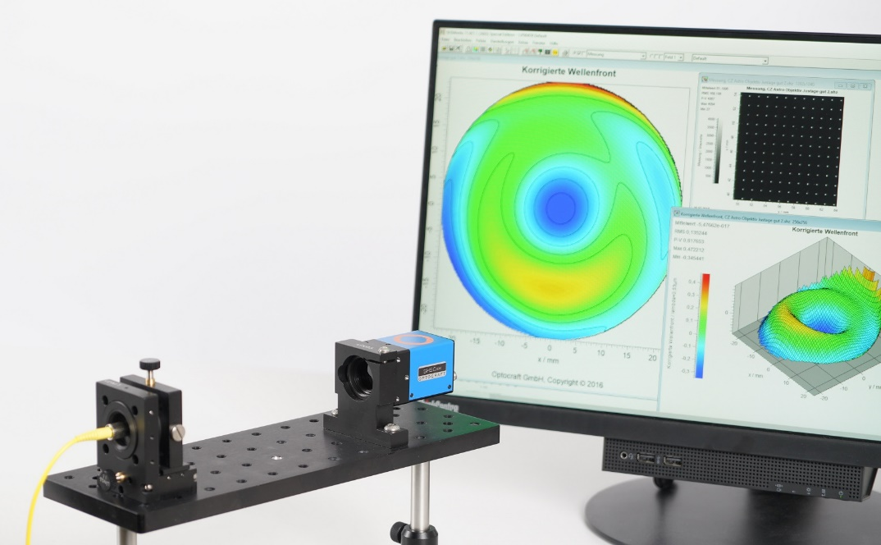
SHSLab delivers high speed, single shot measurements with excellent accuracy.

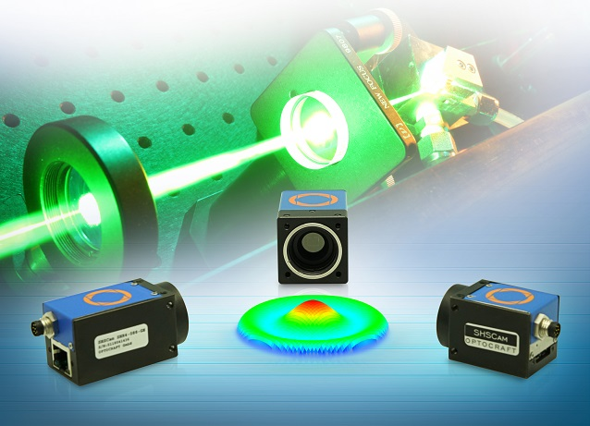
In laser beam characterisation, the single shot wavefront sensor measurement enables rapid, precise measurement of laser beam parameters, control of adaptive optics and thermal lens measurement.
Note to Editors:

About Micro-Epsilon
Manufacturing processes throughout all industries are evolving at a rapid pace, and the quality and tolerances expected from the end user are forever increasing. Thus, the need for smarter measurement solutions is continuously growing. Micro-Epsilon (www.micro-epsilon.co.uk) is renowned globally for being at the forefront of measurement technology.
For more than 50 years, we have continuously offered reliable, high performance, unique solutions particularly when high precision measurement or inspection is required. Our product range covers sensors for the measurement of distance and displacement, sensors for IR temperature measurement and colour detection, as well as turnkey systems for dimensional measurement and defect detection.
We understand that our customers are our business partners and aim to develop long term relationships with them. We work closely with our customers to fully understand their requirements; our salespeople are engineers and understand more than just the sensor performance. We are problem solvers.
We operate a fair working policy, which results in excellent customer service and support even post sale.
Our high performance products and way of working provide our customers with a genuine competitive advantage.

To download high resolution images for this article, please go to www.silverbulletpr.co.uk/press . Alternatively, you can request an image by contacting:

Issued by: Dean Palmer
Director
SilverBullet PR Ltd
19, Glen Crescent, Stamford,
Lincolnshire PE9 1SW
Tel: 07703 023771
Email: dean@silverbulletpr.co.uk

Reader Enquiries/Advertising:
Glenn Wedgbrow,
Business Development Manager,
Micro-Epsilon UK Ltd
1, Shorelines Building,
Shore Road
Birkenhead
Cheshire CH41 1AU
Tel: +44 (0) 151 355 6070
Email: glenn.wedgbrow@micro-epsilon.co.uk

