Ref. ME420 18th October 2022

High accuracy, high sensitivity turnkey wavefront measurement systems for optics testing in both R&D and inline production environments
Precision sensor manufacturer Micro-Epsilon has introduced a range of wavefront measurement systems and modules for optics testing. Based on the SHSLab range of Shack-Hartmann wavefront sensors from Optocraft GmbH – a member of the Micro-Epsilon group of companies since 2018 – SHSInspect is a range of turnkey wavefront measurement systems, measurement modules and automated software tools for a wide variety of applications in optics and optical systems, including objective lens testing, testing of optical elements and windows, surface shape measurement and inline measurement and automation.

Turnkey solutions
Two configurations of SHSInspect are available: with SHSInspect 1Xpass, the measurement beam is transmitted through the test specimens only once, while with the SHSInspect 2Xpass, the light is reflected back after the first transmission by a mirror and passes through the test sample twice.

One advantage of SHSInspect 2Xpass is that the effect of the test specimen on the wavefront is doubled. This means the measurement sensitivity is increased, which enables extremely precise measurements. As a result of the optical layout, the whole measurement configuration can be calibrated simply by means of a plane mirror and a reference sphere.

Flexible and easy to integrate
SHSInspect can be easily integrated into an automated production environment and measures in real time in terms of the production cycle. Depending on sensor size, the SHSInspect 1Xpass and 2Xpass systems reach frame rates between 1 and 50Hz – in special applications even up to 1,000Hz. Ultimately, the time required to insert the test specimen into the measuring equipment determines the measuring rate.

SHSInspect systems can achieve very high accuracy and sensitivity, even in harsh conditions. The pure sensor head (SHSCam HR) achieves a typical base accuracy (uncalibrated) of λ/15 PV. Depending on the optical structure of the test system, even higher precision can be achieved using suitable calibration measures. In the case of the SHSInspect 2Xpass system, a value of λ/20 PV has been proven in direct comparisons with a Fizeau interferometer.

Custom, multi-functional systems
SHSInspect can be considered as a platform that is optimally adapted to the requirements of the customer. The system is flexible and more cost effective than an interferometer, while covering a wider functional range. On-axis and off-axis measurements with field angles up to 50° are currently available, with larger angles feasible. Due to the combination of mechanical and optical measurement variables, both the BFL (Back Focal Length) and the EFL (Effective Focal Length) can be measured.

In production environments, the measurement process can be implemented as a semi- or fully-automatic one. In the case of a semi-automatic system, the test specimen is inserted manually into the measuring system, while SHSInspect carries out the measurement process automatically. However, this manual loading and unloading can be performed using a robot.

Measurement modules
In addition to complete turnkey measurement systems, optical measurement modules are available for inline testing or for integration into customers’ own setups. The SHSInspect RL module, for example, is a high accuracy, flexible module that can be integrated into customer setups, OEM systems or inline testing. The module can be used for:

- Wavefront, Zernike, PSF and MTF
- Alignment and final testing
- Surface and radius of curvature
- Optical elements such as plano optics, filters, spheric and aspheric lens elements, mirrors, etc.
- Optics for lasers and microscopy: objective lenses with low and high NA, air and immersion, high end and mass production
- Optics for consumer devices: R&D and quality control of lenses for mobile devices, camera lenses, etc.
- Astronomy, space: telescopes, instruments, etc.
- Optics in mass production: automated assembly and inspection, etc.

Advanced wavefront analysis software
All SHSInspect systems and modules benefit from SHSWorks, a powerful and comprehensive wavefront analysis software package that can capture multiple properties of optics and optical systems in just a single measurement. The software allows complete Zernike polynomial analysis, PSF/MTF calculation, laser beam parameter calculation and refractive data. It’s also fast and easy to setup using predefined configurations and users benefit from a variety of features such as data logging, advanced reporting and Pass/Fail analysis.

For more information on SHSInspect from Micro-Epsilon, please visit www.micro-epsilon.co.uk or call the Micro-Epsilon sales department on +44 (0)151 355 6070 or email mailto:info@micro-epsilon.co.uk

– ENDS – [686 words]

Photos and captions:
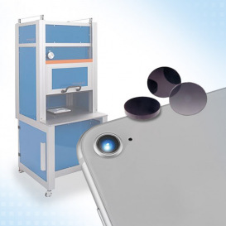
SHSInspect 1Xpass is an all-in-one system for testing the optical quality of flat optics such as single lenses, filters, etc.

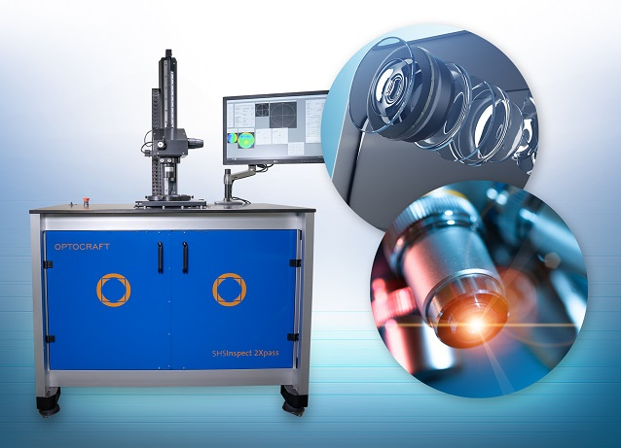
SHSInpect 2Xpass is an all-in-one instrument for multi-functional measurements of objectives and lenses for microscopy and smartphones.

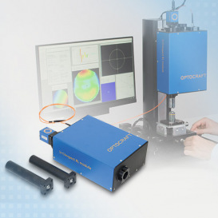

The SHSInspect RL module for testing and adjusting binoculars/spotting scopes and objectives is used for inline testing or integration into customer’s own setups.

Note to Editors:

About Micro-Epsilon
Manufacturing processes throughout all industries are evolving at a rapid pace, and the quality and tolerances expected from the end user are forever increasing. Thus, the need for smarter measurement solutions is continuously growing. Micro-Epsilon (www.micro-epsilon.co.uk) is renowned globally for being at the forefront of measurement technology.
For more than 50 years, we have continuously offered reliable, high performance, unique solutions particularly when high precision measurement or inspection is required. Our product range covers sensors for the measurement of distance and displacement, sensors for IR temperature measurement and colour detection, as well as turnkey systems for dimensional measurement and defect detection.
We understand that our customers are our business partners and aim to develop long term relationships with them. We work closely with our customers to fully understand their requirements; our salespeople are engineers and understand more than just the sensor performance. We are problem solvers.
We operate a fair working policy, which results in excellent customer service and support even post sale.
Our high performance products and way of working provide our customers with a genuine competitive advantage.

To download high resolution images for this article, please go to www.silverbulletpr.co.uk/press . Alternatively, you can request an image by contacting:

Issued by: Dean Palmer
Director
SilverBullet PR Ltd
19, Glen Crescent, Stamford,
Lincolnshire PE9 1SW
Tel: 07703 023771
Email: dean@silverbulletpr.co.uk

Reader Enquiries/Advertising:
Glenn Wedgbrow,
Business Development Manager,
Micro-Epsilon UK Ltd
1, Shorelines Building,
Shore Road
Birkenhead
Cheshire CH41 1AU
Tel: +44 (0) 151 355 6070
Email: glenn.wedgbrow@micro-epsilon.co.uk

