Ref. ME421 5th October 2022

New plug-and-play LVDT gauging system with compact integrated cable electronics for industrial automation and machine building applications
Precision sensor manufacturer Micro-Epsilon has introduced a plug-and-play range of robust, compact inductive sensors for displacement, distance, position, shape and geometry inspection in a wide range of industrial automation, machine building, production monitoring and quality control applications.

The new induSENSOR DTD-xG8 series is a complete preconfigured and calibrated inductive measuring system that consists of a DTA gauge (inductive LVDT probe) and controller integrated into the sensor cable. The cable is suitable for use in drag chains. The factory-calibrated system is fully linearised, enabling fast, easy plug-and-play installation.

LVDT measurement method
The induSENSOR DTD inductive sensor system is based on the proven LVDT measurement method. The fact that the sensor and controller are permanently connected to each other allows the system to be pre-adjusted and calibrated at the factory so that ‘out of the box’ the system can be installed and used. The system offers extreme precision and delivers high signal stability and resolutions down to the sub-micrometer range. Due to its high temperature stability, resistance to shock and vibration, as well as insensitivity to dirt and dust, the induSENSOR DTD is suitable for use in harsh industrial environments.

The system has an adjustable current and voltage output, as well as an RS485 interface, which are output via a standard industrial connector (5-pin, M12). Parameter settings are carried out using freely downloadable software and an optional USB cable. Modern fieldbuses such as Ethernet, Profinet and EtherCAT are supported via optional interface modules. The sensors are available in four measuring ranges of ±1 mm, ±3 mm, ±5 mm and ±10 mm.

Glenn Wedgbrow, Business Development Manager at Micro-Epsilon UK comments: “The induSENSOR DTD system has an excellent price-performance ratio and in the case of high volume applications, unit pricing is particularly attractive. We can also quickly tailor the system to suit individual customer requirements.”

Range of miniature controllers
Micro-Epsilon offers a range of miniature controllers for inductive displacement sensors. In addition to the new DTD system and the induSENSOR MSC7401 single channel miniature controller, there is also the induSENSOR MSC7602 and induSENSOR MSC7802 controllers, which both offer two integrated measurement channels.

In particular, the induSENSOR MSC7602 two-channel controller is for high volume OEM machine build and automation tasks. Up to 62 induSENSOR MSC7602 controllers can be linked, making the controller ideal for multi-channel applications and synchronous operation with up to 124 measurement channels possible. The DIN rail mount and bus connector minimise wiring effort.

For more information on the induSENSOR DTD series from Micro-Epsilon, please visit www.micro-epsilon.co.uk or call the Micro-Epsilon sales department on +44 (0)151 355 6070 or email mailto:info@micro-epsilon.co.uk

– ENDS – [429 words]

Photos and captions:

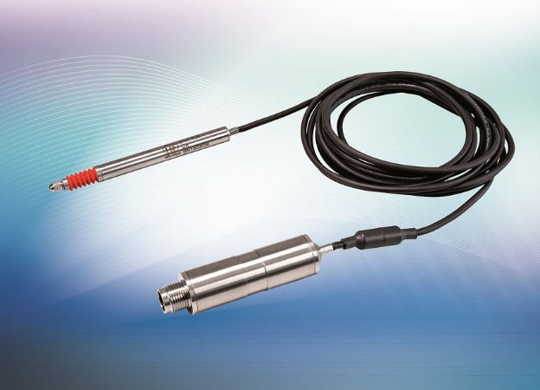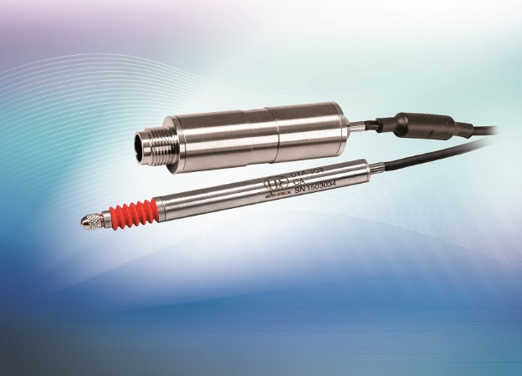
Due to its high temperature stability, resistance to shock and vibration, as well as insensitivity to dirt, the induSENSOR DTD is suitable for use in harsh industrial environments.

Note to Editors:

About Micro-Epsilon
Manufacturing processes throughout all industries are evolving at a rapid pace, and the quality and tolerances expected from the end user are forever increasing. Thus, the need for smarter measurement solutions is continuously growing. Micro-Epsilon (www.micro-epsilon.co.uk) is renowned globally for being at the forefront of measurement technology.
For more than 50 years, we have continuously offered reliable, high performance, unique solutions particularly when high precision measurement or inspection is required. Our product range covers sensors for the measurement of distance and displacement, sensors for IR temperature measurement and colour detection, as well as turnkey systems for dimensional measurement and defect detection.
We understand that our customers are our business partners and aim to develop long term relationships with them. We work closely with our customers to fully understand their requirements; our salespeople are engineers and understand more than just the sensor performance. We are problem solvers.
We operate a fair working policy, which results in excellent customer service and support even post sale.
Our high performance products and way of working provide our customers with a genuine competitive advantage.

To download high resolution images for this article, please go to www.silverbulletpr.co.uk/press . Alternatively, you can request an image by contacting:

Issued by: Dean Palmer
Director
SilverBullet PR Ltd
19, Glen Crescent, Stamford,
Lincolnshire PE9 1SW
Tel: 07703 023771
Email: dean@silverbulletpr.co.uk

Reader Enquiries/Advertising:
Glenn Wedgbrow,
Business Development Manager,
Micro-Epsilon UK Ltd
1, Shorelines Building,
Shore Road
Birkenhead
Cheshire CH41 1AU
Tel: +44 (0) 151 355 6070
Email: glenn.wedgbrow@micro-epsilon.co.uk

